Employee Management System

Current Scenario

As per the current process, Admin adds new regulations and assigns them to the department manually. Department Head will send these regulations to the individual users through mail to get their consent. Users will send their comments through the courier service after reading regulations. Department head has to collect the user inputs and will have to pass it on to Admin. As a lot of manual workflow is involved, it takes lot of time for Admin to close each regulation.

Therefore, a new system is required to automate this regulation creation and closure process.

**Solution**

**To accomplish these tasks I will first connect to mysql which I’ve already installed to create a database and the table schema.Here I will login to the database with User:root**

**and with my own Password:Nkululeko_93**

**Screenshot**

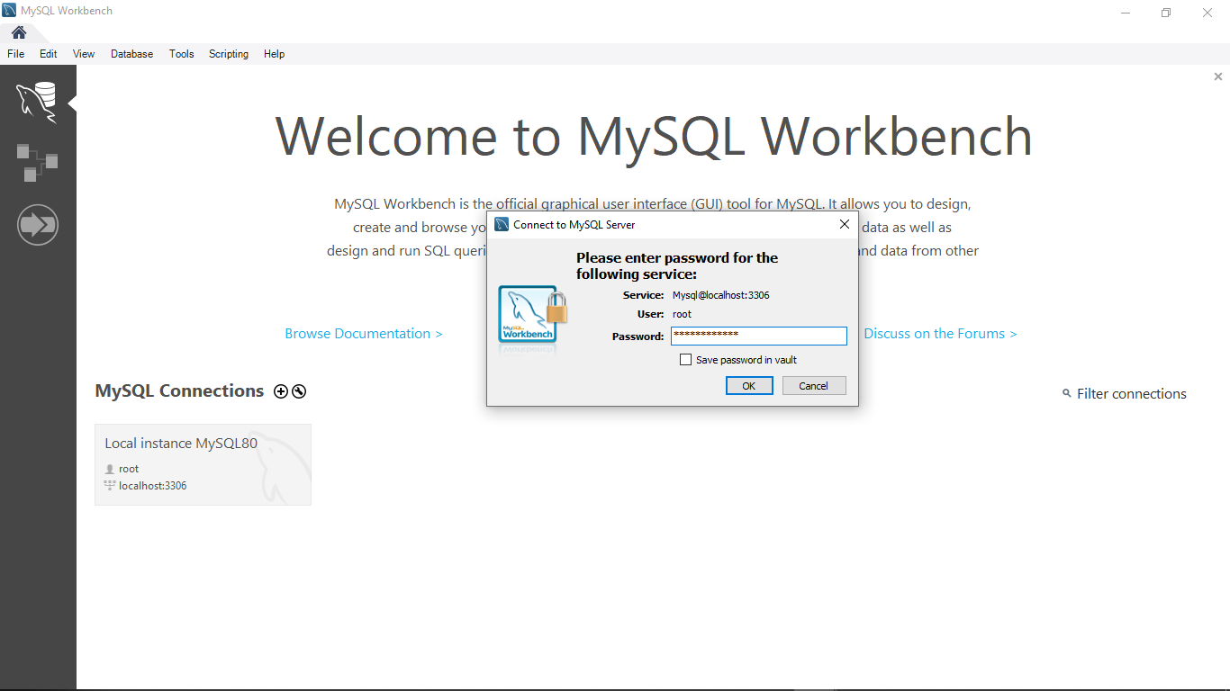

**We will create a database and named it as employee-db,and create 5 tables inside the database**

department

compliance

employees

login_master

statusreport

**Screenshot of the diagram showing tables created and their relations with one another.**

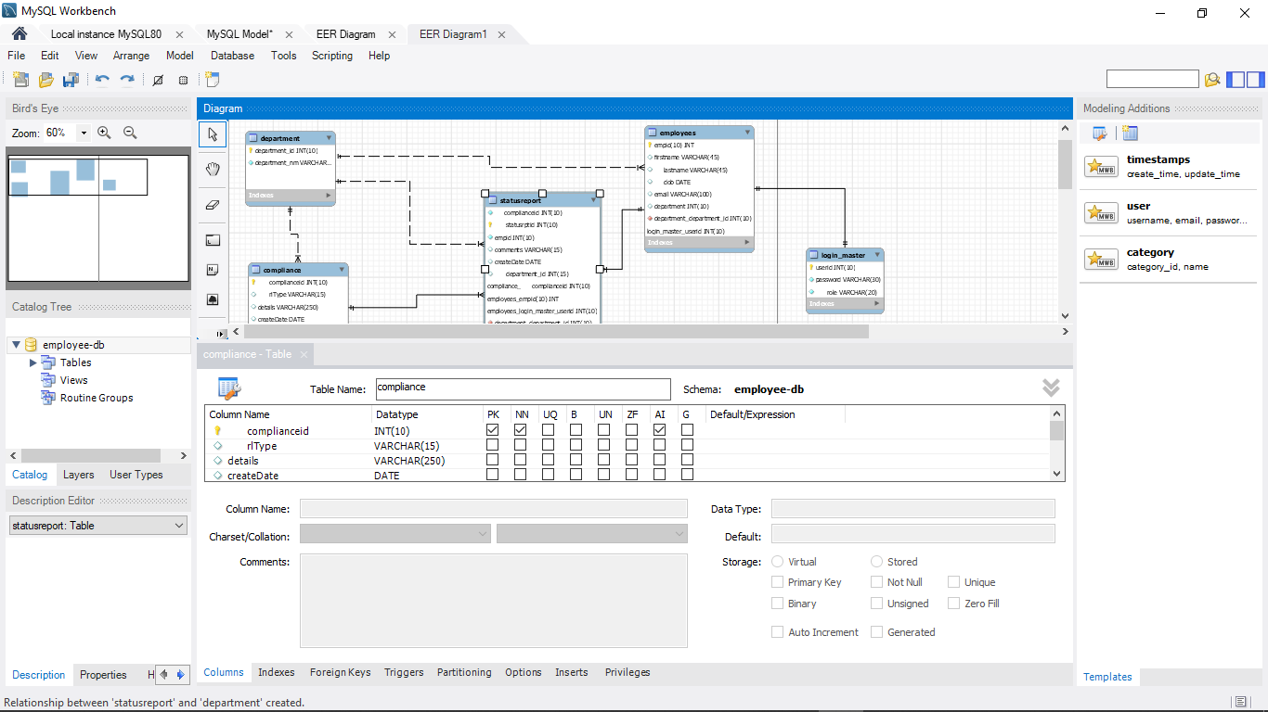

**Here is the structure of the employee-db above with the schema**

* **There is a one-to-many relationship between** department **and** employees

**A** department **can have many** employees.

* **There is a one-to-many relationship between** department **and** compliance

**A** department **can have many regulations.**

* **There is a one-to-many relationship between the** department **and** statusreport**,a department can receive many comments**

**from employees.**

* **There is only a one-one relationship between the** employees **and** login_master

**An employee can be assigned only one role,one userid and password.**

* **There is a one-to-many relationship between the** employees **and** statusreport

**An employee can send as many comments to the department.**

**After that we need to export an sql scipt to create a schema by clicking File,selecting Export and selecting Forward Engineer SQL CREATE Script…….Ctrl+Shift+G**

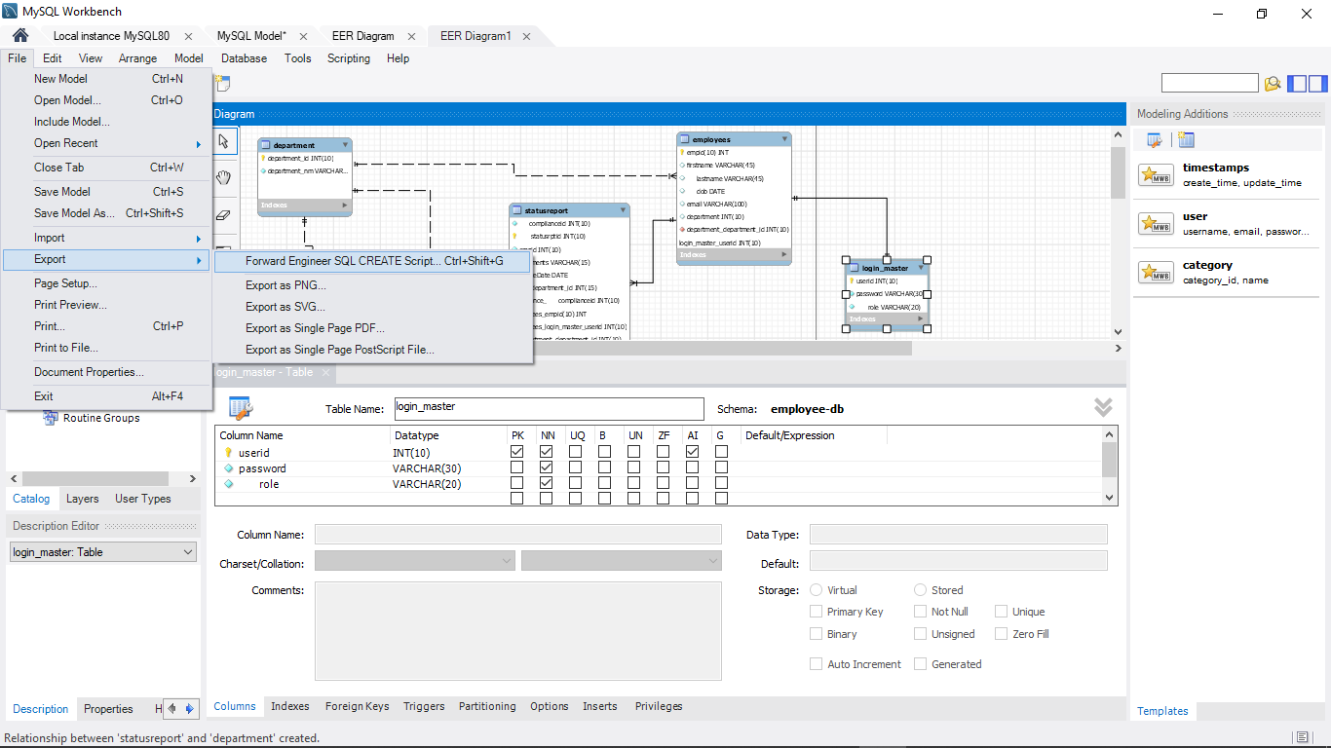

**We can modify the SQL Script that we’ve created,and here’s the modified and amended employee-db SQL script below.**

-- MySQL Script generated by MySQL Workbench

-- Wed Apr 15 00:04:05 2020

-- Model: New Model Version: 1.0

-- MySQL Workbench Forward Engineering

SET @OLD_UNIQUE_CHECKS=@@UNIQUE_CHECKS, UNIQUE_CHECKS=0;

SET @OLD_FOREIGN_KEY_CHECKS=@@FOREIGN_KEY_CHECKS, FOREIGN_KEY_CHECKS=0;

SET @OLD_SQL_MODE=@@SQL_MODE, SQL_MODE='ONLY_FULL_GROUP_BY,STRICT_TRANS_TABLES,NO_ZERO_IN_DATE,NO_ZERO_DATE,ERROR_FOR_DIVISION_BY_ZERO,NO_ENGINE_SUBSTITUTION';

-- -----------------------------------------------------

-- Schema employee-db

-- -----------------------------------------------------

DROP SCHEMA IF EXISTS `employee-db` ;

-- -----------------------------------------------------

-- Schema employee-db

-- -----------------------------------------------------

CREATE SCHEMA IF NOT EXISTS `employee-db` DEFAULT CHARACTER SET utf8 ;

USE `employee-db` ;

-- -----------------------------------------------------

-- Table `employee-db`.`Department`

-- -----------------------------------------------------

DROP TABLE IF EXISTS `employee-db`.`Department` ;

CREATE TABLE IF NOT EXISTS `employee-db`.`Department` (

`department_id` INT(10) NOT NULL AUTO_INCREMENT ,

`department_nm` VARCHAR(45) NOT NULL,

PRIMARY KEY (`department_id`))

ENGINE = InnoDB;

-- -----------------------------------------------------

-- Table `employee-db`.`Compliance`

-- -----------------------------------------------------

DROP TABLE IF EXISTS `employee-db`.`Compliance` ;

CREATE TABLE IF NOT EXISTS `employee-db`.`Compliance` (

`complianceid` INT(10) NOT NULL AUTO_INCREMENT,

`rlType` VARCHAR(15) DEFAULT (NULL),

`details` VARCHAR(250) DEFAULT(NULL),

`createDate` DATE DEFAULT(NULL),

`department_id` INT(10) DEFAULT (NULL),

`Department_department_id` INT(10) DEFAULT (NULL),

PRIMARY KEY (`complianceid`),

INDEX `fk_Compliance_Department_idx` (`Department_department_id` ASC) VISIBLE,

CONSTRAINT `fk_Compliance_Department`

FOREIGN KEY (`Department_department_id`)

REFERENCES `employee-db`.`Department` (`department_id`)

ON DELETE NO ACTION

ON UPDATE NO ACTION)

ENGINE = InnoDB;

-- -----------------------------------------------------

-- Table `employee-db`.`Login_master`

-- -----------------------------------------------------

CREATE TABLE IF NOT EXISTS `employee-db`.`Login_master` (

userid INT(10) NOT NULL PRIMARY KEY AUTO_INCREMENT,

password VARCHAR(30) NOT NULL,

role VARCHAR(20) DEFAULT (NULL),

empid INT(10) DEFAULT (NULL),

CONSTRAINT FK_EMPID

FOREIGN KEY (empid)

REFERENCES employees(empid))

ENGINE = InnoDB;

-- -----------------------------------------------------

-- Table `employee-db`.`Employees`

-- -----------------------------------------------------

CREATE TABLE IF NOT EXISTS `employee-db`.`Employees` (

empid INT(10) NOT NULL PRIMARY KEY AUTO_INCREMENT,

firstname VARCHAR(45) DEFAULT (NULL),

lastname VARCHAR(45) DEFAULT (NULL),

dob DATE DEFAULT (NULL),

email VARCHAR(100) DEFAULT (NULL),

department_id INT(10) DEFAULT (NULL),

CONSTRAINT FK_DEPARTMENT_ID

FOREIGN KEY (department_id)

REFERENCES department (department_id)

)

ENGINE = InnoDB;

-- -----------------------------------------------------

-- Table `employee-db`.`Statusreport`

-- -----------------------------------------------------

CREATE TABLE IF NOT EXISTS `employee-db`.`Statusreport` (

complianceid INT(10) NOT NULL ,

statusrptid INT(10) NOT NULL PRIMARY KEY AUTO_INCREMENT,

empid INT(10) NOT NULL,

comments VARCHAR(45) DEFAULT (NULL),

createDate DATE DEFAULT (NULL),

department_id INT(10) DEFAULT (NULL),

CONSTRAINT statusreport_ibfk_1

FOREIGN KEY (department_id)

REFERENCES department (department_id),

CONSTRAINT statusreport_ibfk_2

FOREIGN KEY (empid)

REFERENCES employees (empid),

CONSTRAINT statusreport_ibfk_3

FOREIGN KEY (complianceid)

REFERENCES compliance (complianceid)

)

ENGINE = InnoDB;

**If we open mysl we can see that the schema is now created with the tables.**

**We must ensure that the application is always open**

**Screenshot showing a schema**

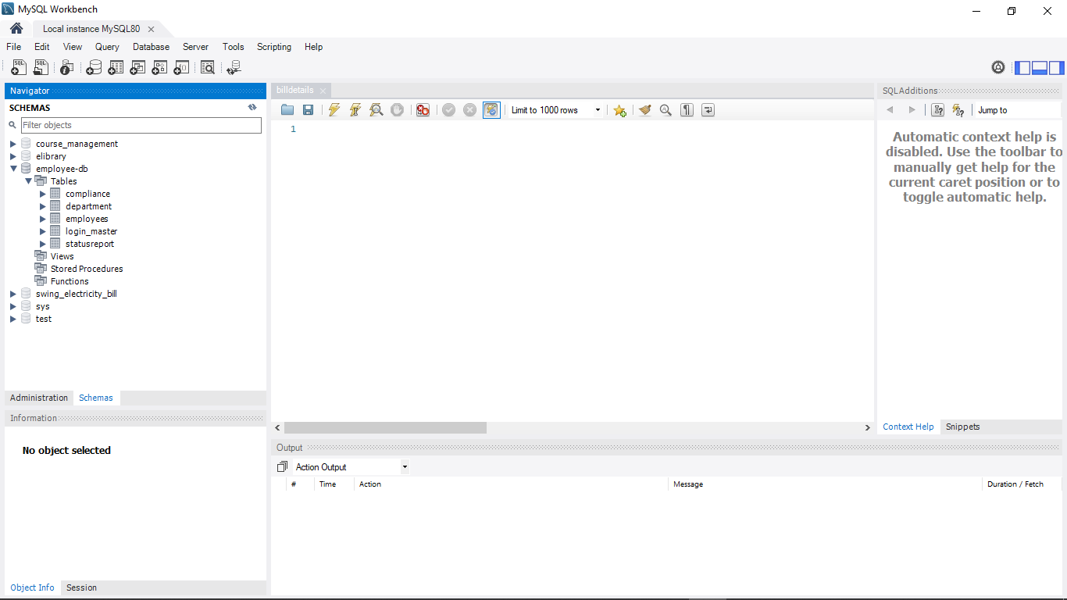

**Now everything is sorted on the database side.We’ve created the schema and tables.Now we come to the coding side,Eclipse.**

**I will create a new Java project and named it as employee-system.**

**After that I will create a package called com.java.employeesystem.This is where I will insert my code like classes,DAO,DB etc.**

**I will first create the classes Compliance.java,Department.java,Employees.java,Login_master.java and Statusreport.java**

**Before we start we need to include some packages here by right clicking the employee-system application,selecting build path and Configure Build Path and include the**

**Following libraries protobuf-java-3.6.1.jar**

**jgoodies-validation-2.4.2-sources.jar**

**binding-1.0.jar**

**forms-1.0.5.jar**

**validation-1.0.jar**

**mysql-connector-java-8.0.19.jar**

**jgoodies-common-1.8.0-sources.jar**

**jgoodies-common-1.8.0.jar**

**jgoodies-forms-1.8.0-sources.jar**

**jgoodies-forms-1.8.0.jar**

**The Classes**

**package** com.java.employeesystem;

**import** java.sql.Date;

**public** **class** Compliance {

**private** **int** compliance_id,department_id;

**private** String rlType ,details;

**private** Date createDate;

**public** Compliance() {}

**public** Compliance(**int** compliance_id,**int** department_id, String rlType,String details, Date createDate)

{

**super**();

**this**.compliance_id=compliance_id;

**this**.department_id = department_id;

**this**. rlType = rlType;

**this**.details = details;

**this**.createDate = createDate;

}

**public** **int** getCompliance_id()

{

**return** compliance_id;

}

**public** **void** setCompliance_id(**int** compliance_id)

{

**this**.compliance_id=compliance_id;

}

**public** **int** getDepartment_id() {

**return** department_id;

}

**public** **void** setDepartment_id(**int** department_id) {

**this**.department_id = department_id;

}

**public** String getRlType() {

**return** rlType;

}

**public** **void** setDetails(String details) {

**this**.details = details;

}

**public** String getDetails() {

**return** details;

}

**public** **void** setRlType(String rlType) {

**this**.rlType = rlType;

}

**public** Date getCreateDate() {

**return** createDate;

}

**public** **void** setCreateDate(Date createDate) {

**this**.createDate = createDate;

}

}

**package** com.java.employeesystem;

**public** **class** Department {

**private** **int** department_id ;

**private** String department_nm ;

**public** Department() {}

**public** Department(**int** department_id, String department_nm ) {

**super**();

**this**.department_id = department_id;

**this**.department_nm = department_nm;

}

**public** **int** getDepartment_id() {

**return** department_id;

}

**public** **void** setDepartment_id(**int** department_id ) {

**this**.department_id = department_id;

}

**public** String getDepartment_nm() {

**return** department_nm;

}

**public** **void** setDepartment_nm(String department_nm) {

**this**.department_nm=department_nm;

}

}

**package** com.java.employeesystem;

**import** java.sql.Date;

**public** **class** Employees {

**private** **int** empid,department_id;

**private** String firstname,lastname ,email;

**private** Date dob;

**public** Employees() {}

**public** Employees(**int** empid , String firstname,String lastname, String email,Date dob,**int** department_id)

{

**super**();

**this**.empid = empid;

**this**.firstname = firstname;

**this**.lastname = lastname;

**this**.email = email;

**this**.dob = dob;

**this**.department_id=department_id;

}

**public** **int** getEmpid() {

**return** empid;

}

**public** **void** setEmpid(**int** empid) {

**this**.empid = empid;

}

**public** String getFirstname() {

**return** firstname;

}

**public** **void** setFirstname(String firstname ) {

**this**.firstname = firstname;

}

**public** String getLasttname() {

**return** lastname;

}

**public** **void** setLasttname(String lastname ) {

**this**.lastname = lastname;

}

**public** String getEmail() {

**return** email;

}

**public** **void** setEmail(String email ) {

**this**.email = email;

}

**public** Date getDob() {

**return** dob;

}

**public** **void** setDob(Date dob ) {

**this**.dob = dob;

}

**public** **int** getDepartment_id() {

**return** department_id;

}

**public** **void** setDepartment_id(**int** department_id) {

**this**.department_id=department_id;

}

}

**package** com.java.employeesystem;

**public** **class** Login_master {

**private** **int** userid ;

**private** String password ;

**private** String role;

**public** Login_master() {}

**public** Login_master(**int** userid, String password,String role ) {

**super**();

**this**.userid =userid ;

**this**.password = password;

**this**.role = role;

}

**public** **int** getUserid() {

**return** userid;

}

**public** **void** setDepartment_id(**int** userid ) {

**this**.userid = userid;

}

**public** String getPassword() {

**return** password;

}

**public** **void** setPassword(String password) {

**this**.password=password;

}

**public** String getRole() {

**return** role;

}

**public** **void** setRole(String role) {

**this**.role=role;

}

}

**package** com.java.employeesystem;

**import** java.sql.Date;

**public** **class** Statusreport {

**private** **int** complianceid,statusrptid,empid,department_id ;

**private** String comments;

**private** Date createDate;

**public** Statusreport() {}

**public** Statusreport(**int** complianceid , **int** statusrptid,**int** empid,**int** department_id,String comments,Date createDate) {

**super**();

**this**.complianceid = complianceid;

**this**.statusrptid = statusrptid;

**this**.empid = empid;

**this**.department_id = department_id;

**this**.comments =comments ;

**this**.createDate = createDate;

}

**public** **int** getComplianceid() {

**return** complianceid;

}

**public** **void** setComplianceid(**int** complianceid ) {

**this**.complianceid = complianceid;

}

**public** **int** getStatusrptid() {

**return** statusrptid;

}

**public** **void** setStatusrptid(**int** statusrptid ) {

**this**.statusrptid = statusrptid;

}

**public** **int** getEmpid() {

**return** empid;

}

**public** **void** setEmpid(**int** empid ) {

**this**.empid = empid;

}

**public** **int** getDepartment_id() {

**return** department_id;

}

**public** **void** setDepartment_id(**int** department_id ) {

**this**.department_id = department_id;

}

**public** String getComments() {

**return** comments;

}

**public** **void** setComments(String comments) {

**this**.comments=comments;

}

**public** Date getCreateDate() {

**return** createDate;

}

**public** **void** setCreateDate(Date createDate) {

**this**.createDate=createDate;

}

}

**Now that we’ve included the mysql-connector-java-8.0.19.jar library,we will create the Data Access Objects which will have**

**functions to interact with the database.We will create the ComplianceDao.java,DepartmentDao.java,EmployeeDao.java and StatusReportDao.java**

**ComplianceDao.java class**

**package** com.java.employeesystem;

**import** java.sql.Connection;

**import** java.sql.Date;

**import** java.sql.DriverManager;

**import** java.sql.PreparedStatement;

**import** java.sql.ResultSet;

**import** java.util.ArrayList;

**import** java.util.List;

**public** **class** ComplianceDao {

**public** **static** Connection getCon(){

Connection con=**null**;

**try**{

Class.*forName*("com.mysql.jdbc.Driver");

con=DriverManager.*getConnection*("jdbc:mysql://localhost:3306/employee-db","root","Nkululeko_93");// remember here we’ve used our credentials to login to //mysql

}**catch**(Exception e){System.***out***.println(e);}

**return** con;

}

**public** **static** **int** save( **int** department_id,String rltype,String details,Date createdate){

**int** status=0;

**try**{

Connection con=*getCon*();

PreparedStatement ps=con.prepareStatement("insert into compliance(department_id,rlType,details,createDate) values(?,?,?,?)");

ps.setInt(1,department_id);

ps.setString(2,rltype);

ps.setString(3,details);

ps.setDate(4,createdate);

status=ps.executeUpdate();

con.close();

}**catch**(Exception e){System.***out***.println(e);}

**return** status;

}

**public** **static** **int** update(Compliance c){

**int** status=0;

**try**{

Connection con=ComplianceDao.*getCon*();

PreparedStatement ps=con.prepareStatement("update compliance set rlType=?,details=?,createDate=?,department_id=? where complianceid=?");

ps.setString(1,c.getRlType());

ps.setString(2, c.getDetails());

ps.setDate(3,**new** java.sql.Date(c.getCreateDate().getTime()));

ps.setInt(4, c.getDepartment_id());

ps.setInt(5,c.getCompliance_id());

status=ps.executeUpdate();

status=ps.executeUpdate();

con.close();

}**catch**(Exception e){System.***out***.println(e);}

**return** status;

}

**public** **static** List<Compliance> view(){

List<Compliance> list=**new** ArrayList<Compliance>();

**try**{

Connection con=ComplianceDao.*getCon*();

PreparedStatement ps=con.prepareStatement("select * from compliance");

ResultSet rs=ps.executeQuery();

**while**(rs.next()){

Compliance c=**new** Compliance();

c.setCompliance_id(rs.getInt("complianceid"));

c.setRlType(rs.getString("rlType"));

c.setDetails(rs.getString("details"));

c.setCreateDate(rs.getDate("createDate"));

c.setDepartment_id(rs.getInt("department_id"));

list.add(c);

}

con.close();

}**catch**(Exception e){System.***out***.println(e);}

**return** list;

}

**public** **static** Compliance getComplianceByid(**int** complianceid){

Compliance c=**new** Compliance();

**try**{

Connection con=ComplianceDao.*getCon*();

PreparedStatement ps=con.prepareStatement("select * from compliance where complianceid=?");

ps.setInt(1,complianceid);

ResultSet rs=ps.executeQuery();

**if**(rs.next()){

c.setCompliance_id(rs.getInt("complianceid"));

c.setRlType(rs.getString("rlType"));

c.setDetails(rs.getString("details"));

c.setCreateDate(rs.getDate("createDate"));

c.setDepartment_id(rs.getInt("department_id"));

}

con.close();

}**catch**(Exception e){System.***out***.println(e);}

**return** c;

}

}

**DepartmentDao class**

**package** com.java.employeesystem;

**import** java.sql.Connection;

**import** java.sql.DriverManager;

**import** java.sql.PreparedStatement;

**import** java.sql.ResultSet;

**import** java.util.ArrayList;

**import** java.util.List;

**public** **class** DepartmentDao {

**public** **static** Connection getCon(){

Connection con=**null**;

**try**{

Class.*forName*("com.mysql.jdbc.Driver");

con=DriverManager.*getConnection*("jdbc:mysql://localhost:3306/employee-db","root","Nkululeko_93");

}**catch**(Exception e){System.***out***.println(e);}

**return** con;

}

**public** **static** **int** save(String departmentname)

{

**int** status=0;

**try**{

Connection con=DepartmentDao.*getCon*();

PreparedStatement ps=con.prepareStatement("insert into department(department_nm) values(?)");

ps.setString(1,departmentname);

status=ps.executeUpdate();

con.close();

}**catch**(Exception e){System.***out***.println(e);}

**return** status;

}

**public** **static** **int** update(Department d){

**int** status=0;

**try**{

Connection con=DepartmentDao.*getCon*();

PreparedStatement ps=con.prepareStatement("update department set department_nm=? where department_id=?");

ps.setString(1,d.getDepartment_nm());

ps.setInt(2,d.getDepartment_id());

status=ps.executeUpdate();

status=ps.executeUpdate();

con.close();

}**catch**(Exception e){System.***out***.println(e);}

**return** status;

}

**public** **static** List<Department> view(){

List<Department> list=**new** ArrayList<Department>();

**try**{

Connection con=DepartmentDao.*getCon*();

PreparedStatement ps=con.prepareStatement("select * from department");

ResultSet rs=ps.executeQuery();

**while**(rs.next()){

Department d=**new** Department();

d.setDepartment_id(rs.getInt("department_id"));

d.setDepartment_nm(rs.getString("department_nm"));

list.add(d);

}

con.close();

}**catch**(Exception e){System.***out***.println(e);}

**return** list;

}

**public** **static** Department getDepartmentByid(**int** department_id){

Department d=**new** Department();

**try**{

Connection con=DepartmentDao.*getCon*();

PreparedStatement ps=con.prepareStatement("select * from department where department_id=?");

ps.setInt(1,department_id);

ResultSet rs=ps.executeQuery();

**if**(rs.next()){

d.setDepartment_id(rs.getInt("department_id"));

d.setDepartment_nm(rs.getString("department_nm"));

}

con.close();

}**catch**(Exception e){System.***out***.println(e);}

**return** d;

}

**EmployeeDao class**

**package** com.java.employeesystem;

**import** java.sql.Connection;

**import** java.sql.Date;

**import** java.sql.DriverManager;

**import** java.sql.PreparedStatement;

**import** java.sql.ResultSet;

**import** java.util.ArrayList;

**import** java.util.List;

**public** **class** EmployeeDao {

**public** **static** Connection getCon(){

Connection con=**null**;

**try**{

Class.*forName*("com.mysql.jdbc.Driver");

con=DriverManager.*getConnection*("jdbc:mysql://localhost:3306/employee-db","root","Nkululeko_93");

}**catch**(Exception e){System.***out***.println(e);}

**return** con;

}

**public** **static** **int** save(**int** departmentid,String firstname,String lastname,String email,Date dob){

**int** status=0;

**try**{

Connection con=EmployeeDao.*getCon*();

PreparedStatement ps=con.prepareStatement("insert into employees(department_id,firstname,lastname,email,dob) values(?,?,?,?,?)");

ps.setInt(1,departmentid);

ps.setString(2,firstname);

ps.setString(3, lastname);

ps.setString(4,email);

ps.setDate(5,dob);

status=ps.executeUpdate();

con.close();

}**catch**(Exception e){System.***out***.println(e);}

**return** status;

}

**public** **static** **int** delete(**int** empid){

**int** status=0;

**try**{

Connection con=EmployeeDao.*getCon*();

PreparedStatement ps=con.prepareStatement("delete from employees where empid=?");

ps.setInt(1,empid);

status=ps.executeUpdate();

con.close();

}**catch**(Exception e){System.***out***.println(e);}

**return** status;

}

**public** **static** **int** update(Employees em){

**int** status=0;

**try**{

Connection con=EmployeeDao.*getCon*();

PreparedStatement ps=con.prepareStatement("update employees set firstname=?,lastname=?,dob=?,email=?,department_id=? where empid=?");

ps.setString(1,em.getFirstname());

ps.setString(2, em.getLasttname());

ps.setDate(3, **new** java.sql.Date(em.getDob().getTime()));

ps.setString(4, em.getEmail());

ps.setInt(5, em.getDepartment_id());

ps.setInt(6,em.getEmpid());

status=ps.executeUpdate();

status=ps.executeUpdate();

con.close();

}**catch**(Exception e){System.***out***.println(e);}

**return** status;

}

**public** **static** List<Employees> view(){

List<Employees> list=**new** ArrayList<Employees>();

**try**{

Connection con=EmployeeDao.*getCon*();

PreparedStatement ps=con.prepareStatement("select * from employees");

ResultSet rs=ps.executeQuery();

**while**(rs.next()){

Employees em=**new** Employees();

em.setEmpid(rs.getInt("empid"));

em.setFirstname(rs.getString("firstname"));

em.setLasttname(rs.getString("lastname"));

em.setDob(rs.getDate("dob"));

em.setEmail(rs.getString("email"));

em.setDepartment_id(rs.getInt("department_id"));

list.add(em);

}

con.close();

}**catch**(Exception e){System.***out***.println(e);}

**return** list;

}

**public** **static** Employees getEmployeeByid(**int** empid){

Employees em=**new** Employees();

**try**{

Connection con=EmployeeDao.*getCon*();

PreparedStatement ps=con.prepareStatement("select * from employees where empid=?");

ps.setInt(1,empid);

ResultSet rs=ps.executeQuery();

**if**(rs.next()){

em.setEmpid(rs.getInt("empid"));

em.setFirstname(rs.getString("firstname"));

em.setLasttname(rs.getString("lastname"));

em.setDob(rs.getDate("dob"));

em.setEmail(rs.getString("email"));

em.setDepartment_id(rs.getInt("department_id"));

}

con.close();

}**catch**(Exception e){System.***out***.println(e);}

**return** em;

}

}

**StatusReportDao class**

**package** com.java.employeesystem;

**import** java.sql.Connection;

**import** java.sql.DriverManager;

**import** java.sql.PreparedStatement;

**import** java.sql.ResultSet;

**import** java.util.ArrayList;

**import** java.sql.Date;

**import** java.util.List;

**public** **class** StatusReportDao {

**public** **static** Connection getCon(){

Connection con=**null**;

**try**{

Class.*forName*("com.mysql.jdbc.Driver");

con=DriverManager.*getConnection*("jdbc:mysql://localhost:3306/employee-db","root","Nkululeko_93");

}**catch**(Exception e){System.***out***.println(e);}

**return** con;

}

**public** **static** **int** save(**int** complianceid,**int** empid,String comments,Date createdate,**int** departmentid){

**int** status=0;

**try**{

Connection con=*getCon*();

PreparedStatement ps=con.prepareStatement("insert into statusreport(complianceid,empid,comments,createDate,department_id) values(?,?,?,?,?)");

ps.setInt(1,complianceid);

ps.setInt(2, empid);

ps.setString(3,comments);

ps.setDate(4, createdate);

ps.setInt(5,departmentid);

status=ps.executeUpdate();

con.close();

}**catch**(Exception e){System.***out***.println(e);}

**return** status;

}

**public** **static** **int** update(Statusreport s){

**int** status=0;

**try**{

Connection con=StatusReportDao.*getCon*();

PreparedStatement ps=con.prepareStatement("update statusreport set complianceid=?,empid=?,comments=?,createDate=?,department_id=? where statusrptid=?");

ps.setInt(1,s.getComplianceid());

ps.setInt(2, s.getEmpid());

ps.setString(3,s.getComments());

ps.setDate(4, **new** java.sql.Date(s.getCreateDate().getTime()));

ps.setInt(5,s.getDepartment_id());

ps.setInt(6,s.getStatusrptid());

status=ps.executeUpdate();

status=ps.executeUpdate();

con.close();

}**catch**(Exception e){System.***out***.println(e);}

**return** status;

}

**public** **static** List<Statusreport> view(){

List<Statusreport> list=**new** ArrayList<Statusreport>();

**try**{

Connection con=StatusReportDao.*getCon*();

PreparedStatement ps=con.prepareStatement("select * from statusreport");

ResultSet rs=ps.executeQuery();

**while**(rs.next()){

Statusreport s=**new** Statusreport();

s.setComplianceid(rs.getInt("complianceid"));

s.setStatusrptid(rs.getInt("statusrptid"));

s.setEmpid(rs.getInt("empid"));

s.setComments(rs.getString("comments"));

s.setCreateDate(rs.getDate("createDate"));

s.setDepartment_id(rs.getInt("department_id"));

list.add(s);

}

con.close();

}**catch**(Exception e){System.***out***.println(e);}

**return** list;

}

**public** **static** Statusreport getStatusreportByid(**int** statusrptid){

Statusreport s=**new** Statusreport();

**try**{

Connection con=StatusReportDao.*getCon*();

PreparedStatement ps=con.prepareStatement("select * from statusreport where statusrptid=?");

ps.setInt(1,statusrptid);

ResultSet rs=ps.executeQuery();

**if**(rs.next()){

s.setComplianceid(rs.getInt("complianceid"));

s.setStatusrptid(rs.getInt("statusrptid"));

s.setEmpid(rs.getInt("empid"));

s.setComments(rs.getString("comments"));

s.setCreateDate(rs.getDate("createDate"));

s.setDepartment_id(rs.getInt("department_id"));

}

con.close();

}**catch**(Exception e){System.***out***.println(e);}

**return** s;

}

}

**Now that we’ve completed our Data Access Objects(DAO) and included the functions in these Data Access Objects ,we can now accomplish**

**our functionalities like Add new Regulations,Add new Employees,Add new Departments,Edit Regulations etc.**

**We will start with the functionality to add a new department.So we create a new class called AddNewDepartment.java**

**AddNewDepartment.java class**

**package** com.java.employeesystem;

**import** java.awt.Color;

**import** java.awt.EventQueue;

**import** java.awt.Font;

**import** java.awt.event.ActionEvent;

**import** java.awt.event.ActionListener;

**import** javax.swing.GroupLayout;

**import** javax.swing.GroupLayout.Alignment;

**import** javax.swing.JButton;

**import** javax.swing.JFrame;

**import** javax.swing.JLabel;

**import** javax.swing.JOptionPane;

**import** javax.swing.JPanel;

**import** javax.swing.JTextField;

**import** javax.swing.border.EmptyBorder;

**public** **class** AddNewDepartment **extends** JFrame {

/**

*

*/

**private** **static** **final** **long** ***serialVersionUID*** = 1L;

**static** AddNewDepartment *frame*;

**private** JPanel contentPane;

**private** JTextField textField;

/**

* Launch the application.

*/

**public** **static** **void** main(String[] args) {

EventQueue.*invokeLater*(**new** Runnable() {

**public** **void** run() {

**try** {

*frame* = **new** AddNewDepartment();

*frame*.setVisible(**true**);

} **catch** (Exception e) {

e.printStackTrace();

}

}

});

}

/**

* Create the frame.

*/

**public** AddNewDepartment() {

setDefaultCloseOperation(JFrame.***EXIT_ON_CLOSE***);

setBounds(100, 100, 450, 300);

contentPane = **new** JPanel();

contentPane.setBorder(**new** EmptyBorder(5, 5, 5, 5));

setContentPane(contentPane);

JLabel lblAddDepartment = **new** JLabel("Add Department");

lblAddDepartment.setForeground(Color.***DARK_GRAY***);

lblAddDepartment.setFont(**new** Font("Tahoma", Font.***PLAIN***, 20));

JLabel lbldepartment_nm = **new** JLabel("DepartmentName");

textField = **new** JTextField();

textField.setColumns(10);

JButton btnAddDepartment = **new** JButton("Add Department");

btnAddDepartment.addActionListener(**new** ActionListener() {

**public** **void** actionPerformed(ActionEvent e) {

String department_nm=textField.getText();

**boolean** performSave=**true**;

**if**(textField.getText().isEmpty())

{

JOptionPane.*showMessageDialog*(**null**,"Please Enter Department Name");

performSave=**false**;

}

**if**(performSave)

{

**int** status=DepartmentDao.*save*(department_nm);

**if**(status>0){

JOptionPane.*showMessageDialog*(AddNewDepartment.**this**,"Department added successfully!");

textField.setText("");

}**else**{

JOptionPane.*showMessageDialog*(AddNewDepartment.**this**,"Sorry, Unable to add Department!");

}

}

}

});

JButton btnBack = **new** JButton("Back");

btnBack.addActionListener(**new** ActionListener() {

**public** **void** actionPerformed(ActionEvent e) {

AdminSection.*main*(**new** String[]{});

*frame*.dispose();

}

});

GroupLayout gl_contentPane = **new** GroupLayout(contentPane);

gl_contentPane.setHorizontalGroup(

gl_contentPane.createParallelGroup(Alignment.***LEADING***)

.addGroup(gl_contentPane.createSequentialGroup()

.addGroup(gl_contentPane.createParallelGroup(Alignment.***LEADING***)

.addGroup(gl_contentPane.createSequentialGroup()

.addGap(144)

.addComponent(lblAddDepartment))

.addGroup(gl_contentPane.createSequentialGroup()

.addContainerGap()

.addGroup(gl_contentPane.createParallelGroup(Alignment.***LEADING***)

.addComponent(lbldepartment_nm, GroupLayout.***PREFERRED_SIZE***, 133, GroupLayout.***PREFERRED_SIZE***))

.addGap(33)

.addGroup(gl_contentPane.createParallelGroup(Alignment.***LEADING***, **false**)

.addComponent(textField, GroupLayout.***DEFAULT_SIZE***, 193, Short.***MAX_VALUE***))))

.addContainerGap(124, Short.***MAX_VALUE***))

.addGroup(gl_contentPane.createSequentialGroup()

.addGap(128)

.addComponent(btnAddDepartment, GroupLayout.***PREFERRED_SIZE***, 145, GroupLayout.***PREFERRED_SIZE***)

.addGap(18)

.addComponent(btnBack)

.addContainerGap(44, Short.***MAX_VALUE***))

.addGroup(gl_contentPane.createSequentialGroup()

.addContainerGap()

.addComponent(lbldepartment_nm, GroupLayout.***PREFERRED_SIZE***, 50, GroupLayout.***PREFERRED_SIZE***)

.addContainerGap(364, Short.***MAX_VALUE***))

);

gl_contentPane.setVerticalGroup(

gl_contentPane.createParallelGroup(Alignment.***LEADING***)

.addGroup(gl_contentPane.createSequentialGroup()

.addComponent(lblAddDepartment)

.addGap(18)

.addGroup(gl_contentPane.createParallelGroup(Alignment.***BASELINE***)

.addComponent(lbldepartment_nm)

.addComponent(textField, GroupLayout.***PREFERRED_SIZE***, GroupLayout.***DEFAULT_SIZE***, GroupLayout.***PREFERRED_SIZE***))

.addGap(7)

.addGroup(gl_contentPane.createParallelGroup(Alignment.***LEADING***)

.addComponent(btnAddDepartment, GroupLayout.***PREFERRED_SIZE***, 38, GroupLayout.***PREFERRED_SIZE***)

.addComponent(btnBack))

.addContainerGap())

);

contentPane.setLayout(gl_contentPane);

}

}

**After we run the code this is how the user interface looks like.Notice we have used the save method of the DepartmentDao class.**

**Int status=DepartmentDao.save(department_name);**

**Screen shot**

**Screenshot of the AddNewDepartment user-interface**

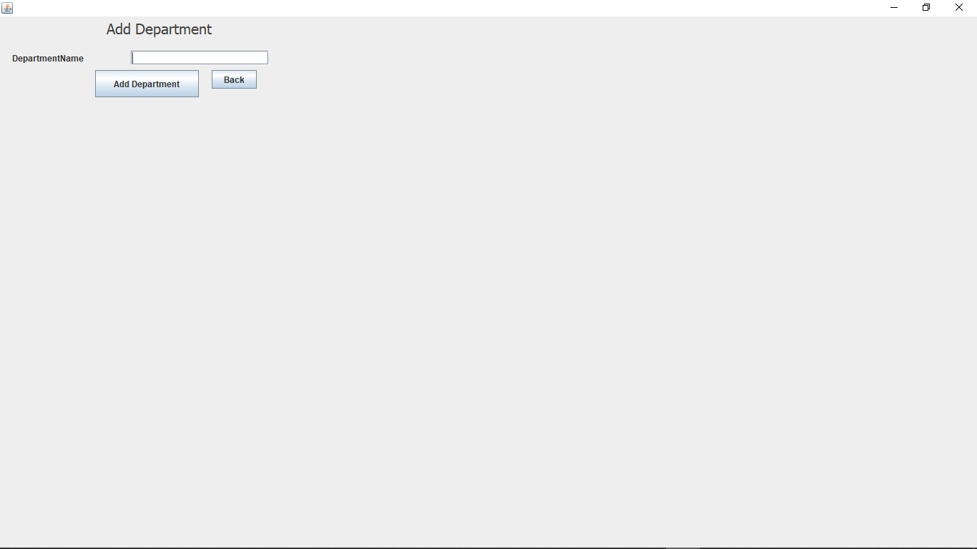

**We can test whether the application will be able to validate if the textfield is empty.If we entered nothing**

**It will display a message with the help of JOptionPane “Please Enter Department Name”.**

**Screen shot -Validate Department Name**

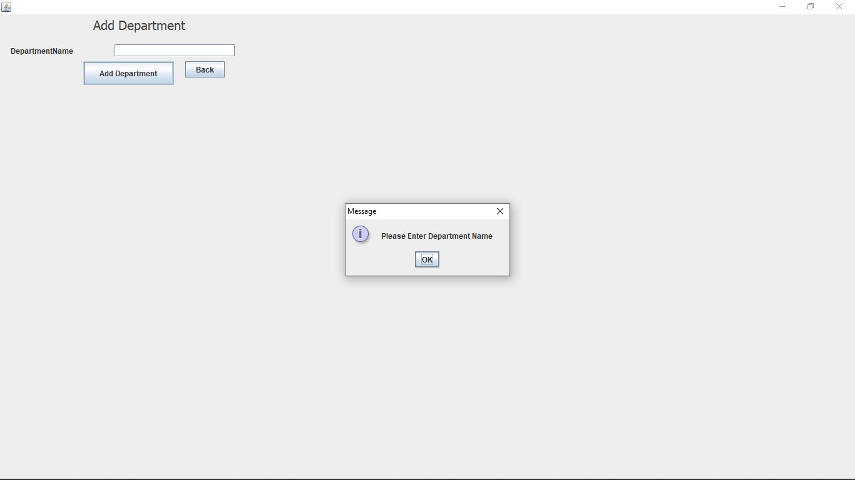

**But if we’ve entered all the required information, it will display a message to confirm that Department has been added.**

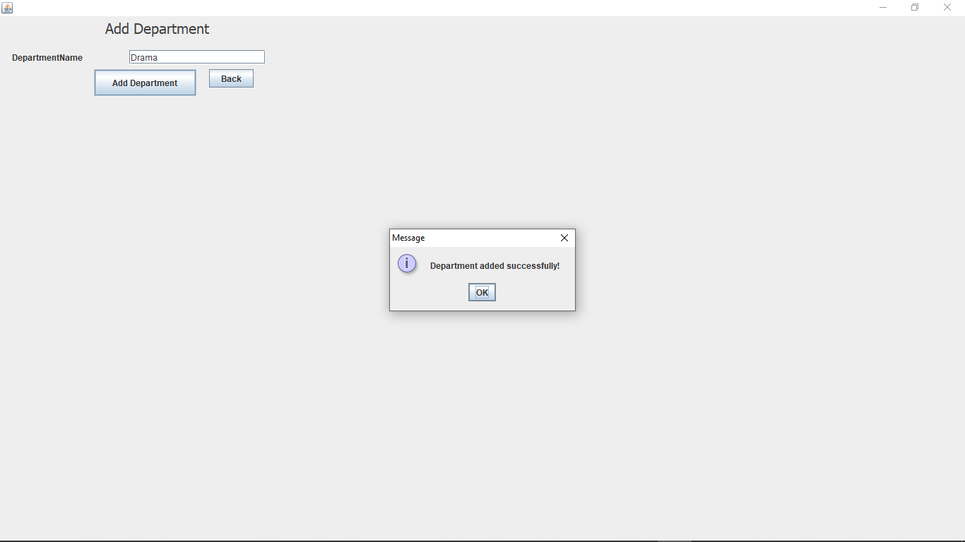

**ViewDepartments**

**The other functionality is to view departments added.So we create a class ViewDepartments**

**ViewDepartments.java class**

**package** com.java.employeesystem;

**import** java.awt.BorderLayout;

**import** java.awt.EventQueue;

**import** java.util.List;

**import** javax.swing.JFrame;

**import** javax.swing.JPanel;

**import** javax.swing.JScrollPane;

**import** javax.swing.JTable;

**import** javax.swing.border.EmptyBorder;

**public** **class** ViewDepartments **extends** JFrame {

**static** ViewDepartments *frame*;

**public** ViewDepartments() {

//Code to view data in JTable

List<Department> list=DepartmentDao.*view*();

**int** size=list.size();

String data[][]=**new** String[size][2];

**int** row=0;

**for**(Department d:list){

data[row][0]=String.*valueOf*(d.getDepartment_id());

data[row][1]=d.getDepartment_nm();

row++;

}

String columnNames[]={"DepartmentID","DepartmentName"};

JTable jt=**new** JTable(data,columnNames);

JScrollPane sp=**new** JScrollPane(jt);

add(sp);

setDefaultCloseOperation(JFrame.***DISPOSE_ON_CLOSE***);

setBounds(100, 100, 800, 400);

}

**public** **static** **void** main(String[] args) {

EventQueue.*invokeLater*(**new** Runnable() {

**public** **void** run() {

**try** {

*frame* = **new** ViewDepartments();

*frame*.setVisible(**true**);

} **catch** (Exception e) {

e.printStackTrace();

}

}

});

}

}

**Here we can view a list of Departments.Notice that we have used the view function of the DepartmentDao.**

**List<Department> list=DepartmentDao.view()**

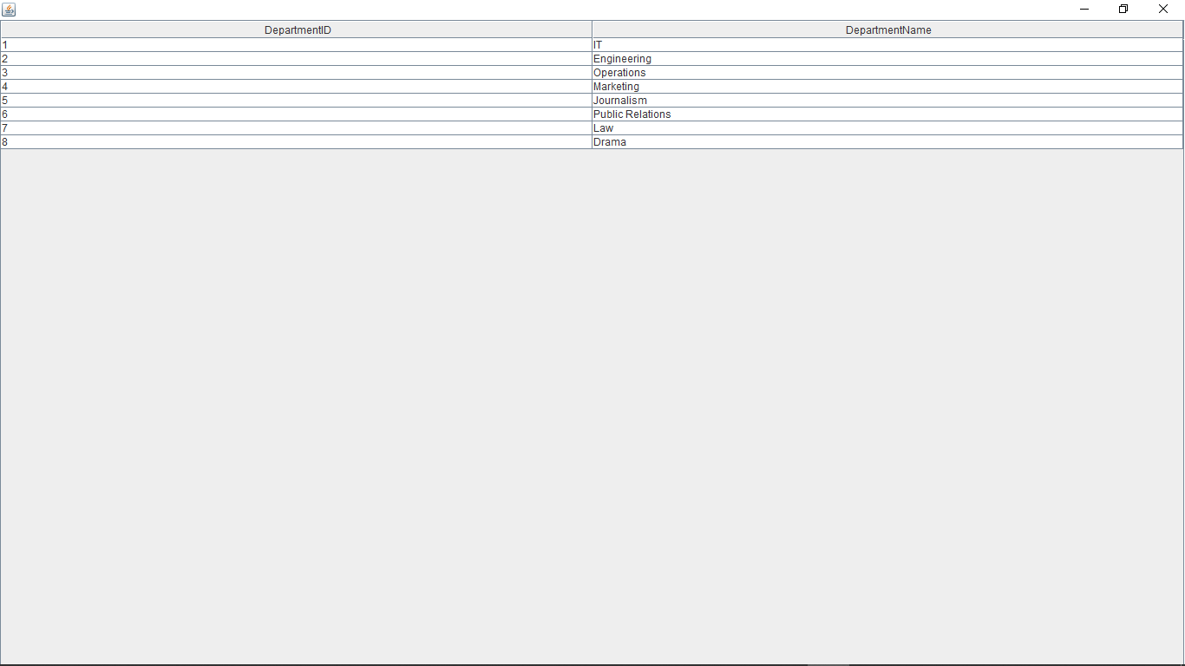

**However, the departments can also be edited. So ,we create a class called EditDepartment.Here’s the code below.**

**EditDepartment.java class**

**package** com.java.employeesystem;

**import** java.awt.BorderLayout;

**import** java.awt.EventQueue;

**import** javax.swing.JFrame;

**import** javax.swing.JPanel;

**import** javax.swing.border.EmptyBorder;

**import** javax.swing.GroupLayout;

**import** javax.swing.GroupLayout.Alignment;

**import** javax.swing.JLabel;

**import** javax.swing.JOptionPane;

**import** java.awt.Font;

**import** java.awt.Color;

**import** javax.swing.LayoutStyle.ComponentPlacement;

**import** javax.swing.JButton;

**import** javax.swing.JTextField;

**import** javax.swing.JTextPane;

**import** java.awt.event.ActionListener;

**import** java.awt.event.ActionEvent;

**import** javax.swing.JTextArea;

**import** javax.swing.JSeparator;

**public** **class** EditDepartment **extends** JFrame {

**static** EditDepartment *frame*;

**private** JPanel contentPane;

**private** JTextField textField;

**private** JTextField textField_1;

/**

* Launch the application.

*/

**public** **static** **void** main(String[] args) {

EventQueue.*invokeLater*(**new** Runnable() {

**public** **void** run() {

**try** {

*frame* = **new** EditDepartment();

*frame*.setVisible(**true**);

} **catch** (Exception e) {

e.printStackTrace();

}

}

});

}

/**

* Create the frame.

*/

**public** EditDepartment() {

setDefaultCloseOperation(JFrame.***EXIT_ON_CLOSE***);

setBounds(100, 100, 450, 550);

contentPane = **new** JPanel();

contentPane.setBorder(**new** EmptyBorder(5, 5, 5, 5));

setContentPane(contentPane);

JLabel lbldepartment_nm = **new** JLabel("DepartmentName:");

JButton btnEditDepartment = **new** JButton("Update Department");

btnEditDepartment.addActionListener(**new** ActionListener() {

**public** **void** actionPerformed(ActionEvent e) {

String department_nm=textField.getText();

**int** department_id=Integer.*parseInt*(textField_1.getText());

Department d=**new** Department(department_id,department_nm);

**int** status=DepartmentDao.*update*(d);

**if**(status>0){

JOptionPane.*showMessageDialog*(EditDepartment.**this**,"Department updated successfully!");

AdminSection.*main*(**new** String[]{});

*frame*.dispose();

}**else**{

JOptionPane.*showMessageDialog*(EditDepartment.**this**,"Sorry, Unable to edit Department!");

}

}

});

textField = **new** JTextField();

textField.setColumns(10);

JButton btnBack = **new** JButton("back");

btnBack.addActionListener(**new** ActionListener() {

**public** **void** actionPerformed(ActionEvent e) {

AdminSection.*main*(**new** String[]{});

*frame*.dispose();

}

});

JLabel lbldepartment_id = **new** JLabel("DepartmentID:");

textField_1 = **new** JTextField();

textField_1.setColumns(10);

JSeparator separator = **new** JSeparator();

JButton btnLoadRecord = **new** JButton("Load Record");

btnLoadRecord.addActionListener(**new** ActionListener() {

**public** **void** actionPerformed(ActionEvent arg0) {

String sdepartment_id=textField_1.getText();

**if**(sdepartment_id==**null**||sdepartment_id.trim().equals("")){

JOptionPane.*showMessageDialog*(EditDepartment.**this**,"Please enter DepartmentID first!");

}**else**{

**int** departmentid=Integer.*parseInt*(sdepartment_id);

Department d=DepartmentDao.*getDepartmentByid*(departmentid);

textField.setText(d.getDepartment_nm());

}

}

});

GroupLayout gl_contentPane = **new** GroupLayout(contentPane);

gl_contentPane.setHorizontalGroup(

gl_contentPane.createParallelGroup(Alignment.***LEADING***)

.addGroup(gl_contentPane.createSequentialGroup()

.addContainerGap()

.addGroup(gl_contentPane.createParallelGroup(Alignment.***LEADING***)

.addComponent(lbldepartment_nm)

.addGroup(gl_contentPane.createParallelGroup(Alignment.***TRAILING***, **false**)

.addComponent(lbldepartment_id, Alignment.***LEADING***, GroupLayout.***DEFAULT_SIZE***, GroupLayout.***DEFAULT_SIZE***, Short.***MAX_VALUE***)))

.addGap(33)

.addGroup(gl_contentPane.createParallelGroup(Alignment.***LEADING***)

.addGroup(gl_contentPane.createParallelGroup(Alignment.***LEADING***, **false**)

.addComponent(textField, GroupLayout.***DEFAULT_SIZE***, 193, Short.***MAX_VALUE***))

.addGroup(gl_contentPane.createSequentialGroup()

.addComponent(textField_1, GroupLayout.***PREFERRED_SIZE***, 193, GroupLayout.***PREFERRED_SIZE***)

.addPreferredGap(ComponentPlacement.***RELATED***, 25, Short.***MAX_VALUE***)

.addComponent(btnLoadRecord)))

.addGap(16)

.addContainerGap())

.addGroup(gl_contentPane.createSequentialGroup()

.addContainerGap()

.addComponent(lbldepartment_nm, GroupLayout.***DEFAULT_SIZE***, 64, Short.***MAX_VALUE***)

.addContainerGap(383, Short.***MAX_VALUE***))

.addGroup(gl_contentPane.createSequentialGroup()

.addGap(128)

.addComponent(btnEditDepartment, GroupLayout.***PREFERRED_SIZE***, 145, GroupLayout.***PREFERRED_SIZE***)

.addGap(18)

.addComponent(btnBack)

.addContainerGap(78, Short.***MAX_VALUE***))

.addGroup(gl_contentPane.createSequentialGroup()

.addContainerGap()

.addComponent(lbldepartment_id, GroupLayout.***PREFERRED_SIZE***, 50, GroupLayout.***PREFERRED_SIZE***)

.addContainerGap(364, Short.***MAX_VALUE***))

.addGroup(gl_contentPane.createSequentialGroup()

.addGap(27)

.addComponent(separator, GroupLayout.***PREFERRED_SIZE***, 351, GroupLayout.***PREFERRED_SIZE***)

.addContainerGap(46, Short.***MAX_VALUE***))

);

gl_contentPane.setVerticalGroup(

gl_contentPane.createParallelGroup(Alignment.***LEADING***)

.addGroup(gl_contentPane.createSequentialGroup()

.addGroup(gl_contentPane.createParallelGroup(Alignment.***BASELINE***)

.addComponent(lbldepartment_id)

.addComponent(textField_1, GroupLayout.***PREFERRED_SIZE***, GroupLayout.***DEFAULT_SIZE***, GroupLayout.***PREFERRED_SIZE***)

.addComponent(btnLoadRecord))

.addGap(16)

.addComponent(separator, GroupLayout.***PREFERRED_SIZE***, GroupLayout.***DEFAULT_SIZE***, GroupLayout.***PREFERRED_SIZE***)

.addPreferredGap(ComponentPlacement.***UNRELATED***)

.addGroup(gl_contentPane.createParallelGroup(Alignment.***BASELINE***)

.addComponent(lbldepartment_nm)

.addComponent(textField, GroupLayout.***PREFERRED_SIZE***, GroupLayout.***DEFAULT_SIZE***, GroupLayout.***PREFERRED_SIZE***))

.addPreferredGap(ComponentPlacement.***UNRELATED***)

.addGap(7)

.addGroup(gl_contentPane.createParallelGroup(Alignment.***LEADING***)

.addComponent(btnEditDepartment, GroupLayout.***PREFERRED_SIZE***, 38, GroupLayout.***PREFERRED_SIZE***)

.addComponent(btnBack))

.addContainerGap())

);

contentPane.setLayout(gl_contentPane);

}

}

**Screenshot-EditDepartment**

**If we want to edit the department,we must first enter the DepartmentID of the department we want to edit.**

**After we’ve entered the DepartmentID,we must press the Load Record button to load the records of the department.**

**Then we can do some edits,and then finally press the Update Department button.**

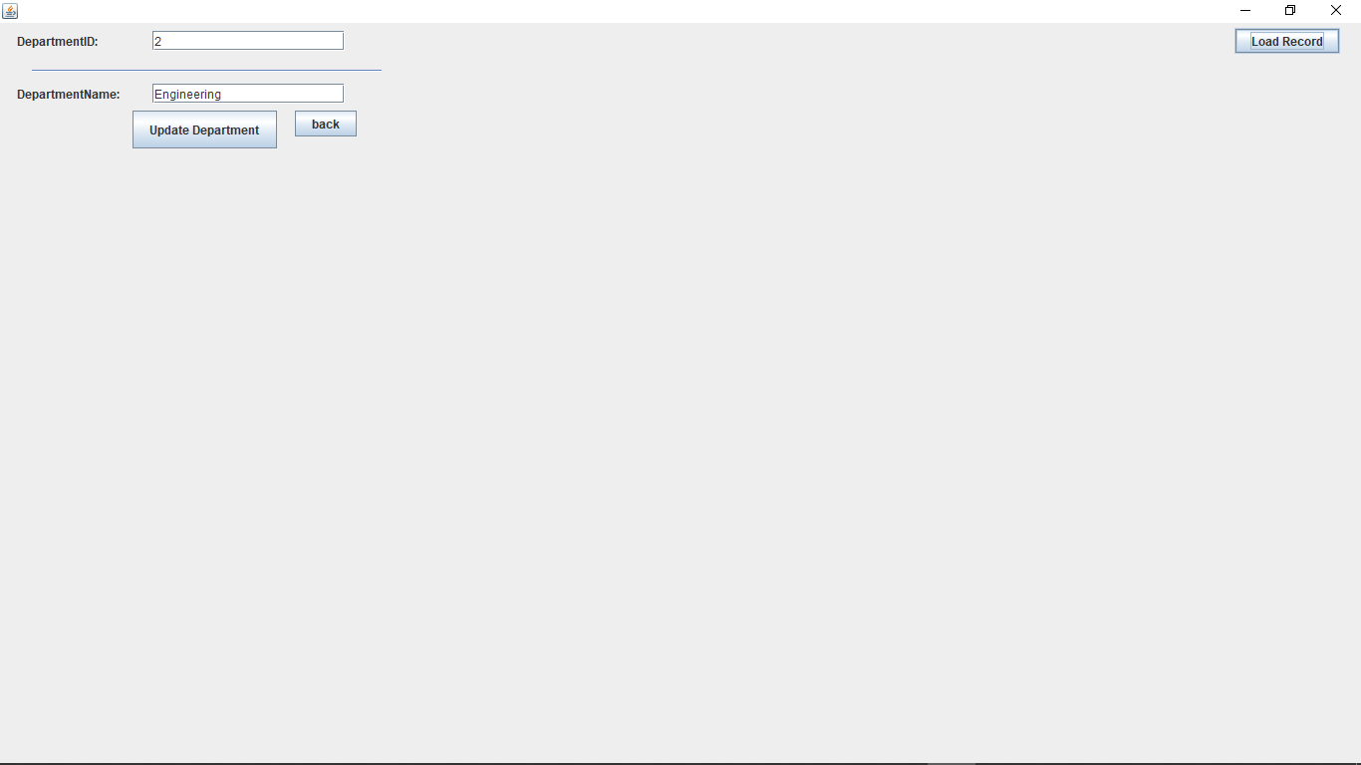

**If we’ve pressed the Update Department button it will display a message “Department updated successfully” to confirm**

**that the Department was updated.Note that we’ve updated the DepartmentName from Engineering to Chemical Engineering.**

**To confirm that the DepartmentName was really updated we can go to the ViewDepartments to confirm that the update was done.**

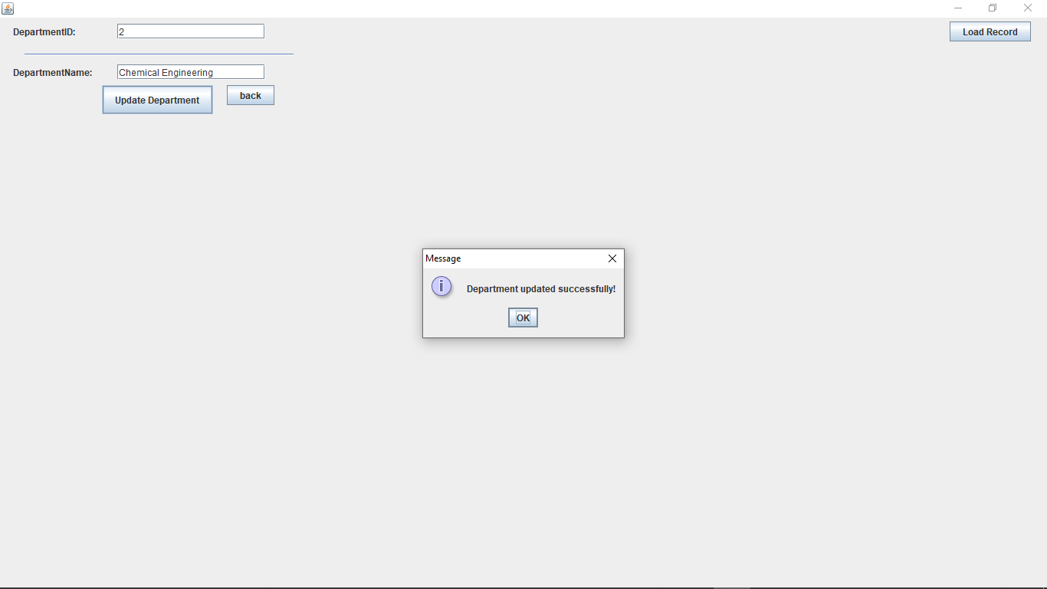

**The update was really done successfully.The DepartmentName with DepartmentID 2 was changed from Engineering to Chemical Engineering.**

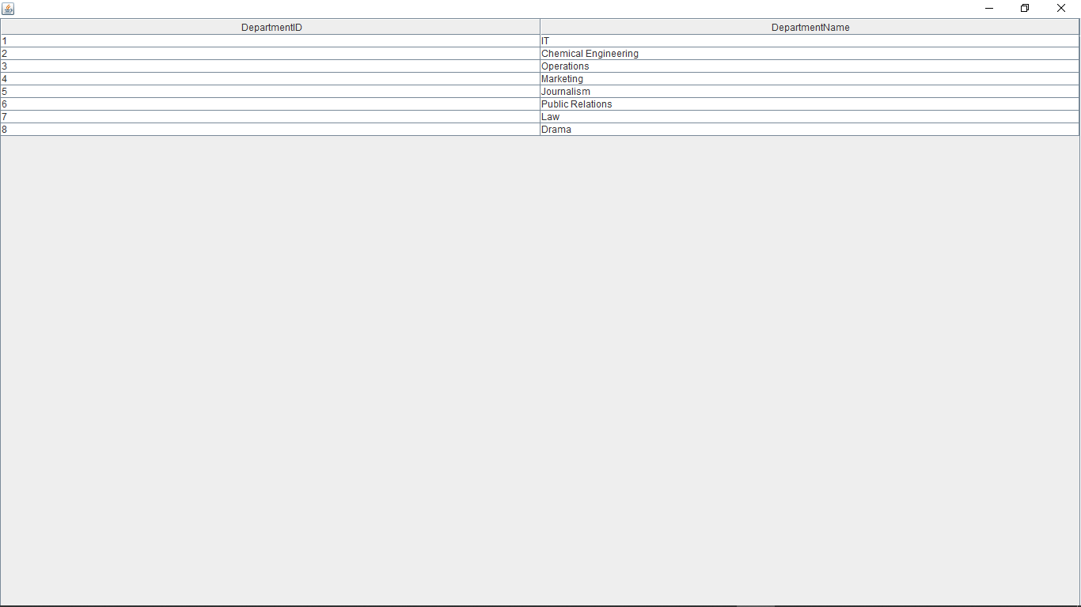

**We are now done with the Department functionalities AddNewDepartment,ViewDepartments and EditDepartment.**

**Now we come to the Regulation functionalities: AddNewRegulation,ViewRegulations,and EditRegulation.**

**AddNewRegulation.**

**We will create the first functionality AddNewRegulation,so we create a class called AddNewRegualtion.java.**

**Here’s the code**

**package** com.java.employeesystem;

**import** java.awt.Color;

**import** java.awt.EventQueue;

**import** java.awt.Font;

**import** java.awt.event.ActionEvent;

**import** java.awt.event.ActionListener;

**import** javax.swing.GroupLayout;

**import** javax.swing.GroupLayout.Alignment;

**import** javax.swing.JButton;

**import** javax.swing.JFrame;

**import** javax.swing.JLabel;

**import** javax.swing.JOptionPane;

**import** javax.swing.JPanel;

**import** javax.swing.JTextArea;

**import** javax.swing.JTextField;

**import** javax.swing.border.EmptyBorder;

**import** java.sql.Date;

**import** java.text.DateFormat;

**import** java.text.ParseException;

**import** java.text.SimpleDateFormat;

**import** javax.swing.LayoutStyle.ComponentPlacement;

**public** **class** AddNewRegulation **extends** JFrame {

/**

*

*/

**private** **static** **final** **long** ***serialVersionUID*** = 1L;

**static** AddNewRegulation *frame*;

**private** JPanel contentPane;

**private** JTextField textField;

**private** JTextField textField_1;

**private** JTextField textField_3;

JTextArea textArea;

/**

* Launch the application.

*/

**public** **static** **void** main(String[] args) {

EventQueue.*invokeLater*(**new** Runnable() {

**public** **void** run() {

**try** {

*frame* = **new** AddNewRegulation();

*frame*.setVisible(**true**);

} **catch** (Exception e) {

e.printStackTrace();

}

}

});

}

/**

* Create the frame.

*/

**public** AddNewRegulation() {

setDefaultCloseOperation(JFrame.***EXIT_ON_CLOSE***);

setBounds(100, 100, 450, 300);

contentPane = **new** JPanel();

contentPane.setBorder(**new** EmptyBorder(5, 5, 5, 5));

setContentPane(contentPane);

JLabel lblAddRegulation = **new** JLabel("Add Regulation");

lblAddRegulation.setForeground(Color.***DARK_GRAY***);

lblAddRegulation.setFont(**new** Font("Tahoma", Font.***PLAIN***, 20));

JLabel lbldepartment_id = **new** JLabel("Department ID:");

JLabel lblrlType = **new** JLabel("Regulation Type");

JLabel lbldetails = **new** JLabel("Details:");

JLabel lblcreateDate = **new** JLabel("Create Date:");

textField = **new** JTextField();

textField.setColumns(10);

textField_1 = **new** JTextField();

textField_1.setColumns(10);

textField_3 = **new** JTextField();

textField_3.setColumns(10);

textArea = **new** JTextArea();

textArea.setRows(3);

textArea.setColumns(20);

JButton btnAddRegulation = **new** JButton("Add Regulation");

btnAddRegulation.addActionListener(**new** ActionListener()

{

**public** **void** actionPerformed(ActionEvent e)

{

String rlType=textField_1.getText();

String details=textArea.getText();

**boolean** performSave=**true**;

String screatedate=textField_3.getText();

DateFormat sdf=**new** SimpleDateFormat("dd/MM/yyyy");

Date createdate =**null**;

**if**(!screatedate.equals(""))

{

screatedate=textField_3.getText();

createdate=Date.*valueOf*(screatedate);

**try** {

createdate=(Date) sdf.parse(screatedate);

} **catch** (ParseException e1) {

// **TODO** Auto-generated catch block

e1.printStackTrace();

}

performSave=**true**;

}

**else**

{

JOptionPane.*showMessageDialog*(**null**,"Please Enter Date");

performSave=**false**;

}

String s_departmentid=textField.getText();

**int** department_id=0;

**if**( ! s_departmentid.equals(""))

{

s_departmentid=textField.getText();

department_id=Integer.*valueOf*(s_departmentid);

performSave=**true**;

}

**else**

{

JOptionPane.*showMessageDialog*(**null**,"Please Enter Department ID");

performSave=**false**;

}

**if**(textField_1.getText().isEmpty())

{

JOptionPane.*showMessageDialog*(**null**,"Please Enter RLType");

performSave=**false**;

}

**if**(textArea.getText().isEmpty())

{

JOptionPane.*showMessageDialog*(**null**,"Please Enter Details");

performSave=**false**;

}

**if**(performSave)

{

**int** status=ComplianceDao.*save*(department_id,rlType,details,createdate);

**if**(status>0){

JOptionPane.*showMessageDialog*(AddNewRegulation.**this**,"Regulation added successfully!");

textField.setText("");textField_1.setText("");

textField_3.setText("");textArea.setText("");

}**else**{

JOptionPane.*showMessageDialog*(AddNewRegulation.**this**,"Sorry, Unable to add Regulation!");

}

}

}

});

JButton btnBack = **new** JButton("Back");

btnBack.addActionListener(**new** ActionListener() {

**public** **void** actionPerformed(ActionEvent e) {

AdminSection.*main*(**new** String[]{});

*frame*.dispose();

}

});

GroupLayout gl_contentPane = **new** GroupLayout(contentPane);

gl_contentPane.setHorizontalGroup(

gl_contentPane.createParallelGroup(Alignment.***LEADING***)

.addGroup(gl_contentPane.createSequentialGroup()

.addGroup(gl_contentPane.createParallelGroup(Alignment.***LEADING***)

.addGroup(gl_contentPane.createSequentialGroup()

.addGap(144)

.addComponent(lblAddRegulation))

.addGroup(gl_contentPane.createSequentialGroup()

.addContainerGap()

.addGroup(gl_contentPane.createParallelGroup(Alignment.***LEADING***)

.addComponent(lbldepartment_id, GroupLayout.***PREFERRED_SIZE***, 133, GroupLayout.***PREFERRED_SIZE***)

.addComponent(lblrlType, GroupLayout.***PREFERRED_SIZE***, 133, GroupLayout.***PREFERRED_SIZE***)

.addComponent(lbldetails, GroupLayout.***PREFERRED_SIZE***, 133, GroupLayout.***PREFERRED_SIZE***)

.addComponent(lblcreateDate, GroupLayout.***PREFERRED_SIZE***, 133, GroupLayout.***PREFERRED_SIZE***))

.addGap(33)

.addGroup(gl_contentPane.createParallelGroup(Alignment.***LEADING***, **false**)

.addComponent(textField, GroupLayout.***DEFAULT_SIZE***, 193, Short.***MAX_VALUE***)

.addComponent(textField_1, GroupLayout.***DEFAULT_SIZE***, 193, Short.***MAX_VALUE***)

.addComponent(textArea, GroupLayout.***DEFAULT_SIZE***, 193, Short.***MAX_VALUE***)

.addComponent(textField_3, GroupLayout.***DEFAULT_SIZE***, 193, Short.***MAX_VALUE***))))

.addContainerGap(124, Short.***MAX_VALUE***))

.addGroup(gl_contentPane.createSequentialGroup()

.addGap(128)

.addComponent(btnAddRegulation, GroupLayout.***PREFERRED_SIZE***, 145, GroupLayout.***PREFERRED_SIZE***)

.addGap(18)

.addComponent(btnBack)

.addContainerGap(44, Short.***MAX_VALUE***))

.addGroup(gl_contentPane.createSequentialGroup()

.addContainerGap()

.addComponent(lblcreateDate, GroupLayout.***PREFERRED_SIZE***, 50, GroupLayout.***PREFERRED_SIZE***)

.addContainerGap(364, Short.***MAX_VALUE***))

);

gl_contentPane.setVerticalGroup(

gl_contentPane.createParallelGroup(Alignment.***LEADING***)

.addGroup(gl_contentPane.createSequentialGroup()

.addComponent(lblAddRegulation)

.addGap(18)

.addGroup(gl_contentPane.createParallelGroup(Alignment.***BASELINE***)

.addComponent(lbldepartment_id)

.addComponent(textField, GroupLayout.***PREFERRED_SIZE***, GroupLayout.***DEFAULT_SIZE***, GroupLayout.***PREFERRED_SIZE***))

.addPreferredGap(ComponentPlacement.***UNRELATED***)

.addGroup(gl_contentPane.createParallelGroup(Alignment.***BASELINE***)

.addComponent(lblrlType)

.addComponent(textField_1, GroupLayout.***PREFERRED_SIZE***, GroupLayout.***DEFAULT_SIZE***, GroupLayout.***PREFERRED_SIZE***))

.addPreferredGap(ComponentPlacement.***UNRELATED***)

.addGroup(gl_contentPane.createParallelGroup(Alignment.***BASELINE***)

.addComponent(lbldetails)

.addComponent(textArea, GroupLayout.***PREFERRED_SIZE***, GroupLayout.***DEFAULT_SIZE***, GroupLayout.***PREFERRED_SIZE***))

.addPreferredGap(ComponentPlacement.***UNRELATED***)

.addGroup(gl_contentPane.createParallelGroup(Alignment.***BASELINE***)

.addComponent(lblcreateDate)

.addComponent(textField_3, GroupLayout.***PREFERRED_SIZE***, GroupLayout.***DEFAULT_SIZE***, GroupLayout.***PREFERRED_SIZE***))

.addGap(7)

.addGroup(gl_contentPane.createParallelGroup(Alignment.***LEADING***)

.addComponent(btnAddRegulation, GroupLayout.***PREFERRED_SIZE***, 38, GroupLayout.***PREFERRED_SIZE***)

.addComponent(btnBack))

.addContainerGap())

);

contentPane.setLayout(gl_contentPane);

}

}

**We must take note of the following in this code.We’ve imported java.sql.Date to be able to parse it.The createdDate must be entered in an appropriate format, for example someone**

**born on 22 June 1990,will enter 1990-06-22 in the textField.**

**After we’ve run the code,this is how the user interface will look like.Note in the Details it’s a TextArea because there’s a lot to write.**

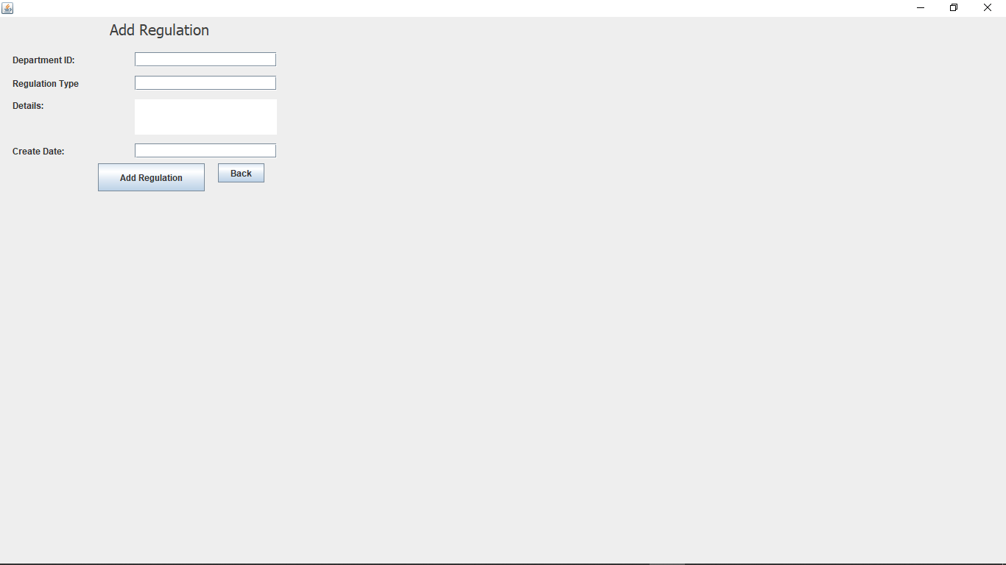

**We can validate if the textfields are empty ,when the user entered nothing,and it will display a message with the help of JOptionPane.**

**Screen-shot Add**

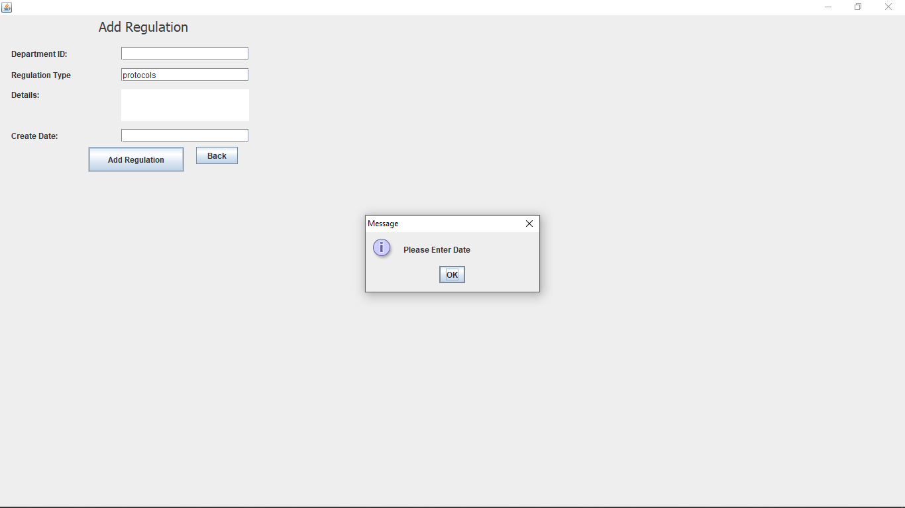

**When the regulation is added it will display a message to confirm the regulation is added.**

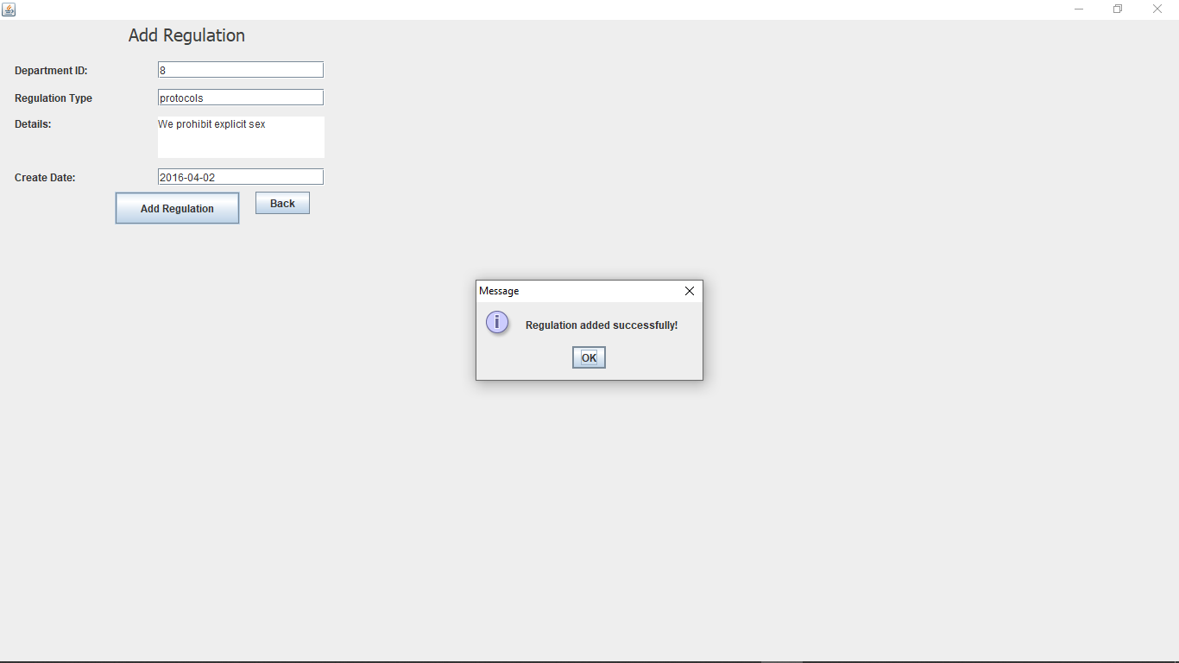

**Now that we’ve added the regulation,we need the view the regulations.Here’s the code below.**

**package** com.java.employeesystem;

**import** java.awt.BorderLayout;

**import** java.awt.EventQueue;

**import** java.util.List;

**import** javax.swing.JFrame;

**import** javax.swing.JPanel;

**import** javax.swing.JScrollPane;

**import** javax.swing.JTable;

**import** javax.swing.border.EmptyBorder;

**public** **class** ViewRegulations **extends** JFrame {

**static** ViewRegulations *frame*;

**public** ViewRegulations() {

//Code to view data in JTable

List<Compliance> list=ComplianceDao.*view*();

**int** size=list.size();

String data[][]=**new** String[size][5];

**int** row=0;

**for**(Compliance c:list){

data[row][0]=String.*valueOf*(c.getCompliance_id());

data[row][1]=c.getRlType();

data[row][2]=c.getDetails();

data[row][3]=String.*valueOf*(c.getCreateDate());

data[row][4]=String.*valueOf*(c.getDepartment_id());

row++;

}

String columnNames[]={"ComplianceID","RLType","Details","CreateDate","DepartmentID"};

JTable jt=**new** JTable(data,columnNames);

JScrollPane sp=**new** JScrollPane(jt);

add(sp);

setDefaultCloseOperation(JFrame.***DISPOSE_ON_CLOSE***);

setBounds(100, 100, 800, 400);

}

**public** **static** **void** main(String[] args) {

EventQueue.*invokeLater*(**new** Runnable() {

**public** **void** run() {

**try** {

*frame* = **new** ViewRegulations();

*frame*.setVisible(**true**);

} **catch** (Exception e) {

e.printStackTrace();

}

}

});

}

}

**After we’ve run the code,this is how the user-interface will look like.**

**We must take note:**

**A department can one-to-many regulations with department_id foreign key.This is illustrated on the diagram below.**

**As we can see that the department_id 1 have 3 regulations as shown with RLType working hours,work-morale and code of conduct.**

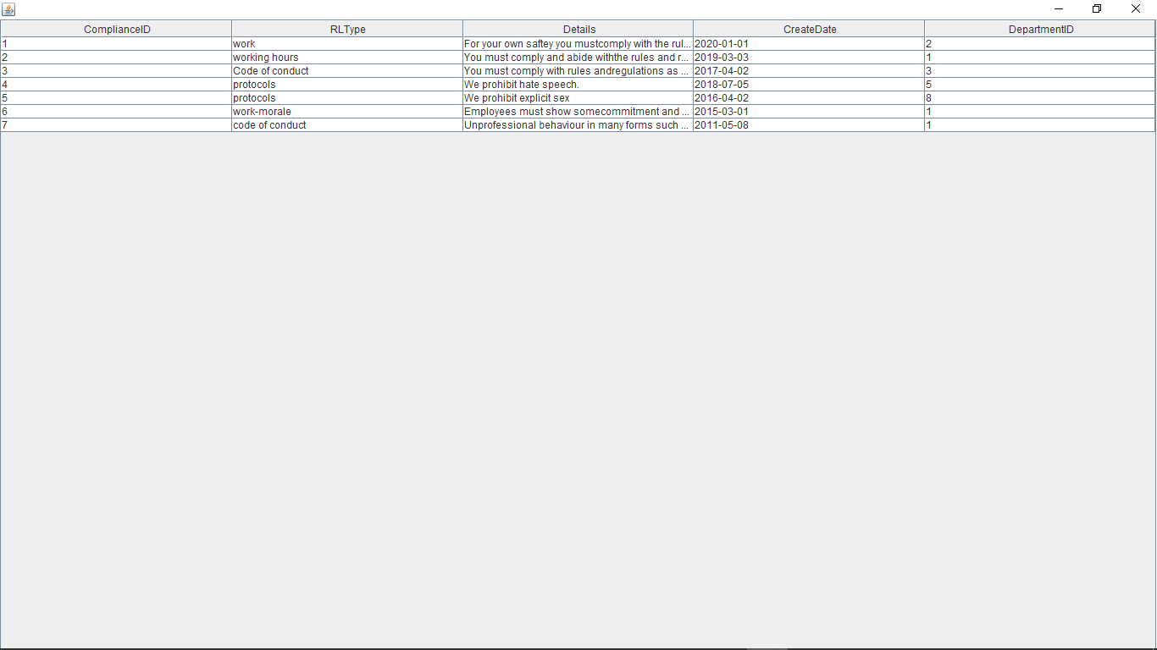

**A regulation can also be edited.Here’s the code below.**

**package** com.java.employeesystem;

**import** java.awt.BorderLayout;

**import** java.awt.EventQueue;

**import** javax.swing.JFrame;

**import** javax.swing.JPanel;

**import** javax.swing.border.EmptyBorder;

**import** javax.swing.GroupLayout;

**import** javax.swing.GroupLayout.Alignment;

**import** javax.swing.JLabel;

**import** javax.swing.JOptionPane;

**import** java.awt.Font;

**import** java.awt.Color;

**import** javax.swing.LayoutStyle.ComponentPlacement;

**import** javax.swing.JButton;

**import** javax.swing.JTextField;

**import** javax.swing.JTextPane;

**import** java.awt.event.ActionListener;

**import** java.text.ParseException;

**import** java.text.SimpleDateFormat;

**import** java.sql.Date;

**import** java.awt.event.ActionEvent;

**import** javax.swing.JTextArea;

**import** javax.swing.JSeparator;

**public** **class** EditRegulation **extends** JFrame {

**static** EditRegulation *frame*;

**private** JPanel contentPane;

**private** JTextField textField;

JTextArea textArea;

**private** JTextField textField_2;

**private** JTextField textField_3;

**private** JTextField textField_4;

/**

* Launch the application.

*/

**public** **static** **void** main(String[] args) {

EventQueue.*invokeLater*(**new** Runnable() {

**public** **void** run() {

**try** {

*frame* = **new** EditRegulation();

*frame*.setVisible(**true**);

} **catch** (Exception e) {

e.printStackTrace();

}

}

});

}

/**

* Create the frame.

*/

**public** EditRegulation() {

setDefaultCloseOperation(JFrame.***EXIT_ON_CLOSE***);

setBounds(100, 100, 450, 550);

contentPane = **new** JPanel();

contentPane.setBorder(**new** EmptyBorder(5, 5, 5, 5));

setContentPane(contentPane);

JLabel lblrlType = **new** JLabel("RLType:");

JLabel lbldetails = **new** JLabel("Details:");

JLabel lblcreateDate = **new** JLabel("Paid:");

JLabel lbldepartment_id = **new** JLabel("DepartmentID:");

JButton btnEditRegulation = **new** JButton("Update Regulation");

btnEditRegulation.addActionListener(**new** ActionListener() {

**public** **void** actionPerformed(ActionEvent e) {

String rlType=textField.getText();

String details=textArea.getText();

String screateDate=textField_2.getText();

String format="dd/MM/yyyy";

SimpleDateFormat sdf= **new** SimpleDateFormat(format);

Date createdate = Date.*valueOf*(screateDate);

**try** {

createdate = (Date) sdf.parse(screateDate);

} **catch** (ParseException e1) {

// **TODO** Auto-generated catch block

e1.printStackTrace();

}

**int** department_id=Integer.*parseInt*(textField_3.getText());

**int** complianceid=Integer.*parseInt*(textField_4.getText());

Compliance c=**new** Compliance(complianceid,department_id,rlType,details,createdate);

**int** status=ComplianceDao.*update*(c);

**if**(status>0){

JOptionPane.*showMessageDialog*(EditRegulation.**this**,"Regulation updated successfully!");

AdminSection.*main*(**new** String[]{});

*frame*.dispose();

}**else**{

JOptionPane.*showMessageDialog*(EditRegulation.**this**,"Sorry, Unable to edit Regulation!");

}

}

});

textField = **new** JTextField();

textField.setColumns(10);

textArea = **new** JTextArea();

textField_2 = **new** JTextField();

textField_2.setColumns(10);

textField_3 = **new** JTextField();

textField_3.setColumns(10);

JButton btnBack = **new** JButton("back");

btnBack.addActionListener(**new** ActionListener() {

**public** **void** actionPerformed(ActionEvent e) {

AdminSection.*main*(**new** String[]{});

*frame*.dispose();

}

});

JLabel lblcomplianceid = **new** JLabel("ComplianceID:");

textField_4 = **new** JTextField();

textField_4.setColumns(10);

JSeparator separator = **new** JSeparator();

JButton btnLoadRecord = **new** JButton("Load Record");

btnLoadRecord.addActionListener(**new** ActionListener() {

**public** **void** actionPerformed(ActionEvent arg0) {

String scomplianceid=textField_4.getText();

**if**(scomplianceid==**null**||scomplianceid.trim().equals("")){

JOptionPane.*showMessageDialog*(EditRegulation.**this**,"Please enter ComplianceID first!");

}**else**{

**int** complianceid=Integer.*parseInt*(scomplianceid);

Compliance c=ComplianceDao.*getComplianceByid*(complianceid);

textField.setText(c.getRlType());

textArea.setText(c.getDetails());

textField_2.setText(String.*valueOf*(c.getCreateDate()));

textField_3.setText(String.*valueOf*(c.getDepartment_id()));

}

}

});

GroupLayout gl_contentPane = **new** GroupLayout(contentPane);

gl_contentPane.setHorizontalGroup(

gl_contentPane.createParallelGroup(Alignment.***LEADING***)

.addGroup(gl_contentPane.createSequentialGroup()

.addContainerGap()

.addGroup(gl_contentPane.createParallelGroup(Alignment.***LEADING***)

.addComponent(lblrlType)

.addComponent(lbldetails , GroupLayout.***PREFERRED_SIZE***, 133, GroupLayout.***PREFERRED_SIZE***)

.addComponent(lblcreateDate, GroupLayout.***PREFERRED_SIZE***, 133, GroupLayout.***PREFERRED_SIZE***)

.addComponent(lbldepartment_id, GroupLayout.***PREFERRED_SIZE***, 133, GroupLayout.***PREFERRED_SIZE***)

.addGroup(gl_contentPane.createParallelGroup(Alignment.***TRAILING***, **false**)

.addComponent(lblcomplianceid, Alignment.***LEADING***, GroupLayout.***DEFAULT_SIZE***, GroupLayout.***DEFAULT_SIZE***, Short.***MAX_VALUE***)))

.addGap(33)

.addGroup(gl_contentPane.createParallelGroup(Alignment.***LEADING***)

.addGroup(gl_contentPane.createParallelGroup(Alignment.***LEADING***, **false**)

.addComponent(textField_3, GroupLayout.***DEFAULT_SIZE***, 193, Short.***MAX_VALUE***)

.addComponent(textField_2, GroupLayout.***DEFAULT_SIZE***, 193, Short.***MAX_VALUE***)

.addComponent(textArea, GroupLayout.***DEFAULT_SIZE***, 193, Short.***MAX_VALUE***)

.addComponent(textField, GroupLayout.***DEFAULT_SIZE***, 193, Short.***MAX_VALUE***))

.addGroup(gl_contentPane.createSequentialGroup()

.addComponent(textField_4, GroupLayout.***PREFERRED_SIZE***, 193, GroupLayout.***PREFERRED_SIZE***)

.addPreferredGap(ComponentPlacement.***RELATED***, 25, Short.***MAX_VALUE***)

.addComponent(btnLoadRecord)))

.addGap(16)

.addContainerGap())

.addGroup(gl_contentPane.createSequentialGroup()

.addContainerGap()

.addComponent(lbldepartment_id)

.addContainerGap(356, Short.***MAX_VALUE***))

.addGroup(gl_contentPane.createSequentialGroup()

.addContainerGap()

.addComponent(lblcreateDate, GroupLayout.***DEFAULT_SIZE***, 64, Short.***MAX_VALUE***)

.addContainerGap(383, Short.***MAX_VALUE***))

.addGroup(gl_contentPane.createSequentialGroup()

.addGap(128)

.addComponent(btnEditRegulation, GroupLayout.***PREFERRED_SIZE***, 145, GroupLayout.***PREFERRED_SIZE***)

.addGap(18)

.addComponent(btnBack)

.addContainerGap(78, Short.***MAX_VALUE***))

.addGroup(gl_contentPane.createSequentialGroup()

.addContainerGap()

.addComponent(lbldetails, GroupLayout.***PREFERRED_SIZE***, 50, GroupLayout.***PREFERRED_SIZE***)

.addContainerGap(364, Short.***MAX_VALUE***))

.addGroup(gl_contentPane.createSequentialGroup()

.addGap(27)

.addComponent(separator, GroupLayout.***PREFERRED_SIZE***, 351, GroupLayout.***PREFERRED_SIZE***)

.addContainerGap(46, Short.***MAX_VALUE***))

);

gl_contentPane.setVerticalGroup(

gl_contentPane.createParallelGroup(Alignment.***LEADING***)

.addGroup(gl_contentPane.createSequentialGroup()

.addGroup(gl_contentPane.createParallelGroup(Alignment.***BASELINE***)

.addComponent(lblcomplianceid)

.addComponent(textField_4, GroupLayout.***PREFERRED_SIZE***, GroupLayout.***DEFAULT_SIZE***, GroupLayout.***PREFERRED_SIZE***)

.addComponent(btnLoadRecord))

.addGap(16)

.addComponent(separator, GroupLayout.***PREFERRED_SIZE***, GroupLayout.***DEFAULT_SIZE***, GroupLayout.***PREFERRED_SIZE***)

.addPreferredGap(ComponentPlacement.***UNRELATED***)

.addGroup(gl_contentPane.createParallelGroup(Alignment.***BASELINE***)

.addComponent(lblrlType)

.addComponent(textField, GroupLayout.***PREFERRED_SIZE***, GroupLayout.***DEFAULT_SIZE***, GroupLayout.***PREFERRED_SIZE***))

.addPreferredGap(ComponentPlacement.***UNRELATED***)

.addGroup(gl_contentPane.createParallelGroup(Alignment.***BASELINE***)

.addComponent(lbldetails)

.addComponent(textArea, GroupLayout.***PREFERRED_SIZE***, GroupLayout.***DEFAULT_SIZE***, GroupLayout.***PREFERRED_SIZE***))

.addPreferredGap(ComponentPlacement.***UNRELATED***)

.addGroup(gl_contentPane.createParallelGroup(Alignment.***BASELINE***)

.addComponent(lblcreateDate)

.addComponent(textField_2, GroupLayout.***PREFERRED_SIZE***, GroupLayout.***DEFAULT_SIZE***, GroupLayout.***PREFERRED_SIZE***))

.addPreferredGap(ComponentPlacement.***UNRELATED***)

.addGroup(gl_contentPane.createParallelGroup(Alignment.***BASELINE***)

.addComponent(lbldepartment_id)

.addComponent(textField_3, GroupLayout.***PREFERRED_SIZE***, GroupLayout.***DEFAULT_SIZE***, GroupLayout.***PREFERRED_SIZE***))

.addPreferredGap(ComponentPlacement.***UNRELATED***)

.addGap(7)

.addGroup(gl_contentPane.createParallelGroup(Alignment.***LEADING***)

.addComponent(btnEditRegulation, GroupLayout.***PREFERRED_SIZE***, 38, GroupLayout.***PREFERRED_SIZE***)

.addComponent(btnBack))

.addContainerGap())

);

contentPane.setLayout(gl_contentPane);

}

}

**This is how the user-interface will look like after we’ve run the code.Here again we need to enter the ComplianceID**

**first before we do some edit.I’ve entered ComplianceID 1 and after I press the Load Record button it will Load the Record.**

**Here I’ve edited the RLType from work to work ethic,and the regulation was updated successfully.**

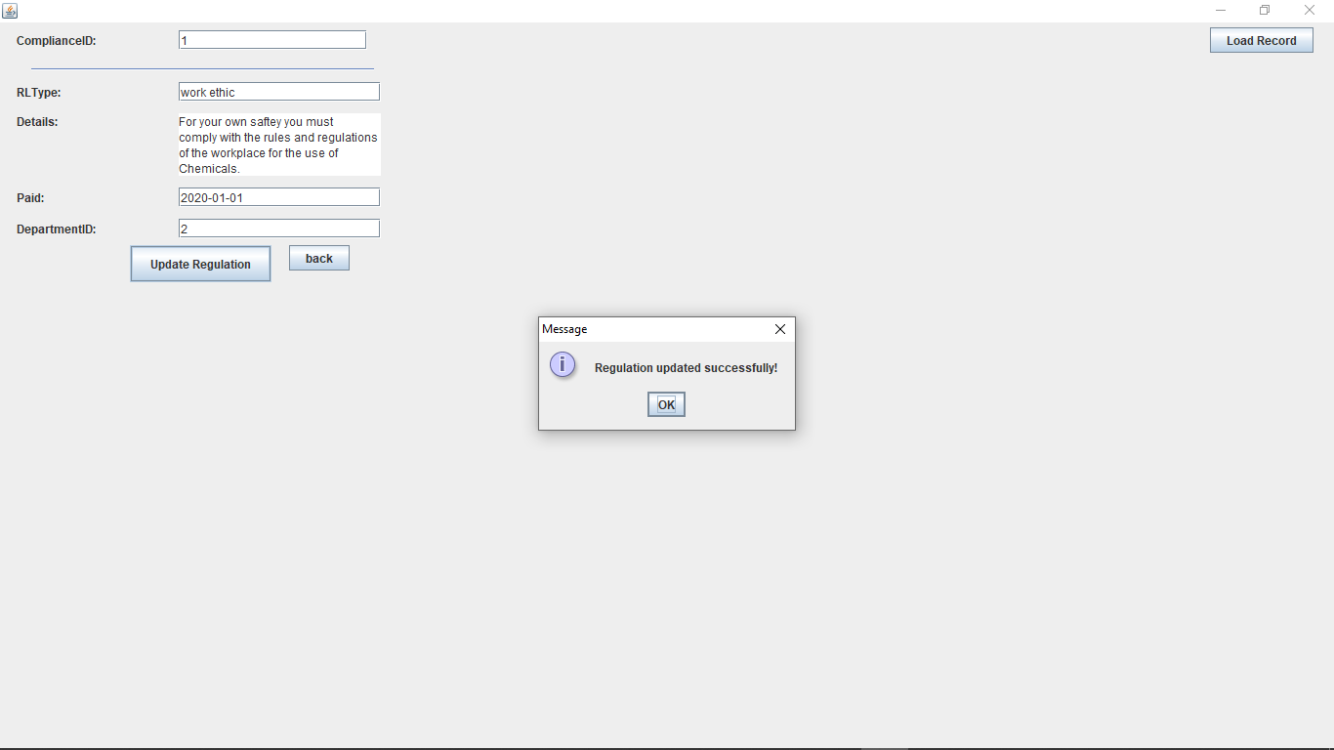

**Now we’ve completed the Regulation functionalities : AddNewRegulation,ViewRegulations and EditRegulation.**

**We now come to the Employee functionalities AddNewEmployee,ViewEmployees and EditEmployee**

**The first functionality AddNewEmployee,so we create a class AddNewEmployee.java.Here’s the code below.**

**package** com.java.employeesystem;

**import** java.awt.Color;

**import** java.awt.EventQueue;

**import** java.awt.Font;

**import** java.awt.event.ActionEvent;

**import** java.awt.event.ActionListener;

**import** java.text.DateFormat;

**import** java.text.ParseException;

**import** java.text.SimpleDateFormat;

**import** javax.swing.GroupLayout;

**import** javax.swing.GroupLayout.Alignment;

**import** javax.swing.JButton;

**import** javax.swing.JFrame;

**import** javax.swing.JLabel;

**import** javax.swing.JOptionPane;

**import** javax.swing.JPanel;

**import** javax.swing.JTextField;

**import** javax.swing.LayoutStyle.ComponentPlacement;

**import** javax.swing.border.EmptyBorder;

**import** java.sql.Date;

**public** **class** AddNewEmployee **extends** JFrame {

/**

*

*/

**private** **static** **final** **long** ***serialVersionUID*** = 1L;

**static** AddNewEmployee *frame*;

**private** JPanel contentPane;

**private** JTextField textField;

**private** JTextField textField_1;

**private** JTextField textField_2;

**private** JTextField textField_3;

**private** JTextField textField_4;

/**

* Launch the application.

*/

**public** **static** **void** main(String[] args) {

EventQueue.*invokeLater*(**new** Runnable() {

**public** **void** run() {

**try** {

*frame* = **new** AddNewEmployee();

*frame*.setVisible(**true**);

} **catch** (Exception e) {

e.printStackTrace();

}

}

});

}

/**

* Create the frame.

*/

**public** AddNewEmployee() {

setDefaultCloseOperation(JFrame.***EXIT_ON_CLOSE***);

setBounds(100, 100, 450, 300);

contentPane = **new** JPanel();

contentPane.setBorder(**new** EmptyBorder(5, 5, 5, 5));

setContentPane(contentPane);

JLabel lblAddEmployee= **new** JLabel("Add Employee");

lblAddEmployee.setForeground(Color.***DARK_GRAY***);

lblAddEmployee.setFont(**new** Font("Tahoma", Font.***PLAIN***, 20));

JLabel lbldepartment_id = **new** JLabel("DepartmentID:");

JLabel lblfirstname = **new** JLabel("FirstName");

JLabel lbllastname = **new** JLabel("LastName:");

JLabel lblemail = **new** JLabel("Email:");

JLabel lbldob = **new** JLabel("DOB:");

textField = **new** JTextField();

textField.setColumns(10);

textField_1 = **new** JTextField();

textField_1.setColumns(10);

textField_2 = **new** JTextField();

textField_2.setColumns(10);

textField_3 = **new** JTextField();

textField_3.setColumns(10);

textField_4 = **new** JTextField();

textField_4.setColumns(10);

JButton btnAddEmployee = **new** JButton("Add Employee");

btnAddEmployee.addActionListener(**new** ActionListener() {

**public** **void** actionPerformed(ActionEvent e) {

String firstname=textField_1.getText();

String lastname=textField_2.getText();

String email=textField_3.getText();

//String sdob=textField_4.getText();

**boolean** performSave=**true**;

String sdob=textField_4.getText();

DateFormat sdf=**new** SimpleDateFormat("dd/MM/yyyy");

Date dob =**null**;

**if**(!sdob.equals(""))

{

sdob=textField_4.getText();

dob=Date.*valueOf*(sdob);

**try** {

dob=(Date) sdf.parse(sdob);

} **catch** (ParseException e1) {

// **TODO** Auto-generated catch block

e1.printStackTrace();

}

performSave=**true**;

}

**else**

{

JOptionPane.*showMessageDialog*(**null**,"Please Enter Date of Birth");

performSave=**false**;

}

String s_departmentid=textField.getText();

**int** department_id=0;

**if**( ! s_departmentid.equals(""))

{

s_departmentid=textField.getText();

//department_id=Integer.valueOf(s_departmentid);

department_id=Integer.*parseInt*(s_departmentid);

performSave=**true**;

}

**else**

{

JOptionPane.*showMessageDialog*(**null**,"Please Enter Department ID");

performSave=**false**;

}

**if**(textField_1.getText().isEmpty())

{

JOptionPane.*showMessageDialog*(**null**,"Please Enter FirstName");

performSave=**false**;

}

**if**(textField_2.getText().isEmpty())

{

JOptionPane.*showMessageDialog*(**null**,"Please Enter LastName");

performSave=**false**;

}

**if**(textField_3.getText().isEmpty())

{

JOptionPane.*showMessageDialog*(**null**,"Please Enter Email");

performSave=**false**;

}

DateFormat dateFormat=**new** SimpleDateFormat("yyyy");

java.util.Date date=**new** java.util.Date();

**int** thisYear=Integer.*parseInt*(dateFormat.format(date));

**int** yearDob=Integer.*parseInt*(sdob.substring(0,4));

**int** age=thisYear-yearDob;

**if**(age<24)

{

JOptionPane.*showMessageDialog*(AddNewEmployee.**this**,"Sorry, You are under age!Someone who is older than 24 is allowed");

performSave=**false**;

}

**if**(performSave)

{

**int** status=EmployeeDao.*save*(department_id,firstname,lastname,email,dob);

**if**(status>0){

JOptionPane.*showMessageDialog*(AddNewEmployee.**this**,"Employee added successfully!");

textField.setText("");textField_1.setText("");textField_2.setText("");

textField_3.setText("");textField_4.setText("");

}**else**{

JOptionPane.*showMessageDialog*(AddNewEmployee.**this**,"Sorry, Unable to add Employee!");

}

}

}

});

JButton btnBack = **new** JButton("Back");

btnBack.addActionListener(**new** ActionListener() {

**public** **void** actionPerformed(ActionEvent e) {

AdminSection.*main*(**new** String[]{});

*frame*.dispose();

}

});

GroupLayout gl_contentPane = **new** GroupLayout(contentPane);

gl_contentPane.setHorizontalGroup(

gl_contentPane.createParallelGroup(Alignment.***LEADING***)

.addGroup(gl_contentPane.createSequentialGroup()

.addGroup(gl_contentPane.createParallelGroup(Alignment.***LEADING***)

.addGroup(gl_contentPane.createSequentialGroup()

.addGap(144)

.addComponent(lblAddEmployee))

.addGroup(gl_contentPane.createSequentialGroup()

.addContainerGap()

.addGroup(gl_contentPane.createParallelGroup(Alignment.***LEADING***)

.addComponent(lbldepartment_id, GroupLayout.***PREFERRED_SIZE***, 133, GroupLayout.***PREFERRED_SIZE***)

.addComponent(lblfirstname, GroupLayout.***PREFERRED_SIZE***, 133, GroupLayout.***PREFERRED_SIZE***)

.addComponent(lbllastname, GroupLayout.***PREFERRED_SIZE***, 133, GroupLayout.***PREFERRED_SIZE***)

.addComponent(lblemail, GroupLayout.***PREFERRED_SIZE***, 133, GroupLayout.***PREFERRED_SIZE***)

.addComponent(lbldob, GroupLayout.***PREFERRED_SIZE***, 133, GroupLayout.***PREFERRED_SIZE***))

.addGap(33)

.addGroup(gl_contentPane.createParallelGroup(Alignment.***LEADING***, **false**)

.addComponent(textField, GroupLayout.***DEFAULT_SIZE***, 193, Short.***MAX_VALUE***)

.addComponent(textField_1, GroupLayout.***DEFAULT_SIZE***, 193, Short.***MAX_VALUE***)

.addComponent(textField_2, GroupLayout.***DEFAULT_SIZE***, 193, Short.***MAX_VALUE***)

.addComponent(textField_3, GroupLayout.***DEFAULT_SIZE***, 193, Short.***MAX_VALUE***)

.addComponent(textField_4, GroupLayout.***DEFAULT_SIZE***, 193, Short.***MAX_VALUE***))))

.addContainerGap(124, Short.***MAX_VALUE***))

.addGroup(gl_contentPane.createSequentialGroup()

.addGap(128)

.addComponent(btnAddEmployee, GroupLayout.***PREFERRED_SIZE***, 145, GroupLayout.***PREFERRED_SIZE***)

.addGap(18)

.addComponent(btnBack)

.addContainerGap(44, Short.***MAX_VALUE***))

.addGroup(gl_contentPane.createSequentialGroup()

.addContainerGap()

.addComponent(lbldob, GroupLayout.***PREFERRED_SIZE***, 50, GroupLayout.***PREFERRED_SIZE***)

.addContainerGap(364, Short.***MAX_VALUE***))

);

gl_contentPane.setVerticalGroup(

gl_contentPane.createParallelGroup(Alignment.***LEADING***)

.addGroup(gl_contentPane.createSequentialGroup()

.addComponent(lblAddEmployee)

.addGap(18)

.addGroup(gl_contentPane.createParallelGroup(Alignment.***BASELINE***)

.addComponent(lbldepartment_id)

.addComponent(textField, GroupLayout.***PREFERRED_SIZE***, GroupLayout.***DEFAULT_SIZE***, GroupLayout.***PREFERRED_SIZE***))

.addPreferredGap(ComponentPlacement.***UNRELATED***)

.addGroup(gl_contentPane.createParallelGroup(Alignment.***BASELINE***)

.addComponent(lblfirstname)

.addComponent(textField_1, GroupLayout.***PREFERRED_SIZE***, GroupLayout.***DEFAULT_SIZE***, GroupLayout.***PREFERRED_SIZE***))

.addPreferredGap(ComponentPlacement.***UNRELATED***)

.addGroup(gl_contentPane.createParallelGroup(Alignment.***BASELINE***)

.addComponent(lbllastname)

.addComponent(textField_2, GroupLayout.***PREFERRED_SIZE***, GroupLayout.***DEFAULT_SIZE***, GroupLayout.***PREFERRED_SIZE***))

.addPreferredGap(ComponentPlacement.***UNRELATED***)

.addGroup(gl_contentPane.createParallelGroup(Alignment.***BASELINE***)

.addComponent(lblemail)

.addComponent(textField_3, GroupLayout.***PREFERRED_SIZE***, GroupLayout.***DEFAULT_SIZE***, GroupLayout.***PREFERRED_SIZE***))

.addPreferredGap(ComponentPlacement.***UNRELATED***)

.addGroup(gl_contentPane.createParallelGroup(Alignment.***BASELINE***)

.addComponent(lbldob)

.addComponent(textField_4, GroupLayout.***PREFERRED_SIZE***, GroupLayout.***DEFAULT_SIZE***, GroupLayout.***PREFERRED_SIZE***))

.addGap(7)

.addGroup(gl_contentPane.createParallelGroup(Alignment.***LEADING***)

.addComponent(btnAddEmployee, GroupLayout.***PREFERRED_SIZE***, 38, GroupLayout.***PREFERRED_SIZE***)

.addComponent(btnBack))

.addContainerGap())

);

contentPane.setLayout(gl_contentPane);

}

}

**In this code we need to take note of the following:**

**We need to import these libraries for date parsing**

**import** java.text.DateFormat;

**import** java.text.ParseException;

**import** java.text.SimpleDateFormat;

**import** java.sql.Date;

**As the system should not allow an entry of Employee who is not older than 24.This can be accomplished with the following code:**

DateFormat dateFormat=**new** SimpleDateFormat("yyyy");

java.util.Date date=**new** java.util.Date();

**int** thisYear=Integer.*parseInt*(dateFormat.format(date));

**int** yearDob=Integer.*parseInt*(sdob.substring(0,4));

**int** age=thisYear-yearDob;

**if**(age<24)

{

JOptionPane.*showMessageDialog*(AddNewEmployee.**this**,"Sorry, You are under age!Someone who is older than 24 is allowed");

performSave=**false**;

}

**We create a dateFormat where format it to year.**

**After that we create date variable java.util.Date date=new java.util.Date();**

**Then we create a variable int this year=Integer.parseInt(dateFormat.format(date));**

**Here we are parsing the date to an Integer.**

**Then after that we create a variable int yearDob=Integer.parseInt(sdob.substring(0,4));**

**Here we are parsing the sdob(a String date of birth) variable to an Integer where we set a substring to a sdob.**

**Then finally we create a variable int age=this year-yearDob where we subtract the YearDob from thisYear.**

**Here’s the user-interface after we’ve run the code.After we’ve entered all required information in the textFields**

**The message “Employee added successfully!” will be displayed.**

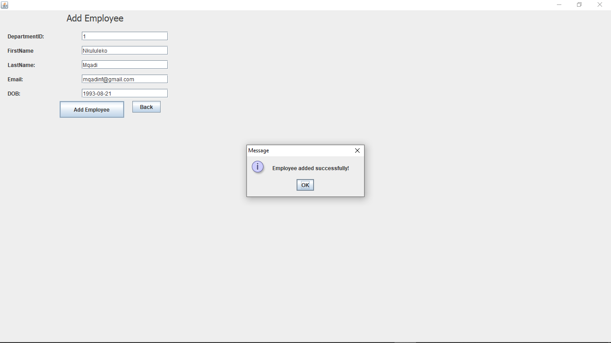

**The application can validate if the textFields are empty,it will display message**

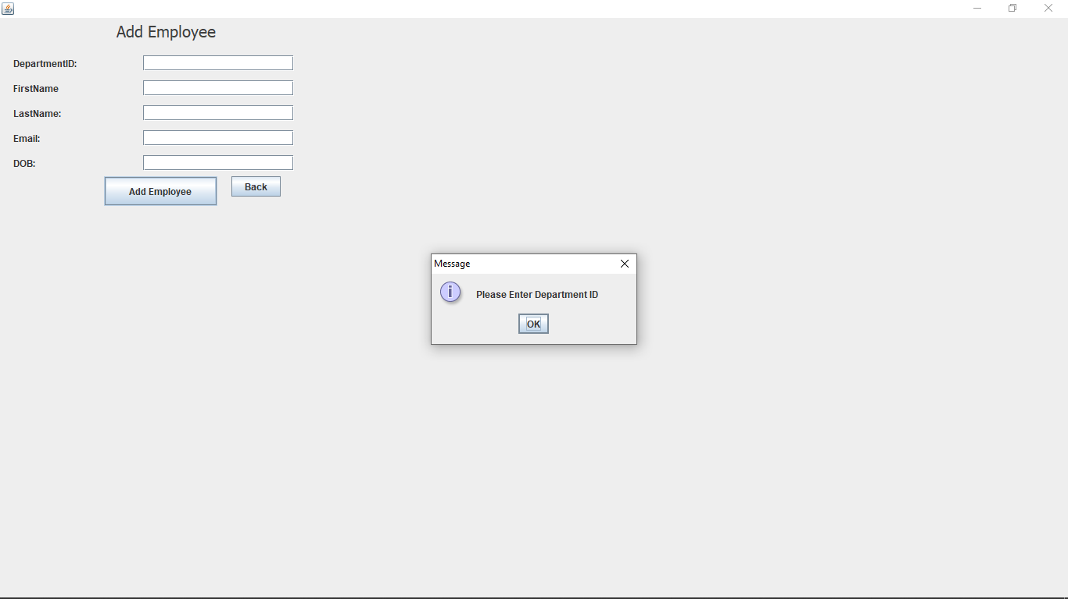

**We can also check whether the application can be able to validate if someone is less than 24.**

**Therefore the application displays a message that the person is underage.**

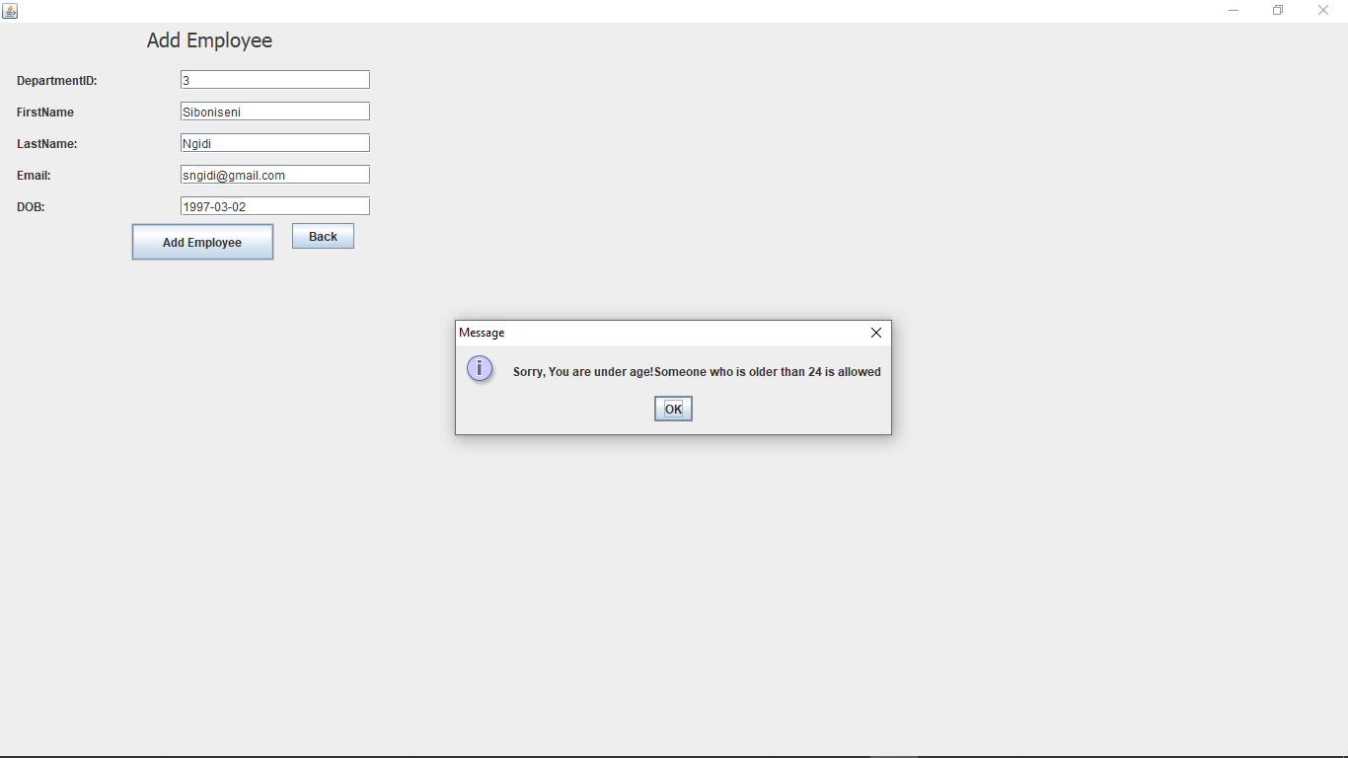

**The Employees can also be viewed.Here’s the code below.So we create a class called ViewEmployees.java**

**package** com.java.employeesystem;

**import** java.awt.BorderLayout;

**import** java.awt.EventQueue;

**import** java.util.List;

**import** javax.swing.JFrame;

**import** javax.swing.JPanel;

**import** javax.swing.JScrollPane;

**import** javax.swing.JTable;

**import** javax.swing.border.EmptyBorder;

**public** **class** ViewEmployees **extends** JFrame {

**static** ViewEmployees *frame*;

**public** ViewEmployees() {

//Code to view data in JTable

List<Employees> list=EmployeeDao.*view*();

**int** size=list.size();

String data[][]=**new** String[size][6];

**int** row=0;

**for**(Employees e1:list){

data[row][0]=String.*valueOf*(e1.getEmpid());

data[row][1]=e1.getFirstname();

data[row][2]=e1.getLasttname();

data[row][3]=String.*valueOf*(e1.getDob());

data[row][4]=e1.getEmail();

data[row][5]=String.*valueOf*(e1.getDepartment_id());

row++;

}

String columnNames[]={"EmpID","FirstName","LastName","DOB","Email","DepartmentID"};

JTable jt=**new** JTable(data,columnNames);

JScrollPane sp=**new** JScrollPane(jt);

add(sp);

setDefaultCloseOperation(JFrame.***DISPOSE_ON_CLOSE***);

setBounds(100, 100, 800, 400);

}

**public** **static** **void** main(String[] args) {

EventQueue.*invokeLater*(**new** Runnable() {

**public** **void** run() {

**try** {

*frame* = **new** ViewEmployees();

*frame*.setVisible(**true**);

} **catch** (Exception e) {

e.printStackTrace();

}

}

});

}

}

**Here are a list of Employees displayed.Take note a department can have many employees.Here we see that 2 employees belong to department_id 1 and 2 employees**

**Belong to department_id 3**

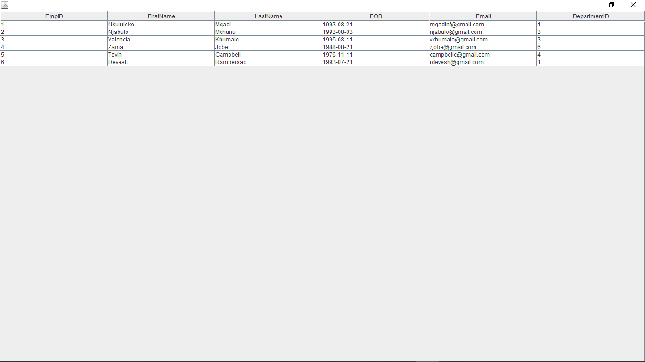

**An employee can also edit some information in the textFields.For example changing the LastName.Here I entered EmpID 1 to do an update.**

**After I clicked the Load Record button the record will load and I’ve changed the LastName from Mqadi to Mtolo,and then finally**

**After I’ve clicked the Update Employee button a message will be displayed for confirmation.**

**package** com.java.employeesystem;

**import** java.awt.BorderLayout;

**import** java.awt.EventQueue;

**import** javax.swing.JFrame;

**import** javax.swing.JPanel;

**import** javax.swing.border.EmptyBorder;

**import** javax.swing.GroupLayout;

**import** javax.swing.GroupLayout.Alignment;

**import** javax.swing.JLabel;

**import** javax.swing.JOptionPane;

**import** java.awt.Font;

**import** java.awt.Color;

**import** javax.swing.LayoutStyle.ComponentPlacement;

**import** javax.swing.JButton;

**import** javax.swing.JTextField;

**import** javax.swing.JTextPane;

**import** java.awt.event.ActionListener;

**import** java.text.ParseException;

**import** java.text.SimpleDateFormat;

**import** java.sql.Date;

**import** java.awt.event.ActionEvent;

**import** javax.swing.JTextArea;

**import** javax.swing.JSeparator;

**public** **class** EditEmployee **extends** JFrame {

**static** EditEmployee *frame*;

**private** JPanel contentPane;

**private** JTextField textField;

**private** JTextField textField_1;

**private** JTextField textField_2;

**private** JTextField textField_3;

**private** JTextField textField_4;

**private** JTextField textField_5;

/**

* Launch the application.

*/

**public** **static** **void** main(String[] args) {

EventQueue.*invokeLater*(**new** Runnable() {

**public** **void** run() {

**try** {

*frame* = **new** EditEmployee();

*frame*.setVisible(**true**);

} **catch** (Exception e) {

e.printStackTrace();

}

}

});

}

/**

* Create the frame.

*/

**public** EditEmployee() {

setDefaultCloseOperation(JFrame.***EXIT_ON_CLOSE***);

setBounds(100, 100, 450, 550);

contentPane = **new** JPanel();

contentPane.setBorder(**new** EmptyBorder(5, 5, 5, 5));

setContentPane(contentPane);

JLabel lblfirstname = **new** JLabel("FirstName:");

JLabel lblastname = **new** JLabel("LastName:");

JLabel lbldob = **new** JLabel("DOB:");

JLabel lblemail = **new** JLabel("Email:");

JLabel lbldepartment_id = **new** JLabel("DepartmentID:");

JButton btnEditEmployee = **new** JButton("Update Employee");

btnEditEmployee.addActionListener(**new** ActionListener() {

**public** **void** actionPerformed(ActionEvent e) {

String firstname=textField.getText();

String lastname=textField_1.getText();

String sdob=textField_2.getText();

String format="dd/MM/yyyy";

SimpleDateFormat sdf= **new** SimpleDateFormat(format);

Date dob = Date.*valueOf*(sdob);

**try** {

dob = (Date) sdf.parse(sdob);

} **catch** (ParseException e1) {

// **TODO** Auto-generated catch block

e1.printStackTrace();

}

String email=textField_3.getText();

**int** department_id=Integer.*parseInt*(textField_4.getText());

**int** empid=Integer.*parseInt*(textField_5.getText());

Employees e1=**new** Employees(empid,firstname,lastname,email,dob,department_id);

**int** status=EmployeeDao.*update*(e1);

**if**(status>0){

JOptionPane.*showMessageDialog*(EditEmployee.**this**,"Employee updated successfully!");

AdminSection.*main*(**new** String[]{});

*frame*.dispose();

}**else**{

JOptionPane.*showMessageDialog*(EditEmployee.**this**,"Sorry, Unable to edit Employee!");

}

}

});

textField = **new** JTextField();

textField.setColumns(10);

textField_1 = **new** JTextField();

textField_1.setColumns(10);

textField_2 = **new** JTextField();

textField_2.setColumns(10);

textField_3 = **new** JTextField();

textField_3.setColumns(10);

textField_4 = **new** JTextField();

textField_4.setColumns(10);

JButton btnBack = **new** JButton("back");

btnBack.addActionListener(**new** ActionListener() {

**public** **void** actionPerformed(ActionEvent e) {

AdminSection.*main*(**new** String[]{});

*frame*.dispose();

}

});

JLabel lblempid = **new** JLabel("EmpID:");

textField_5 = **new** JTextField();

textField_5.setColumns(10);

JSeparator separator = **new** JSeparator();

JButton btnLoadRecord = **new** JButton("Load Record");

btnLoadRecord.addActionListener(**new** ActionListener() {

**public** **void** actionPerformed(ActionEvent arg0) {

String sempid=textField_5.getText();

**if**(sempid==**null**||sempid.trim().equals("")){

JOptionPane.*showMessageDialog*(EditEmployee.**this**,"Please enter EmpID first!");

}**else**{

**int** empid=Integer.*parseInt*(sempid);

Employees e1=EmployeeDao.*getEmployeeByid*(empid);

textField.setText(e1.getFirstname());

textField_1.setText(e1.getLasttname());

textField_2.setText(String.*valueOf*(e1.getDob()));

textField_3.setText(e1.getEmail());

textField_4.setText(String.*valueOf*(e1.getDepartment_id()));

}

}

});

GroupLayout gl_contentPane = **new** GroupLayout(contentPane);

gl_contentPane.setHorizontalGroup(

gl_contentPane.createParallelGroup(Alignment.***LEADING***)

.addGroup(gl_contentPane.createSequentialGroup()

.addContainerGap()

.addGroup(gl_contentPane.createParallelGroup(Alignment.***LEADING***)

.addComponent(lblfirstname)

.addComponent(lblastname , GroupLayout.***PREFERRED_SIZE***, 133, GroupLayout.***PREFERRED_SIZE***)

.addComponent(lbldob , GroupLayout.***PREFERRED_SIZE***, 133, GroupLayout.***PREFERRED_SIZE***)

.addComponent(lblemail, GroupLayout.***PREFERRED_SIZE***, 133, GroupLayout.***PREFERRED_SIZE***)

.addComponent(lbldepartment_id, GroupLayout.***PREFERRED_SIZE***, 133, GroupLayout.***PREFERRED_SIZE***)

.addGroup(gl_contentPane.createParallelGroup(Alignment.***TRAILING***, **false**)

.addComponent(lblempid, Alignment.***LEADING***, GroupLayout.***DEFAULT_SIZE***, GroupLayout.***DEFAULT_SIZE***, Short.***MAX_VALUE***)))

.addGap(33)

.addGroup(gl_contentPane.createParallelGroup(Alignment.***LEADING***)

.addGroup(gl_contentPane.createParallelGroup(Alignment.***LEADING***, **false**)

.addComponent(textField_3, GroupLayout.***DEFAULT_SIZE***, 193, Short.***MAX_VALUE***)

.addComponent(textField_2, GroupLayout.***DEFAULT_SIZE***, 193, Short.***MAX_VALUE***)

.addComponent(textField_1, GroupLayout.***DEFAULT_SIZE***, 193, Short.***MAX_VALUE***)

.addComponent(textField_4, GroupLayout.***DEFAULT_SIZE***, 193, Short.***MAX_VALUE***)

.addComponent(textField, GroupLayout.***DEFAULT_SIZE***, 193, Short.***MAX_VALUE***))

.addGroup(gl_contentPane.createSequentialGroup()

.addComponent(textField_5, GroupLayout.***PREFERRED_SIZE***, 193, GroupLayout.***PREFERRED_SIZE***)

.addPreferredGap(ComponentPlacement.***RELATED***, 25, Short.***MAX_VALUE***)

.addComponent(btnLoadRecord)))

.addGap(16)

.addContainerGap())

.addGroup(gl_contentPane.createSequentialGroup()

.addContainerGap()

.addComponent(lbldepartment_id)

.addContainerGap(356, Short.***MAX_VALUE***))

.addGroup(gl_contentPane.createSequentialGroup()

.addContainerGap()

.addComponent(lblemail, GroupLayout.***DEFAULT_SIZE***, 64, Short.***MAX_VALUE***)

.addContainerGap(383, Short.***MAX_VALUE***))

.addGroup(gl_contentPane.createSequentialGroup()

.addGap(128)

.addComponent(btnEditEmployee, GroupLayout.***PREFERRED_SIZE***, 145, GroupLayout.***PREFERRED_SIZE***)

.addGap(18)

.addComponent(btnBack)

.addContainerGap(78, Short.***MAX_VALUE***))

.addGroup(gl_contentPane.createSequentialGroup()

.addContainerGap()

.addComponent(lbldob, GroupLayout.***PREFERRED_SIZE***, 50, GroupLayout.***PREFERRED_SIZE***)

.addContainerGap(364, Short.***MAX_VALUE***))

.addGroup(gl_contentPane.createSequentialGroup()

.addGap(27)

.addComponent(separator, GroupLayout.***PREFERRED_SIZE***, 351, GroupLayout.***PREFERRED_SIZE***)

.addContainerGap(46, Short.***MAX_VALUE***))

);

gl_contentPane.setVerticalGroup(

gl_contentPane.createParallelGroup(Alignment.***LEADING***)

.addGroup(gl_contentPane.createSequentialGroup()

.addGroup(gl_contentPane.createParallelGroup(Alignment.***BASELINE***)

.addComponent(lblempid)

.addComponent(textField_5, GroupLayout.***PREFERRED_SIZE***, GroupLayout.***DEFAULT_SIZE***, GroupLayout.***PREFERRED_SIZE***)

.addComponent(btnLoadRecord))

.addGap(16)

.addComponent(separator, GroupLayout.***PREFERRED_SIZE***, GroupLayout.***DEFAULT_SIZE***, GroupLayout.***PREFERRED_SIZE***)

.addPreferredGap(ComponentPlacement.***UNRELATED***)

.addGroup(gl_contentPane.createParallelGroup(Alignment.***BASELINE***)

.addComponent(lblfirstname)

.addComponent(textField, GroupLayout.***PREFERRED_SIZE***, GroupLayout.***DEFAULT_SIZE***, GroupLayout.***PREFERRED_SIZE***))

.addPreferredGap(ComponentPlacement.***UNRELATED***)

.addGroup(gl_contentPane.createParallelGroup(Alignment.***BASELINE***)

.addComponent(lblastname )

.addComponent(textField_1, GroupLayout.***PREFERRED_SIZE***, GroupLayout.***DEFAULT_SIZE***, GroupLayout.***PREFERRED_SIZE***))

.addPreferredGap(ComponentPlacement.***UNRELATED***)

.addGroup(gl_contentPane.createParallelGroup(Alignment.***BASELINE***)

.addComponent(lbldob)

.addComponent(textField_2, GroupLayout.***PREFERRED_SIZE***, GroupLayout.***DEFAULT_SIZE***, GroupLayout.***PREFERRED_SIZE***))

.addPreferredGap(ComponentPlacement.***UNRELATED***)

.addGroup(gl_contentPane.createParallelGroup(Alignment.***BASELINE***)

.addComponent(lblemail)

.addComponent(textField_3, GroupLayout.***PREFERRED_SIZE***, GroupLayout.***DEFAULT_SIZE***, GroupLayout.***PREFERRED_SIZE***))

.addPreferredGap(ComponentPlacement.***UNRELATED***)

.addGroup(gl_contentPane.createParallelGroup(Alignment.***BASELINE***)

.addComponent(lbldepartment_id)

.addComponent(textField_4, GroupLayout.***PREFERRED_SIZE***, GroupLayout.***DEFAULT_SIZE***, GroupLayout.***PREFERRED_SIZE***))

.addGap(7)

.addGroup(gl_contentPane.createParallelGroup(Alignment.***LEADING***)

.addComponent(btnEditEmployee, GroupLayout.***PREFERRED_SIZE***, 38, GroupLayout.***PREFERRED_SIZE***)

.addComponent(btnBack))

.addContainerGap())

);

contentPane.setLayout(gl_contentPane);

}

}

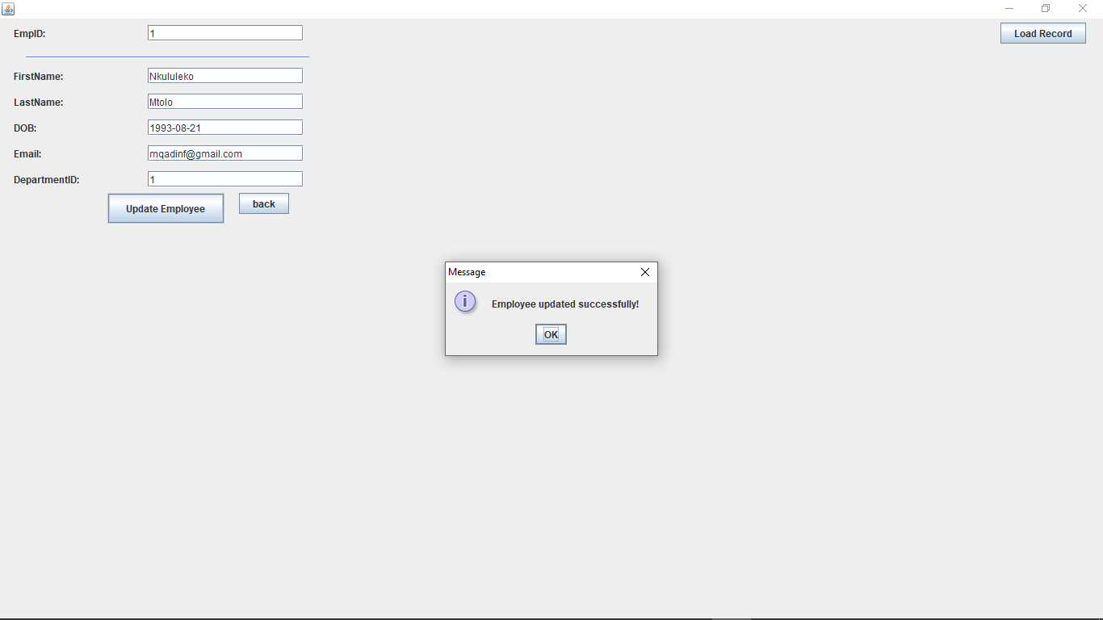

**An employee can be deleted.This is the work of an admin.Here’s the code to delete an Employee.**

**package** com.java.employeesystem;

**import** java.awt.EventQueue;

**import** java.awt.Font;

**import** java.awt.event.ActionEvent;

**import** java.awt.event.ActionListener;

**import** javax.swing.GroupLayout;

**import** javax.swing.GroupLayout.Alignment;

**import** javax.swing.JButton;

**import** javax.swing.JFrame;

**import** javax.swing.JLabel;

**import** javax.swing.JOptionPane;

**import** javax.swing.JPanel;

**import** javax.swing.JTextField;

**import** javax.swing.border.EmptyBorder;

**public** **class** DeleteEmployee **extends** JFrame {

/**

*

*/

**private** **static** **final** **long** ***serialVersionUID*** = 1L;

**static** DeleteEmployee *frame*;

**private** JPanel contentPane;

**private** JTextField textField;

/**

* Launch the application.

*/

**public** **static** **void** main(String[] args) {

EventQueue.*invokeLater*(**new** Runnable() {

**public** **void** run() {

**try** {

*frame* = **new** DeleteEmployee();

*frame*.setVisible(**true**);

} **catch** (Exception e) {

e.printStackTrace();

}

}

});

}

/**

* Create the frame.

*/

**public** DeleteEmployee() {

setDefaultCloseOperation(JFrame.***EXIT_ON_CLOSE***);

setBounds(100, 100, 450, 300);

contentPane = **new** JPanel();

contentPane.setBorder(**new** EmptyBorder(5, 5, 5, 5));

setContentPane(contentPane);

JLabel lblEnterId = **new** JLabel("Enter Id:");

textField = **new** JTextField();

textField.setColumns(10);

JButton btnDelete = **new** JButton("Delete");

btnDelete.addActionListener(**new** ActionListener() {

**public** **void** actionPerformed(ActionEvent e) {

String sid=textField.getText();

**if**(sid==**null**||sid.trim().equals("")){

JOptionPane.*showMessageDialog*(DeleteEmployee.**this**,"Id can't be blank");

}**else**{

**int** id=Integer.*parseInt*(sid);

**int** i=EmployeeDao.*delete*(id);

**if**(i>0){

JOptionPane.*showMessageDialog*(DeleteEmployee.**this**,"Record deleted successfully!");

}**else**{

JOptionPane.*showMessageDialog*(DeleteEmployee.**this**,"Unable to delete given id!");

}

}

}

});

btnDelete.setFont(**new** Font("Tahoma", Font.***PLAIN***, 13));

JButton btnNewButton = **new** JButton("Back");

btnNewButton.addActionListener(**new** ActionListener() {

**public** **void** actionPerformed(ActionEvent e) {

AdminSection.*main*(**new** String[]{});

*frame*.dispose();

}

});

btnNewButton.setFont(**new** Font("Tahoma", Font.***PLAIN***, 13));

GroupLayout gl_contentPane = **new** GroupLayout(contentPane);

gl_contentPane.setHorizontalGroup(

gl_contentPane.createParallelGroup(Alignment.***LEADING***)

.addGroup(gl_contentPane.createSequentialGroup()

.addGap(39)

.addComponent(lblEnterId)

.addGap(57)

.addComponent(textField, GroupLayout.***PREFERRED_SIZE***, 178, GroupLayout.***PREFERRED_SIZE***)

.addContainerGap(107, Short.***MAX_VALUE***))

.addGroup(Alignment.***TRAILING***, gl_contentPane.createSequentialGroup()

.addContainerGap(175, Short.***MAX_VALUE***)

.addComponent(btnDelete, GroupLayout.***PREFERRED_SIZE***, 109, GroupLayout.***PREFERRED_SIZE***)

.addGap(140))

.addGroup(Alignment.***TRAILING***, gl_contentPane.createSequentialGroup()

.addContainerGap(322, Short.***MAX_VALUE***)

.addComponent(btnNewButton, GroupLayout.***PREFERRED_SIZE***, 92, GroupLayout.***PREFERRED_SIZE***)

.addContainerGap())

);

gl_contentPane.setVerticalGroup(

gl_contentPane.createParallelGroup(Alignment.***LEADING***)

.addGroup(gl_contentPane.createSequentialGroup()

.addGap(19)

.addGroup(gl_contentPane.createParallelGroup(Alignment.***LEADING***)

.addComponent(textField, GroupLayout.***PREFERRED_SIZE***, GroupLayout.***DEFAULT_SIZE***, GroupLayout.***PREFERRED_SIZE***)

.addComponent(lblEnterId))

.addGap(33)

.addComponent(btnDelete, GroupLayout.***PREFERRED_SIZE***, 33, GroupLayout.***PREFERRED_SIZE***)

.addGap(43)

.addComponent(btnNewButton)

.addContainerGap(78, Short.***MAX_VALUE***))

);

contentPane.setLayout(gl_contentPane);

}

}

**To delete an employee we are required to enter an Empid of an employee to delete an employee.After we click the Delete button a message will**

**be displayed as a confirmation saying that a record was deleted.**

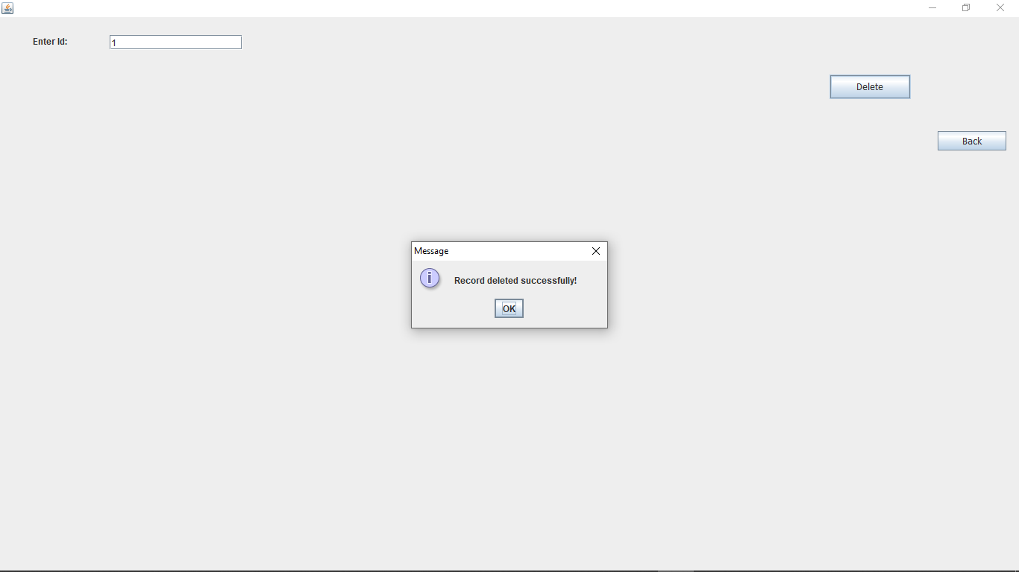

**If we look at the ViewEmployees we can confirm that the Employee record was successfully deleted.**

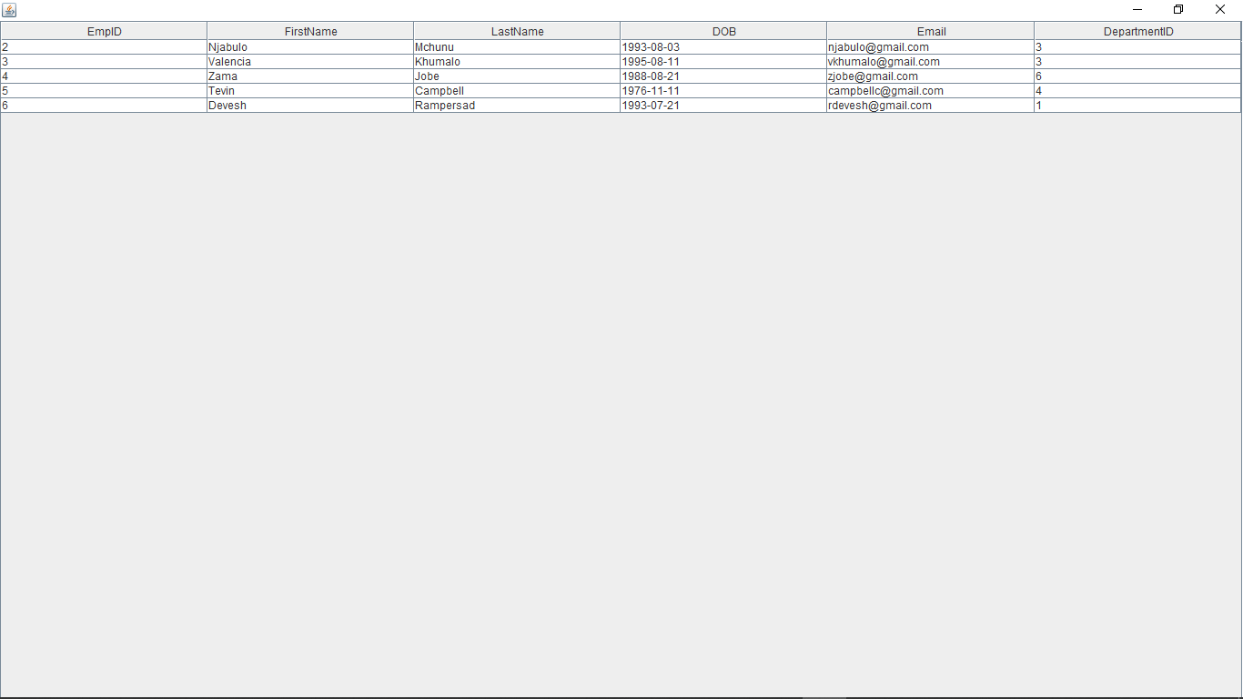

**The Employee functionalities AddNewEmployee,ViewEmployees ,EditEmployee and DeleteEmployee are done.**

**We now come to the Comments functionality where an Employees can send comments on the regulations that they must comply with.**

**So the functionalities are SendComments,ViewComments and EditComments.**

**We will create a class for the first functionality SendComments,so we create a new class SendComments.java.**

**Here’s the code below.**

**package** com.java.employeesystem;

**import** java.awt.Color;

**import** java.awt.EventQueue;

**import** java.awt.Font;

**import** java.awt.event.ActionEvent;

**import** java.awt.event.ActionListener;

**import** java.text.DateFormat;

**import** java.text.ParseException;

**import** java.text.SimpleDateFormat;

**import** java.sql.Date;

**import** javax.swing.GroupLayout;

**import** javax.swing.GroupLayout.Alignment;

**import** javax.swing.JButton;

**import** javax.swing.JFrame;

**import** javax.swing.JLabel;

**import** javax.swing.JOptionPane;

**import** javax.swing.JPanel;

**import** javax.swing.JTextArea;

**import** javax.swing.JTextField;

**import** javax.swing.LayoutStyle.ComponentPlacement;

**import** javax.swing.border.EmptyBorder;

**public** **class** SendComments **extends** JFrame {

/**

*

*/

**private** **static** **final** **long** ***serialVersionUID*** = 1L;

**static** SendComments *frame*;

**private** JPanel contentPane;

**private** JTextField textField;

**private** JTextField textField_1;

**private** JTextField textField_2;

**private** JTextField textField_3;

JTextArea textArea;

/**

* Launch the application.

*/

**public** **static** **void** main(String[] args) {

EventQueue.*invokeLater*(**new** Runnable() {

**public** **void** run() {

**try** {

*frame* = **new** SendComments();

*frame*.setVisible(**true**);

} **catch** (Exception e) {

e.printStackTrace();

}

}

});

}

/**

* Create the frame.

*/

**public** SendComments() {

setDefaultCloseOperation(JFrame.***EXIT_ON_CLOSE***);

setBounds(100, 100, 450, 503);

contentPane = **new** JPanel();

contentPane.setBorder(**new** EmptyBorder(5, 5, 5, 5));

setContentPane(contentPane);

JLabel lblSendComments = **new** JLabel("Enter Your Feedback Here.....");

lblSendComments.setForeground(Color.***DARK_GRAY***);

lblSendComments.setFont(**new** Font("Tahoma", Font.***PLAIN***, 20));

JLabel lblcomplianceid = **new** JLabel("ComplianceID:");

JLabel lblempid = **new** JLabel("EmpID:");

JLabel lblcomments = **new** JLabel("Comments:");

JLabel lblcreateDate = **new** JLabel("CreateDate:");

JLabel lbldepartment_id = **new** JLabel("DepartmentID:");

JButton btnSendComments = **new** JButton("Send Comments");

btnSendComments.addActionListener(**new** ActionListener() {

**public** **void** actionPerformed(ActionEvent e) {

String comments=textArea.getText();

**boolean** performSave=**true**;

String screatedate=textField_2.getText();

DateFormat sdf=**new** SimpleDateFormat("dd/MM/yyyy");

Date createdate =**null**;

**if**(!screatedate.equals(""))

{

screatedate=textField_2.getText();

createdate=Date.*valueOf*(screatedate);

**try** {

createdate=(Date) sdf.parse(screatedate);

} **catch** (ParseException e1) {

// **TODO** Auto-generated catch block

e1.printStackTrace();

}

performSave=**true**;

}

**else**

{

JOptionPane.*showMessageDialog*(**null**,"Please Enter Create Date");

performSave=**false**;

}

String s_complianceid=textField.getText();

**int** compliance_id=0;

**if**( ! s_complianceid.equals(""))

{

s_complianceid=textField.getText();

compliance_id=Integer.*valueOf*(s_complianceid);

performSave=**true**;

}

**else**

{

JOptionPane.*showMessageDialog*(**null**,"Please Enter Compliance ID");

performSave=**false**;

}

String s_empid=textField_1.getText();

**int** emp_id=0;

**if**( ! s_empid.equals(""))

{

s_empid=textField_1.getText();

emp_id=Integer.*valueOf*(s_empid);

performSave=**true**;

}

**else**

{

JOptionPane.*showMessageDialog*(**null**,"Please Enter Emp ID");

performSave=**false**;

}

String s_departmentid=textField_3.getText();

**int** department_id=0;

**if**( ! s_departmentid.equals(""))

{

s_departmentid=textField_3.getText();

department_id=Integer.*valueOf*(s_departmentid);

performSave=**true**;

}

**else**

{

JOptionPane.*showMessageDialog*(**null**,"Please Enter Department ID");

performSave=**false**;

}

**if**(textArea.getText().isEmpty())

{

JOptionPane.*showMessageDialog*(**null**,"Please Enter Comments");

performSave=**false**;

}

**if**(performSave)

{

**int** status=StatusReportDao.*save*(compliance_id, emp_id, comments, createdate, department_id);

**if**(status>0){

JOptionPane.*showMessageDialog*(SendComments.**this**,"Comment sent successfully!");

textField.setText("");textField_1.setText("");textField_2.setText("");

textField_3.setText("");

textArea.setText("");

}**else**{

JOptionPane.*showMessageDialog*(SendComments.**this**,"Sorry, Unable to send comment!");

}

}

}

});

textField = **new** JTextField();

textField.setColumns(10);

textField_1 = **new** JTextField();

textField_1.setColumns(10);

textField_2 = **new** JTextField();

textField_2.setColumns(10);

textField_3 = **new** JTextField();

textField_3.setColumns(10);

textArea = **new** JTextArea();

textArea.setRows(3);

textArea.setColumns(20);

JButton btnBack = **new** JButton("back");

btnBack.addActionListener(**new** ActionListener() {

**public** **void** actionPerformed(ActionEvent e) {

EmployeeSection.*main*(**new** String[]{});

*frame*.dispose();

}

});

GroupLayout gl_contentPane = **new** GroupLayout(contentPane);

gl_contentPane.setHorizontalGroup(

gl_contentPane.createParallelGroup(Alignment.***LEADING***)

.addGroup(gl_contentPane.createSequentialGroup()

.addGroup(gl_contentPane.createParallelGroup(Alignment.***LEADING***)

.addGroup(gl_contentPane.createSequentialGroup()

.addGap(144)

.addComponent(lblSendComments))

.addGroup(gl_contentPane.createSequentialGroup()

.addContainerGap()

.addGroup(gl_contentPane.createParallelGroup(Alignment.***LEADING***)

.addComponent(lblcomplianceid)

.addComponent(lblempid, GroupLayout.***PREFERRED_SIZE***, 133, GroupLayout.***PREFERRED_SIZE***)

.addComponent(lblcomments, GroupLayout.***PREFERRED_SIZE***, 133, GroupLayout.***PREFERRED_SIZE***)

.addComponent(lblcreateDate, GroupLayout.***PREFERRED_SIZE***, 133, GroupLayout.***PREFERRED_SIZE***)

.addComponent(lbldepartment_id, GroupLayout.***PREFERRED_SIZE***, 133, GroupLayout.***PREFERRED_SIZE***))

.addGap(33)

.addGroup(gl_contentPane.createParallelGroup(Alignment.***LEADING***, **false**)

.addComponent(textField, GroupLayout.***DEFAULT_SIZE***, 193, Short.***MAX_VALUE***)

.addComponent(textField_1, GroupLayout.***DEFAULT_SIZE***, 193, Short.***MAX_VALUE***)

.addComponent(textArea, GroupLayout.***DEFAULT_SIZE***, 193, Short.***MAX_VALUE***)

.addComponent(textField_2, GroupLayout.***PREFERRED_SIZE***, GroupLayout.***DEFAULT_SIZE***, GroupLayout.***PREFERRED_SIZE***)

.addComponent(textField_3, GroupLayout.***DEFAULT_SIZE***, 193, Short.***MAX_VALUE***))))

.addContainerGap(124, Short.***MAX_VALUE***))

.addGroup(gl_contentPane.createSequentialGroup()

.addGap(128)

.addComponent(btnSendComments, GroupLayout.***PREFERRED_SIZE***, 145, GroupLayout.***PREFERRED_SIZE***)

.addGap(18)

.addComponent(btnBack)

.addContainerGap(44, Short.***MAX_VALUE***))

.addGroup(gl_contentPane.createSequentialGroup()

.addContainerGap()

.addComponent(lblcreateDate, GroupLayout.***PREFERRED_SIZE***, 50, GroupLayout.***PREFERRED_SIZE***)

.addContainerGap(364, Short.***MAX_VALUE***))

);

gl_contentPane.setVerticalGroup(

gl_contentPane.createParallelGroup(Alignment.***LEADING***)

.addGroup(gl_contentPane.createSequentialGroup()

.addComponent(lblSendComments)

.addGap(18)

.addGroup(gl_contentPane.createParallelGroup(Alignment.***BASELINE***)

.addComponent(lblcomplianceid)

.addComponent(textField, GroupLayout.***PREFERRED_SIZE***, GroupLayout.***DEFAULT_SIZE***, GroupLayout.***PREFERRED_SIZE***))

.addPreferredGap(ComponentPlacement.***UNRELATED***)

.addGroup(gl_contentPane.createParallelGroup(Alignment.***BASELINE***)

.addComponent(lblempid)

.addComponent(textField_1, GroupLayout.***PREFERRED_SIZE***, GroupLayout.***DEFAULT_SIZE***, GroupLayout.***PREFERRED_SIZE***))

.addPreferredGap(ComponentPlacement.***UNRELATED***)

.addGroup(gl_contentPane.createParallelGroup(Alignment.***BASELINE***)

.addComponent(lblcomments)

.addComponent(textArea, GroupLayout.***PREFERRED_SIZE***, 49, GroupLayout.***PREFERRED_SIZE***))

.addPreferredGap(ComponentPlacement.***UNRELATED***)

.addGroup(gl_contentPane.createParallelGroup(Alignment.***BASELINE***)

.addComponent(lblcreateDate)

.addComponent(textField_2, GroupLayout.***PREFERRED_SIZE***, GroupLayout.***DEFAULT_SIZE***, GroupLayout.***PREFERRED_SIZE***))

.addPreferredGap(ComponentPlacement.***UNRELATED***)

.addGroup(gl_contentPane.createParallelGroup(Alignment.***BASELINE***)

.addComponent(lbldepartment_id)

.addComponent(textField_3, GroupLayout.***PREFERRED_SIZE***, GroupLayout.***DEFAULT_SIZE***, GroupLayout.***PREFERRED_SIZE***))

.addGap(7)

.addGroup(gl_contentPane.createParallelGroup(Alignment.***LEADING***)

.addComponent(btnSendComments, GroupLayout.***PREFERRED_SIZE***, 38, GroupLayout.***PREFERRED_SIZE***)

.addComponent(btnBack))

.addContainerGap())

);

contentPane.setLayout(gl_contentPane);

}

}

**After we run the code we can see how the user-interface looks like.In Comments it is a TextArea because there is a lot we can write.**

**After the required information are entered in the textFields a message will be displayed as a confirmation that the Comment was sent.**

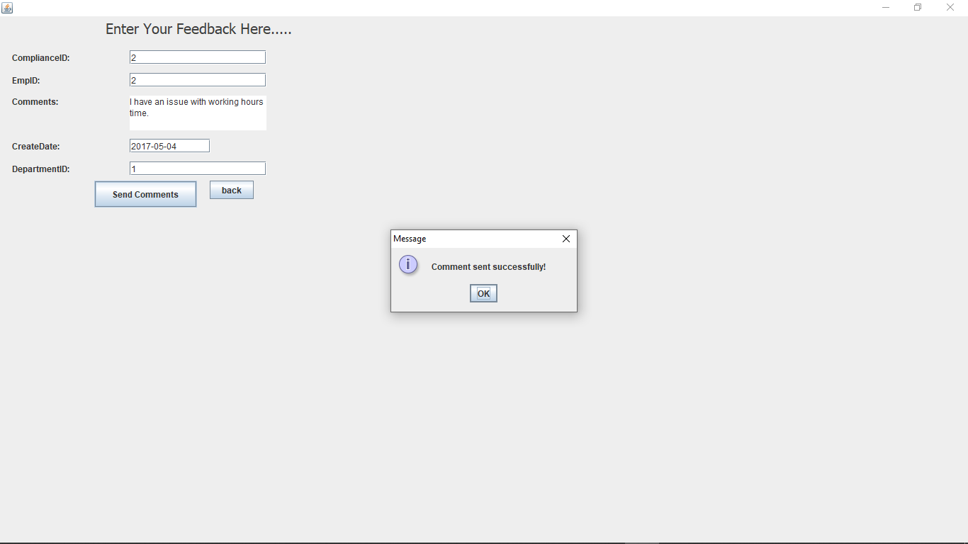

**The application can also validate if the textFields are empty,or when the employee entered nothing in the textFields.**

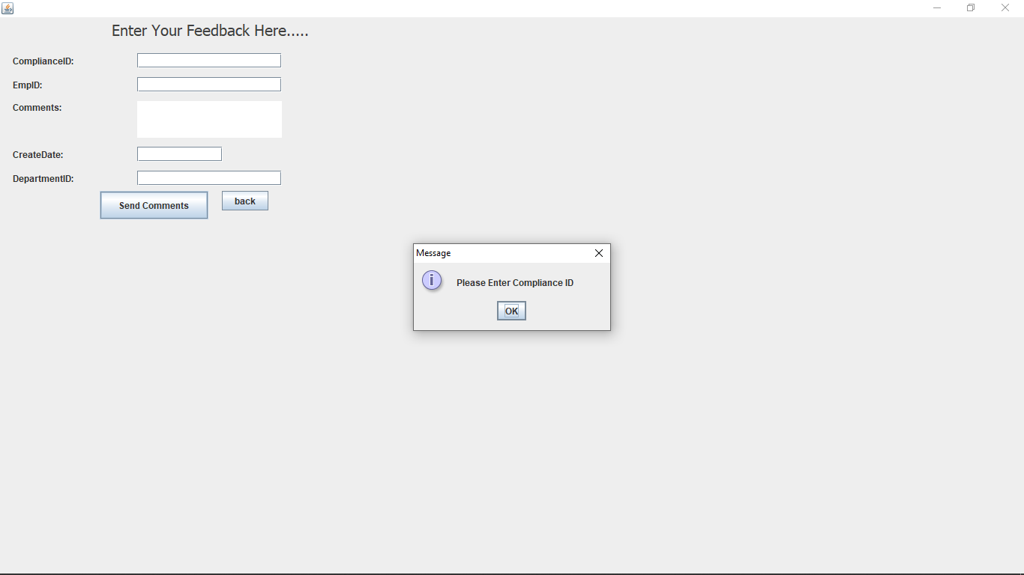

**The Comments entered can also be viewed.Here’s the code below.**

**package** com.java.employeesystem;

**import** java.awt.BorderLayout;

**import** java.awt.EventQueue;

**import** java.util.List;

**import** javax.swing.JFrame;

**import** javax.swing.JPanel;

**import** javax.swing.JScrollPane;

**import** javax.swing.JTable;

**import** javax.swing.border.EmptyBorder;

**public** **class** ViewComments **extends** JFrame {

**static** ViewComments *frame*;

**public** ViewComments() {

//Code to view data in JTable

List<Statusreport> list=StatusReportDao.*view*();

**int** size=list.size();

String data[][]=**new** String[size][6];

**int** row=0;

**for**(Statusreport s:list){

data[row][0]=String.*valueOf*(s.getStatusrptid());

data[row][1]=String.*valueOf*(s.getComplianceid());

data[row][2]=String.*valueOf*(s.getEmpid());

data[row][3]=s.getComments();

data[row][4]=String.*valueOf*(s.getCreateDate());

data[row][5]=String.*valueOf*(s.getDepartment_id());

row++;

}

String columnNames[]={"StatusRPTID","ComplianceID","EMPID","Comments","CreateDate","DepartmentID"};

JTable jt=**new** JTable(data,columnNames);

JScrollPane sp=**new** JScrollPane(jt);

add(sp);

setDefaultCloseOperation(JFrame.***DISPOSE_ON_CLOSE***);

setBounds(100, 100, 800, 400);

}

**public** **static** **void** main(String[] args) {

EventQueue.*invokeLater*(**new** Runnable() {

**public** **void** run() {

**try** {

*frame* = **new** ViewComments();

*frame*.setVisible(**true**);

} **catch** (Exception e) {

e.printStackTrace();

}

}

});

}

}

**After we run the code this is how the user-interface ViewComments looks like.The employees have sent their comments based on the ComplianceID and on their DepartmentID.**

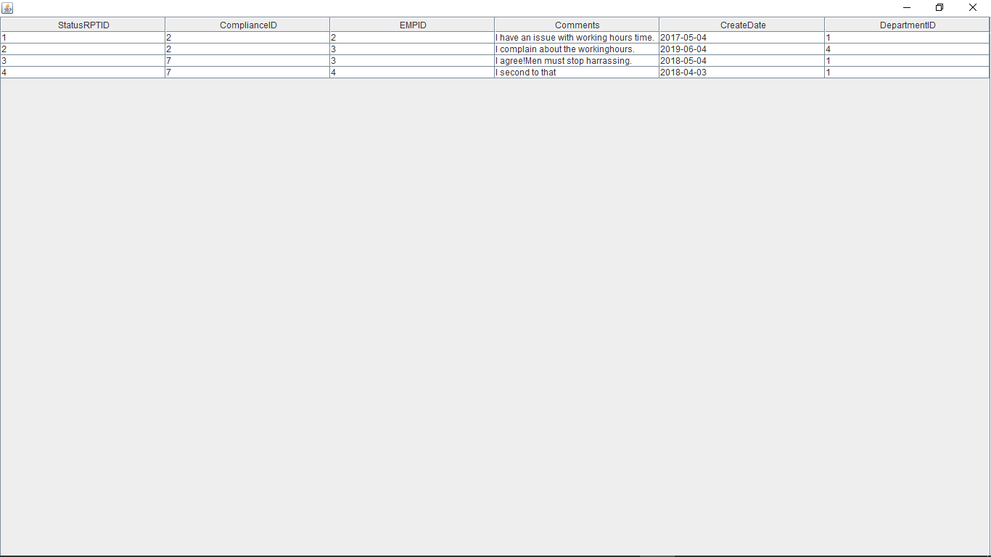

**The Employee can also edit the Comments.Here’s the code below.**

**package** com.java.employeesystem;

**import** java.awt.BorderLayout;

**import** java.awt.EventQueue;

**import** javax.swing.JFrame;

**import** javax.swing.JPanel;

**import** javax.swing.border.EmptyBorder;

**import** javax.swing.GroupLayout;

**import** javax.swing.GroupLayout.Alignment;

**import** javax.swing.JLabel;

**import** javax.swing.JOptionPane;

**import** java.awt.Font;

**import** java.awt.Color;

**import** javax.swing.LayoutStyle.ComponentPlacement;

**import** javax.swing.JButton;

**import** javax.swing.JTextField;

**import** javax.swing.JTextPane;

**import** java.awt.event.ActionListener;

**import** java.text.ParseException;

**import** java.text.SimpleDateFormat;

**import** java.sql.Date;

**import** java.awt.event.ActionEvent;

**import** javax.swing.JTextArea;

**import** javax.swing.JSeparator;

**public** **class** EditComments **extends** JFrame {

**static** EditComments *frame*;

**private** JPanel contentPane;

**private** JTextField textField;

**private** JTextField textField_1;

**private** JTextField textField_2;

**private** JTextField textField_3;

**private** JTextField textField_4;

**private** JTextField textField_5;

/**

* Launch the application.

*/

**public** **static** **void** main (String[] args) {

EventQueue.*invokeLater*(**new** Runnable() {

**public** **void** run() {

**try** {

*frame* = **new** EditComments();

*frame*.setVisible(**true**);

} **catch** (Exception e) {

e.printStackTrace();

}

}

});

}

/**

* Create the frame.

*/

**public** EditComments() {

setDefaultCloseOperation(JFrame.***EXIT_ON_CLOSE***);

setBounds(100, 100, 450, 550);

contentPane = **new** JPanel();

contentPane.setBorder(**new** EmptyBorder(5, 5, 5, 5));

setContentPane(contentPane);

JLabel lblcomplianceid = **new** JLabel("ComplianceID:");

JLabel lblempid = **new** JLabel("EmpID:");

JLabel lblcomments = **new** JLabel("Comments:");

JLabel lblcreateDate = **new** JLabel("CreateDate:");

JLabel lbldepartment_id = **new** JLabel("DepartmentID:");

JButton btnEditComments = **new** JButton("Update Comments");

btnEditComments.addActionListener(**new** ActionListener() {

**public** **void** actionPerformed(ActionEvent e) {

**int** complianceid=Integer.*parseInt*(textField.getText());

**int** empid=Integer.*parseInt*(textField_1.getText());

String comments=textField_2.getText();

String screateDate=textField_3.getText();

String format="dd/MM/yyyy";

SimpleDateFormat sdf= **new** SimpleDateFormat(format);

Date createdate = Date.*valueOf*(screateDate);

**try** {

createdate = (Date) sdf.parse(screateDate);

} **catch** (ParseException e1) {

// **TODO** Auto-generated catch block

e1.printStackTrace();

}

**int** department_id=Integer.*parseInt*(textField_4.getText());

**int** statusrptid=Integer.*parseInt*(textField_5.getText());

Statusreport s=**new** Statusreport(complianceid,statusrptid,empid,department_id,comments,createdate);

**int** status=StatusReportDao.*update*(s);

**if**(status>0){

JOptionPane.*showMessageDialog*(EditComments.**this**,"Comments updated successfully!");

EmployeeSection.*main*(**new** String[]{});

*frame*.dispose();

}**else**{

JOptionPane.*showMessageDialog*(EditComments.**this**,"Sorry, Unable to edit Comments!");

}

}

});

textField = **new** JTextField();

textField.setColumns(10);

textField_1 = **new** JTextField();

textField_1.setColumns(10);

textField_2 = **new** JTextField();

textField_2.setColumns(10);

textField_3 = **new** JTextField();

textField_3.setColumns(10);

textField_4 = **new** JTextField();

textField_4.setColumns(10);

JButton btnBack = **new** JButton("back");

btnBack.addActionListener(**new** ActionListener() {

**public** **void** actionPerformed(ActionEvent e) {

EmployeeSection.*main*(**new** String[]{});

*frame*.dispose();

}

});

JLabel lblstatusrptid = **new** JLabel("StatusRPTID:");

textField_5 = **new** JTextField();

textField_5.setColumns(10);

JSeparator separator = **new** JSeparator();

JButton btnLoadRecord = **new** JButton("Load Record");

btnLoadRecord.addActionListener(**new** ActionListener() {

**public** **void** actionPerformed(ActionEvent arg0) {

String sstatusrptid=textField_5.getText();

**if**(sstatusrptid==**null**||sstatusrptid.trim().equals("")){

JOptionPane.*showMessageDialog*(EditComments.**this**,"Please enter StatusRPTID first!");

}**else**{

**int** statusrptid=Integer.*parseInt*(sstatusrptid);

Statusreport s=StatusReportDao.*getStatusreportByid*(statusrptid);

textField.setText(String.*valueOf*(s.getComplianceid()));

textField_1.setText(String.*valueOf*(s.getEmpid()));

textField_2.setText(s.getComments());

textField_3.setText(String.*valueOf*(s.getCreateDate()));

textField_4.setText(String.*valueOf*(s.getDepartment_id()));

}

}

});

GroupLayout gl_contentPane = **new** GroupLayout(contentPane);

gl_contentPane.setHorizontalGroup(

gl_contentPane.createParallelGroup(Alignment.***LEADING***)

.addGroup(gl_contentPane.createSequentialGroup()

.addContainerGap()

.addGroup(gl_contentPane.createParallelGroup(Alignment.***LEADING***)

.addComponent(lblcomplianceid)

.addComponent(lblempid , GroupLayout.***PREFERRED_SIZE***, 133, GroupLayout.***PREFERRED_SIZE***)

.addComponent(lblcomments, GroupLayout.***PREFERRED_SIZE***, 133, GroupLayout.***PREFERRED_SIZE***)

.addComponent(lblcreateDate, GroupLayout.***PREFERRED_SIZE***, 133, GroupLayout.***PREFERRED_SIZE***)

.addComponent(lbldepartment_id, GroupLayout.***PREFERRED_SIZE***, 133, GroupLayout.***PREFERRED_SIZE***)

.addGroup(gl_contentPane.createParallelGroup(Alignment.***TRAILING***, **false**)

.addComponent(lblstatusrptid, Alignment.***LEADING***, GroupLayout.***DEFAULT_SIZE***, GroupLayout.***DEFAULT_SIZE***, Short.***MAX_VALUE***)))

.addGap(33)

.addGroup(gl_contentPane.createParallelGroup(Alignment.***LEADING***)

.addGroup(gl_contentPane.createParallelGroup(Alignment.***LEADING***, **false**)

.addComponent(textField_3, GroupLayout.***DEFAULT_SIZE***, 193, Short.***MAX_VALUE***)

.addComponent(textField_2, GroupLayout.***DEFAULT_SIZE***, 193, Short.***MAX_VALUE***)

.addComponent(textField_1, GroupLayout.***DEFAULT_SIZE***, 193, Short.***MAX_VALUE***)

.addComponent(textField, GroupLayout.***DEFAULT_SIZE***, 193, Short.***MAX_VALUE***)

.addComponent(textField_4, GroupLayout.***DEFAULT_SIZE***, 193, Short.***MAX_VALUE***))

.addGroup(gl_contentPane.createSequentialGroup()

.addComponent(textField_5, GroupLayout.***PREFERRED_SIZE***, 193, GroupLayout.***PREFERRED_SIZE***)

.addPreferredGap(ComponentPlacement.***RELATED***, 25, Short.***MAX_VALUE***)

.addComponent(btnLoadRecord)))

.addGap(16)

.addContainerGap())

.addGroup(gl_contentPane.createSequentialGroup()

.addContainerGap()

.addComponent(lbldepartment_id)

.addContainerGap(356, Short.***MAX_VALUE***))

.addGroup(gl_contentPane.createSequentialGroup()

.addContainerGap()

.addComponent(lblcreateDate, GroupLayout.***DEFAULT_SIZE***, 64, Short.***MAX_VALUE***)

.addGap(350))

.addGroup(gl_contentPane.createSequentialGroup()

.addContainerGap()

.addComponent(lblcomments, GroupLayout.***DEFAULT_SIZE***, 64, Short.***MAX_VALUE***)

.addContainerGap(383, Short.***MAX_VALUE***))

.addGroup(gl_contentPane.createSequentialGroup()

.addGap(128)

.addComponent(btnEditComments, GroupLayout.***PREFERRED_SIZE***, 145, GroupLayout.***PREFERRED_SIZE***)

.addGap(18)

.addComponent(btnBack)

.addContainerGap(78, Short.***MAX_VALUE***))

.addGroup(gl_contentPane.createSequentialGroup()

.addContainerGap()

.addComponent(lblempid, GroupLayout.***PREFERRED_SIZE***, 50, GroupLayout.***PREFERRED_SIZE***)

.addContainerGap(364, Short.***MAX_VALUE***))

.addGroup(gl_contentPane.createSequentialGroup()

.addGap(27)

.addComponent(separator, GroupLayout.***PREFERRED_SIZE***, 351, GroupLayout.***PREFERRED_SIZE***)

.addContainerGap(46, Short.***MAX_VALUE***))

);

gl_contentPane.setVerticalGroup(

gl_contentPane.createParallelGroup(Alignment.***LEADING***)

.addGroup(gl_contentPane.createSequentialGroup()

.addGroup(gl_contentPane.createParallelGroup(Alignment.***BASELINE***)

.addComponent(lblstatusrptid)

.addComponent(textField_5, GroupLayout.***PREFERRED_SIZE***, GroupLayout.***DEFAULT_SIZE***, GroupLayout.***PREFERRED_SIZE***)

.addComponent(btnLoadRecord))

.addGap(16)

.addComponent(separator, GroupLayout.***PREFERRED_SIZE***, GroupLayout.***DEFAULT_SIZE***, GroupLayout.***PREFERRED_SIZE***)

.addPreferredGap(ComponentPlacement.***UNRELATED***)

.addGroup(gl_contentPane.createParallelGroup(Alignment.***BASELINE***)

.addComponent(lblcomplianceid)

.addComponent(textField, GroupLayout.***PREFERRED_SIZE***, GroupLayout.***DEFAULT_SIZE***, GroupLayout.***PREFERRED_SIZE***))

.addPreferredGap(ComponentPlacement.***UNRELATED***)

.addGroup(gl_contentPane.createParallelGroup(Alignment.***BASELINE***)

.addComponent(lblempid)

.addComponent(textField_1, GroupLayout.***PREFERRED_SIZE***, GroupLayout.***DEFAULT_SIZE***, GroupLayout.***PREFERRED_SIZE***))

.addPreferredGap(ComponentPlacement.***UNRELATED***)

.addGroup(gl_contentPane.createParallelGroup(Alignment.***BASELINE***)

.addComponent(lblcomments)

.addComponent(textField_2, GroupLayout.***PREFERRED_SIZE***, GroupLayout.***DEFAULT_SIZE***, GroupLayout.***PREFERRED_SIZE***))

.addPreferredGap(ComponentPlacement.***UNRELATED***)

.addGroup(gl_contentPane.createParallelGroup(Alignment.***BASELINE***)

.addComponent(lblcreateDate)

.addComponent(textField_3, GroupLayout.***PREFERRED_SIZE***, GroupLayout.***DEFAULT_SIZE***, GroupLayout.***PREFERRED_SIZE***))

.addPreferredGap(ComponentPlacement.***UNRELATED***)

.addGroup(gl_contentPane.createParallelGroup(Alignment.***BASELINE***)

.addComponent(lbldepartment_id)

.addComponent(textField_4, GroupLayout.***PREFERRED_SIZE***, GroupLayout.***DEFAULT_SIZE***, GroupLayout.***PREFERRED_SIZE***))

.addGap(7)

.addGroup(gl_contentPane.createParallelGroup(Alignment.***LEADING***)

.addComponent(btnEditComments, GroupLayout.***PREFERRED_SIZE***, 38, GroupLayout.***PREFERRED_SIZE***)

.addComponent(btnBack))

.addContainerGap())

);

contentPane.setLayout(gl_contentPane);

}

}

**The Employee can also edit the Comments.But first the StatusRPTID must be entered and after clicking the Load Record button the record will load**

**And then the employee can do an update.**

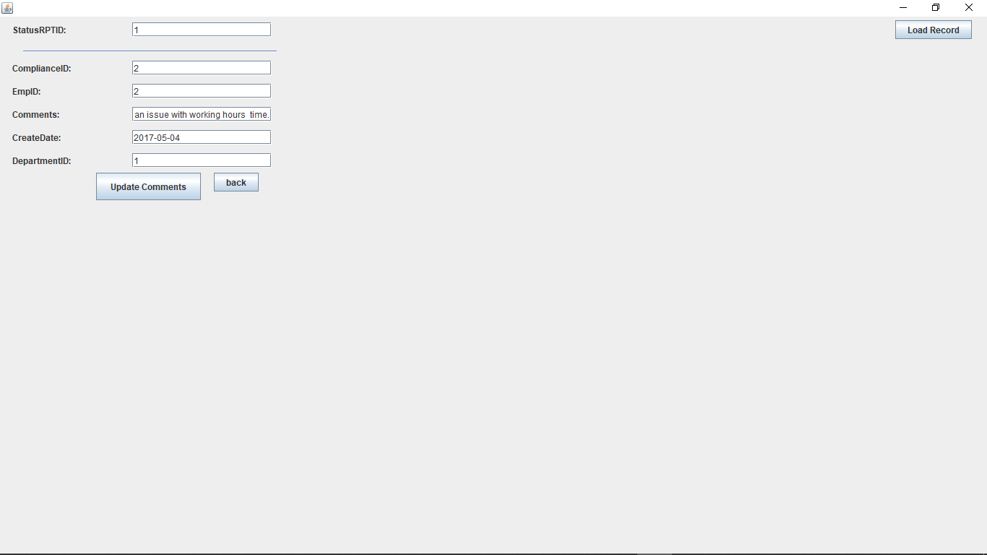

**After updating the Comments the message will be displayed as a confirmation that the Comments were updated successfully.**

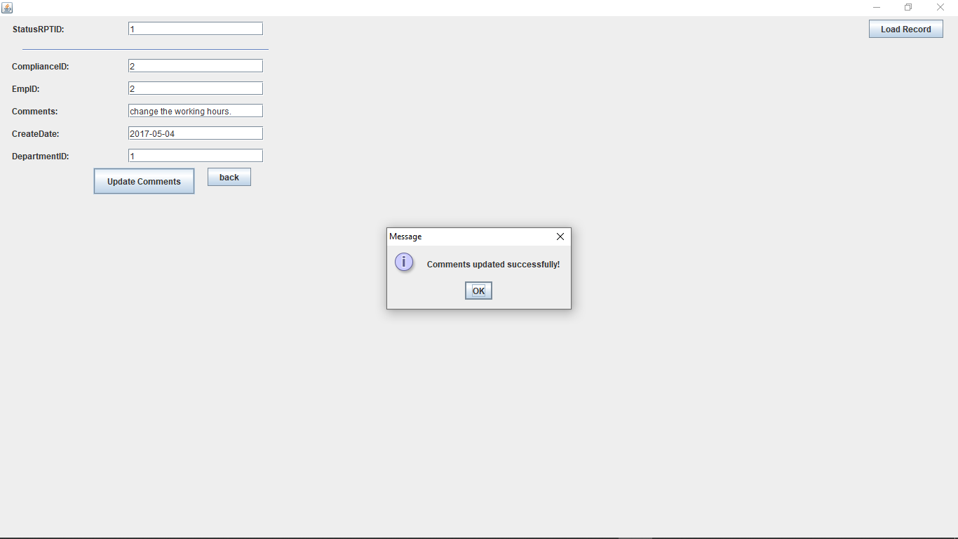

**We have done all the functionalities for Regulation,Department,Employee ,StatusReports**

**Regulation:**

**AddNewRegulation**

**ViewRegulations**

**EditRegulation**

**Department:**

**AddNewDepartment**

**EditDepartment**

**ViewDepartments**

**Employee:**

**AddNewEmployee**

**ViewEmployees**

**EditEmployee**

**DeleteEmployee**

**StatusReport:**

**SendComments**

**ViewComments**

**EditComments**

**All these functionalities must be done by someone.An administrator or a user(employee) can be in charge of**

**performing these tasks.**

**We will start by creating an AdminLogin page where an admin can perform all the required functions.So we will create a new**

**class called AdminLogin.java.Here’s the code below:**

**package** com.java.employeesystem;

**import** java.awt.BorderLayout;

**import** java.awt.EventQueue;

**import** javax.swing.JFrame;

**import** javax.swing.JPanel;

**import** javax.swing.border.EmptyBorder;

**import** javax.swing.GroupLayout;

**import** javax.swing.GroupLayout.Alignment;

**import** javax.swing.JLabel;

**import** javax.swing.JOptionPane;

**import** java.awt.Font;

**import** java.awt.Color;

**import** javax.swing.JTextField;

**import** javax.swing.JPasswordField;

**import** javax.swing.JButton;

**import** javax.swing.LayoutStyle.ComponentPlacement;

**import** java.awt.event.ActionListener;

**import** java.awt.event.ActionEvent;

**public** **class** AdminLogin **extends** JFrame {

**static** AdminLogin *frame*;

**private** JPanel contentPane;

**private** JTextField textField;

**private** JPasswordField passwordField;

/**

* Launch the application.

*/

**public** **static** **void** main(String[] args) {

EventQueue.*invokeLater*(**new** Runnable() {

**public** **void** run() {

**try** {

*frame* = **new** AdminLogin();

*frame*.setVisible(**true**);

} **catch** (Exception e) {

e.printStackTrace();

}

}

});

}

/**

* Create the frame.

*/

**public** AdminLogin() {

setDefaultCloseOperation(JFrame.***EXIT_ON_CLOSE***);

setBounds(100, 100, 450, 300);

contentPane = **new** JPanel();

contentPane.setBorder(**new** EmptyBorder(5, 5, 5, 5));

setContentPane(contentPane);

JLabel lblAdminLogin = **new** JLabel("Admin Login");

lblAdminLogin.setForeground(Color.***DARK_GRAY***);

lblAdminLogin.setFont(**new** Font("Tahoma", Font.***PLAIN***, 20));

JLabel lblName = **new** JLabel("Name:");

JLabel lblPassword = **new** JLabel("Password:");

textField = **new** JTextField();

textField.setColumns(10);

passwordField = **new** JPasswordField();

JButton btnLogin = **new** JButton("login");

btnLogin.addActionListener(**new** ActionListener() {

**public** **void** actionPerformed(ActionEvent e) {

String name=textField.getText();

**char** ch[]=passwordField.getPassword();

String password=String.*valueOf*(ch);

**if**(name.equals("admin")&&password.equals("Nkululeko93")){

String s[]={};

AdminSection.*main*(s);

*frame*.dispose();

}**else**{

JOptionPane.*showMessageDialog*(AdminLogin.**this**,"Sorry, username or password error!");

textField.setText("");passwordField.setText("");

}

}

});

GroupLayout gl_contentPane = **new** GroupLayout(contentPane);

gl_contentPane.setHorizontalGroup(

gl_contentPane.createParallelGroup(Alignment.***LEADING***)

.addGroup(gl_contentPane.createSequentialGroup()

.addGroup(gl_contentPane.createParallelGroup(Alignment.***LEADING***)

.addGroup(gl_contentPane.createSequentialGroup()

.addGap(180)

.addComponent(lblAdminLogin))

.addGroup(gl_contentPane.createSequentialGroup()

.addGap(25)

.addGroup(gl_contentPane.createParallelGroup(Alignment.***LEADING***)

.addComponent(lblName)

.addComponent(lblPassword))

.addGap(58)

.addGroup(gl_contentPane.createParallelGroup(Alignment.***TRAILING***, **false**)

.addComponent(passwordField)

.addComponent(textField, GroupLayout.***DEFAULT_SIZE***, 180, Short.***MAX_VALUE***)))

.addGroup(gl_contentPane.createSequentialGroup()

.addGap(177)

.addComponent(btnLogin, GroupLayout.***PREFERRED_SIZE***, 86, GroupLayout.***PREFERRED_SIZE***)))

.addContainerGap(111, Short.***MAX_VALUE***))

);

gl_contentPane.setVerticalGroup(

gl_contentPane.createParallelGroup(Alignment.***LEADING***)

.addGroup(gl_contentPane.createSequentialGroup()

.addComponent(lblAdminLogin)

.addGap(29)

.addGroup(gl_contentPane.createParallelGroup(Alignment.***BASELINE***)

.addComponent(lblName)

.addComponent(textField, GroupLayout.***PREFERRED_SIZE***, GroupLayout.***DEFAULT_SIZE***, GroupLayout.***PREFERRED_SIZE***))

.addGap(27)

.addGroup(gl_contentPane.createParallelGroup(Alignment.***BASELINE***)

.addComponent(passwordField, GroupLayout.***PREFERRED_SIZE***, GroupLayout.***DEFAULT_SIZE***, GroupLayout.***PREFERRED_SIZE***)

.addComponent(lblPassword))

.addGap(36)

.addComponent(btnLogin, GroupLayout.***PREFERRED_SIZE***, 33, GroupLayout.***PREFERRED_SIZE***)

.addContainerGap(51, Short.***MAX_VALUE***))

);

contentPane.setLayout(gl_contentPane);

}

}

**We’ve created the AdminLogin page for an admin to be able to login.But after an admin has logged in,it must redirect him somewhere.So we must**

**create an admin section page which has all the functionalities the admin must perform.So we must create a class called AdminSection.java.**

**Here’s the code below.**

**package** com.java.employeesystem;

**import** java.awt.Color;

**import** java.awt.EventQueue;

**import** java.awt.Font;

**import** java.awt.event.ActionEvent;

**import** java.awt.event.ActionListener;

**import** javax.swing.GroupLayout;

**import** javax.swing.GroupLayout.Alignment;

**import** javax.swing.JButton;

**import** javax.swing.JFrame;

**import** javax.swing.JLabel;

**import** javax.swing.JPanel;

**import** javax.swing.JScrollPane;

**import** javax.swing.border.EmptyBorder;

**public** **class** AdminSection **extends** JFrame {

/**

*

*/

**private** **static** **final** **long** ***serialVersionUID*** = 1L;

**static** AdminSection *frame*;

**private** JPanel contentPane;

JScrollPane sp;

/**

* Launch the application.

*/

**public** **static** **void** main(String[] args) {

EventQueue.*invokeLater*(**new** Runnable() {

**public** **void** run() {

**try** {

*frame* = **new** AdminSection();

*frame*.setVisible(**true**);

} **catch** (Exception e) {

e.printStackTrace();

}

}

});

}

/**

* Create the frame.

*/

**public** AdminSection() {

setDefaultCloseOperation(JFrame.***EXIT_ON_CLOSE***);

setBounds(100, 100, 450, 300);

contentPane = **new** JPanel();

contentPane.setBorder(**new** EmptyBorder(5, 5, 5, 5));

setContentPane(contentPane);

JLabel lblAdminSection = **new** JLabel("Admin Section");

lblAdminSection.setForeground(Color.***DARK_GRAY***);

lblAdminSection.setFont(**new** Font("Tahoma", Font.***PLAIN***, 20));

JButton btnAddRegulation = **new** JButton("Add Regulations");

btnAddRegulation.addActionListener(**new** ActionListener() {

**public** **void** actionPerformed(ActionEvent e) {

AddNewRegulation.*main*(**new** String[]{});

*frame*.dispose();

}

});

JButton btnViewRegulation = **new** JButton("View Regulations");

btnViewRegulation.addActionListener(**new** ActionListener() {

**public** **void** actionPerformed(ActionEvent e) {

ViewRegulations.*main*(**new** String[]{});

}

});

JButton btnEditRegulation = **new** JButton("Update Regulations");

btnEditRegulation.addActionListener(**new** ActionListener() {

**public** **void** actionPerformed(ActionEvent e) {

EditRegulation.*main*(**new** String[]{});

}

});

JButton btnAddDepartment = **new** JButton("Add Departments");

btnAddDepartment.addActionListener(**new** ActionListener() {

**public** **void** actionPerformed(ActionEvent e) {

AddNewDepartment.*main*(**new** String[]{});

}

});

JButton btnViewDepartment = **new** JButton("View Departments");

btnViewDepartment.addActionListener(**new** ActionListener() {

**public** **void** actionPerformed(ActionEvent e) {

ViewDepartments.*main*(**new** String[]{});

}

});

JButton btnEditDepartment = **new** JButton("Update Departments");

btnEditDepartment.addActionListener(**new** ActionListener() {

**public** **void** actionPerformed(ActionEvent e) {

EditDepartment.*main*(**new** String[]{});

}

});

JButton btnAddEmployee = **new** JButton("Add Employees");

btnAddEmployee.addActionListener(**new** ActionListener() {

**public** **void** actionPerformed(ActionEvent e) {

AddNewEmployee.*main*(**new** String[]{});

}

});

JButton btnViewEmployee = **new** JButton("View Employees");

btnViewEmployee.addActionListener(**new** ActionListener() {

**public** **void** actionPerformed(ActionEvent e) {

ViewEmployees.*main*(**new** String[]{});

}

});

JButton btnEditEmployee = **new** JButton("Edit Employees");

btnEditEmployee.addActionListener(**new** ActionListener() {

**public** **void** actionPerformed(ActionEvent e) {

EditEmployee.*main*(**new** String[]{});

}

});

JButton btnDeleteEmployee = **new** JButton("Delete Employee");

btnDeleteEmployee.addActionListener(**new** ActionListener() {

**public** **void** actionPerformed(ActionEvent e) {

DeleteEmployee.*main*(**new** String[]{});

}

});

JButton btnViewComments = **new** JButton("View Comments");

btnViewComments.addActionListener(**new** ActionListener() {

**public** **void** actionPerformed(ActionEvent e) {

ViewComments.*main*(**new** String[]{});

}

});

JButton btnLogout = **new** JButton("Logout");

btnLogout.addActionListener(**new** ActionListener() {

**public** **void** actionPerformed(ActionEvent e) {

AdminLogin.*main*(**new** String[]{});

*frame*.dispose();

}

});

GroupLayout gl_contentPane = **new** GroupLayout(contentPane);

gl_contentPane.setHorizontalGroup(

gl_contentPane.createParallelGroup(Alignment.***LEADING***)

.addGroup(gl_contentPane.createSequentialGroup()

.addGroup(gl_contentPane.createParallelGroup(Alignment.***LEADING***)

.addGroup(gl_contentPane.createSequentialGroup()

.addGap(161)

.addComponent(lblAdminSection))

.addGroup(gl_contentPane.createSequentialGroup()

.addGap(149)

.addGroup(gl_contentPane.createParallelGroup(Alignment.***LEADING***)

.addComponent(btnAddRegulation, GroupLayout.***PREFERRED_SIZE***, 155, GroupLayout.***PREFERRED_SIZE***)

.addComponent(btnViewRegulation, GroupLayout.***PREFERRED_SIZE***, 155, GroupLayout.***PREFERRED_SIZE***)

.addComponent(btnEditRegulation, GroupLayout.***PREFERRED_SIZE***, 155, GroupLayout.***PREFERRED_SIZE***)

.addComponent(btnAddDepartment, GroupLayout.***PREFERRED_SIZE***, 155, GroupLayout.***PREFERRED_SIZE***)

.addComponent(btnViewDepartment, GroupLayout.***PREFERRED_SIZE***, 155, GroupLayout.***PREFERRED_SIZE***)

.addComponent(btnEditDepartment, GroupLayout.***PREFERRED_SIZE***, 155, GroupLayout.***PREFERRED_SIZE***)

.addComponent(btnAddEmployee, GroupLayout.***PREFERRED_SIZE***, 155,GroupLayout.***PREFERRED_SIZE***)

.addComponent(btnViewEmployee, GroupLayout.***PREFERRED_SIZE***, 155, GroupLayout.***PREFERRED_SIZE***)

.addComponent(btnEditEmployee, GroupLayout.***PREFERRED_SIZE***, 155, GroupLayout.***PREFERRED_SIZE***)

.addComponent(btnDeleteEmployee, GroupLayout.***PREFERRED_SIZE***, 155, GroupLayout.***PREFERRED_SIZE***)

.addComponent(btnViewComments, GroupLayout.***PREFERRED_SIZE***, 155, GroupLayout.***PREFERRED_SIZE***)

.addComponent(btnLogout, GroupLayout.***PREFERRED_SIZE***, 155, GroupLayout.***PREFERRED_SIZE***))))

.addContainerGap(144, Short.***MAX_VALUE***))

);

gl_contentPane.setVerticalGroup(

gl_contentPane.createParallelGroup(Alignment.***LEADING***)

.addGroup(gl_contentPane.createSequentialGroup()

.addComponent(lblAdminSection)

.addGap(29)

.addComponent(btnAddRegulation, GroupLayout.***PREFERRED_SIZE***, 34, GroupLayout.***PREFERRED_SIZE***)

.addGap(18)

.addComponent(btnViewRegulation, GroupLayout.***PREFERRED_SIZE***, 34, GroupLayout.***PREFERRED_SIZE***)

.addGap(18)

.addComponent(btnEditRegulation, GroupLayout.***PREFERRED_SIZE***, 34, GroupLayout.***PREFERRED_SIZE***)

.addGap(18)

.addComponent(btnAddDepartment, GroupLayout.***PREFERRED_SIZE***, 34, GroupLayout.***PREFERRED_SIZE***)

.addGap(18)

.addComponent(btnViewDepartment, GroupLayout.***PREFERRED_SIZE***, 34, GroupLayout.***PREFERRED_SIZE***)

.addGap(18)

.addComponent(btnEditDepartment, GroupLayout.***PREFERRED_SIZE***, 34, GroupLayout.***PREFERRED_SIZE***)

.addGap(18)

.addComponent(btnAddEmployee, GroupLayout.***PREFERRED_SIZE***, 34, GroupLayout.***PREFERRED_SIZE***)

.addGap(18)

.addComponent(btnViewEmployee, GroupLayout.***PREFERRED_SIZE***, 34, GroupLayout.***PREFERRED_SIZE***)

.addGap(18)

.addComponent(btnEditEmployee, GroupLayout.***PREFERRED_SIZE***, 34, GroupLayout.***PREFERRED_SIZE***)

.addGap(18)

.addComponent(btnDeleteEmployee, GroupLayout.***PREFERRED_SIZE***, 34, GroupLayout.***PREFERRED_SIZE***)

.addGap(18)

.addComponent(btnViewComments, GroupLayout.***PREFERRED_SIZE***, 34, GroupLayout.***PREFERRED_SIZE***)

.addGap(18)

.addComponent(btnLogout, GroupLayout.***PREFERRED_SIZE***, 34, GroupLayout.***PREFERRED_SIZE***)

.addContainerGap(59, Short.***MAX_VALUE***))

);

contentPane.setLayout(gl_contentPane);

}

}

**Here’s the Admin Login page**

**Name:admin**

**Password:Nkululeko93**

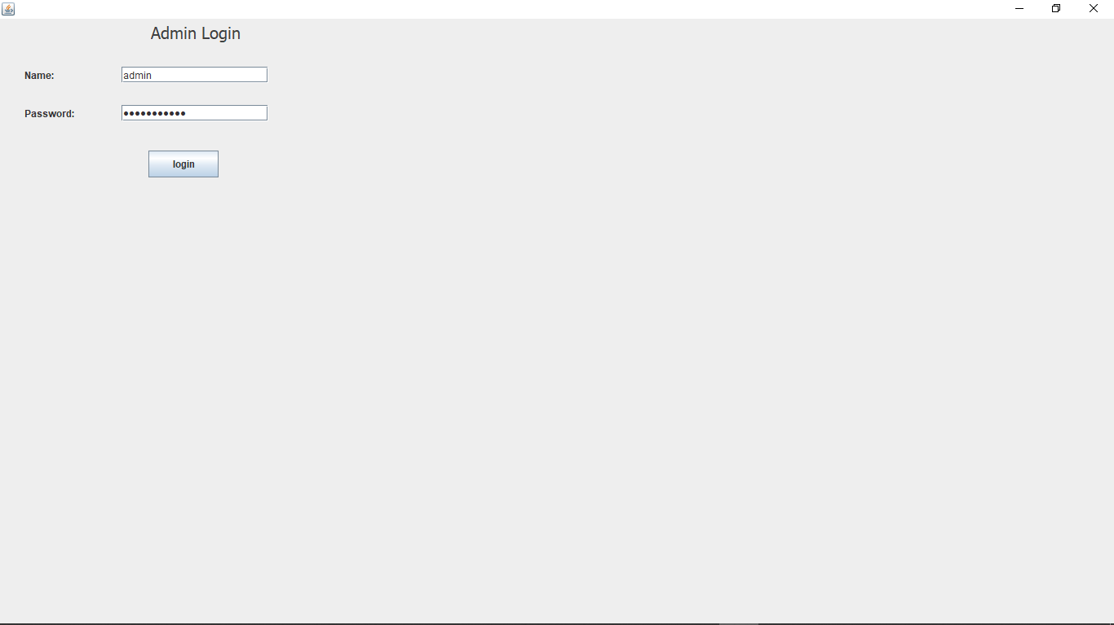

**After the admin has logged in, he will be redirected to the AdminSection page.These are the functions performed**

**by an admin:**

**Add Regulations,View Regulations,Update Regulations,Add Departments,View Departments,Update Departments,Add Employees**

**View Employees,Edit Employees,Delete Employee and View Comments.**

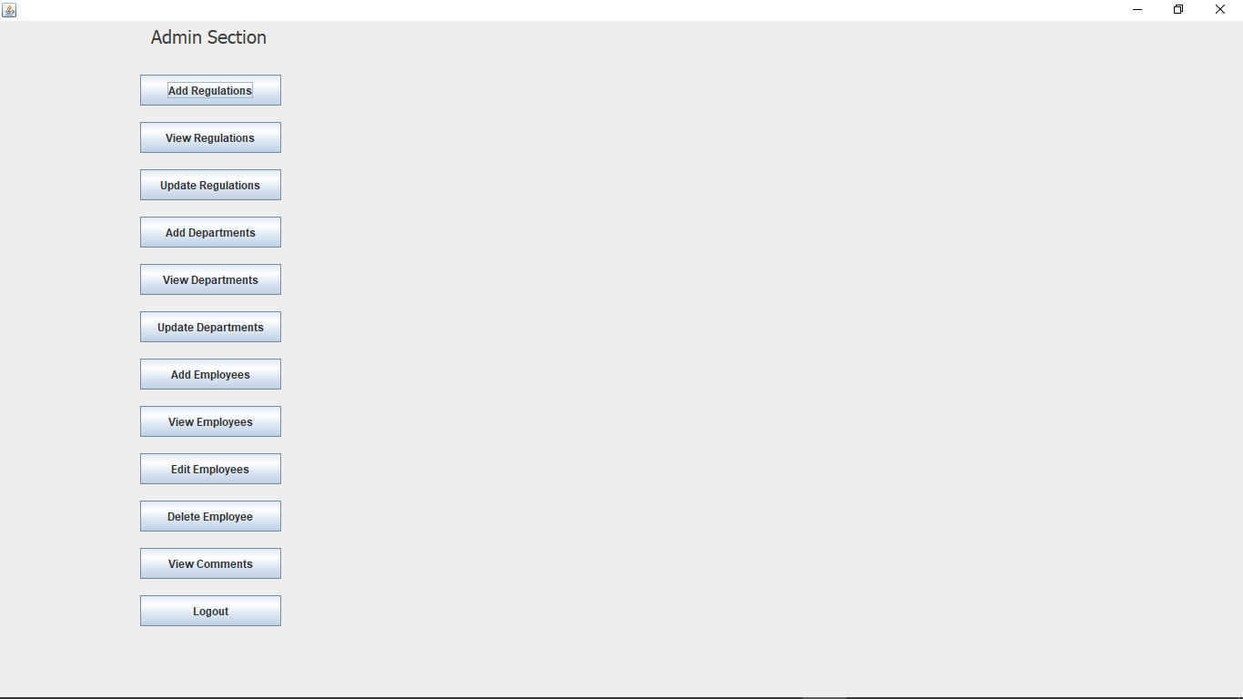

**Users(employees) must be able login.But for the users to be able to log in they must be registered before they can Log in.**

**Therefore we must first create a SignUpPage for users(employees) to be registered.So we will create a SignUpPage.java class.Here’s the code below.**

**Before we create a SignUpPage,we must first DBValues.java class.Here’s the code below.**

**package** com.java.employeesystem;

**public** **class** DBValues {

**static** String *dbname*="employee-db";

**static** String *dbpass*="Nkululeko_93";

**static** String *dbhost*="localhost";

**static** String *dbuname*="root";

**static** String *dbport*="3306";

**static** String *s*="";

}

**Then we can now create the SignUpPage.java class**

**package** com.java.employeesystem;

**import** java.awt.EventQueue;

**import** javax.swing.JFrame;

**import** javax.swing.JLabel;

**import** java.awt.Font;

**import** javax.swing.JOptionPane;

**import** javax.swing.JTextField;

**import** javax.swing.JPasswordField;

**import** javax.swing.JButton;

**import** java.awt.event.ActionListener;

**import** java.awt.event.ActionEvent;

**import** java.sql.Connection;

**import** java.sql.DriverManager;

**import** java.sql.ResultSet;

**import** java.sql.SQLException;

**import** java.sql.Statement;

**import** javax.swing.SwingConstants;

**import** java.awt.Toolkit;

**import** javax.swing.ImageIcon;

**public** **class** SignUpPage {

JFrame frameSignUp;

**private** JTextField txtEmpid;

**private** JPasswordField passwordField;

/**

* Launch the application.

*/

**public** **static** **void** main(String[] args) {

EventQueue.*invokeLater*(**new** Runnable() {

**public** **void** run() {

**try** {

SignUpPage window = **new** SignUpPage();

window.frameSignUp.setVisible(**true**);

} **catch** (Exception e) {

e.printStackTrace();

}

}

});

}

/**

* Create the application.

*/

**public** SignUpPage() {

initialize();

}

/**

* Initialize the contents of the frame.

*/

**private** **void** initialize() {

frameSignUp = **new** JFrame();

frameSignUp.setIconImage(Toolkit.*getDefaultToolkit*().getImage(SignUpPage.**class**.getResource("/com/java/employeesystem/power_icon.png")));

frameSignUp.setResizable(**false**);

frameSignUp.setTitle("Sign Up to continue");

frameSignUp.setBounds(100, 100, 915, 658);

frameSignUp.setDefaultCloseOperation(JFrame.***EXIT_ON_CLOSE***);

frameSignUp.getContentPane().setLayout(**null**);

JLabel lblSignUp = **new** JLabel("Sign Up");

lblSignUp.setHorizontalAlignment(SwingConstants.***CENTER***);

lblSignUp.setFont(**new** Font("GTWalsheimLight", Font.***PLAIN***, 23));

lblSignUp.setBounds(10, 104, 889, 36);

frameSignUp.getContentPane().add(lblSignUp);

JLabel lblEmpid = **new** JLabel("Emp ID");

lblEmpid.setBounds(154, 208, 70, 22);

frameSignUp.getContentPane().add(lblEmpid);

JLabel lblPassword = **new** JLabel("Password");

lblPassword.setBounds(154, 274, 70, 14);

frameSignUp.getContentPane().add(lblPassword);

txtEmpid = **new** JTextField();

txtEmpid.setBounds(341, 209, 309, 20);

frameSignUp.getContentPane().add(txtEmpid);

txtEmpid.setColumns(10);

passwordField = **new** JPasswordField();

passwordField.setBounds(341, 271, 309, 20);

frameSignUp.getContentPane().add(passwordField);

JButton btnSignUp = **new** JButton("Sign Up");

btnSignUp.addActionListener(**new** ActionListener() {

**public** **void** actionPerformed(ActionEvent e) {

**int** empid=Integer.*parseInt*(txtEmpid.getText());

String zpass2=**new** String(passwordField.getPassword());

**if** (zpass2.equals("")) {

JOptionPane.*showMessageDialog*(frameSignUp, "Password cannot be blank");

}

**else**{

**try**{

Class.*forName*("com.mysql.jdbc.Driver");

Connection connection=DriverManager.*getConnection*(

"jdbc:mysql://"+DBValues.*dbhost*+":"+DBValues.*dbport*+"/"+DBValues.*dbname*+"",""+DBValues.*dbuname*+"",""+DBValues.*dbpass*+"");

String qu3= "select * from login_master where empid='"+empid+"'";

Statement statement2= connection.createStatement();

ResultSet row2= statement2.executeQuery(qu3);

**if** (row2.first()) {

JOptionPane.*showMessageDialog*(frameSignUp, " Username already exists!!");

}

**else**{

String qu2= "insert into login_master(empid,password ) values ('"+empid+"','"+zpass2+"')";

Statement statement= connection.createStatement();

**int** row= statement.executeUpdate(qu2);

JOptionPane.*showMessageDialog*(frameSignUp, row+" user registered successfully!");

UserLogin page = **new** UserLogin();

page.frameLoginPage.setVisible(**true**);

frameSignUp.dispose();

}

} **catch** (ClassNotFoundException e1) {

// **TODO** Auto-generated catch block

e1.printStackTrace();

} **catch** (SQLException e2) {

// **TODO** Auto-generated catch block

e2.printStackTrace();

}

}

}});

btnSignUp.setBounds(260, 344, 349, 23);

frameSignUp.getContentPane().add(btnSignUp);

JButton btnLogIn = **new** JButton("Log In");

btnLogIn.addActionListener(**new** ActionListener() {

**public** **void** actionPerformed(ActionEvent e) {

UserLogin page = **new** UserLogin();

page.frameLoginPage.setVisible(**true**);

frameSignUp.dispose();

}

});

btnLogIn.setBounds(367, 428, 153, 23);

frameSignUp.getContentPane().add(btnLogIn);

JLabel label = **new** JLabel("______________________________________");

label.setHorizontalAlignment(SwingConstants.***CENTER***);

label.setBounds(289, 378, 269, 14);

frameSignUp.getContentPane().add(label);

JLabel lblAlreadyAUser = **new** JLabel("Already a User?");

lblAlreadyAUser.setHorizontalAlignment(SwingConstants.***CENTER***);

lblAlreadyAUser.setBounds(357, 403, 153, 14);

frameSignUp.getContentPane().add(lblAlreadyAUser);

JLabel lblAsNewUser = **new** JLabel("as New User");

lblAsNewUser.setHorizontalAlignment(SwingConstants.***CENTER***);

lblAsNewUser.setBounds(20, 143, 879, 14);

frameSignUp.getContentPane().add(lblAsNewUser);

JLabel label_1 = **new** JLabel("");

label_1.setIcon(**new** ImageIcon(SignUpPage.**class**.getResource("/com/java/employeesystem/back_3.jpg")));

label_1.setBounds(-13, 0, 951, 685);

frameSignUp.getContentPane().add(label_1);

}

}

**We need to take note of the following.We’ve included the power_icon.png,and back_3.jpg as images to the com.java.employeeesystem package**

frameSignUp.setIconImage(Toolkit.*getDefaultToolkit*().getImage(SignUpPage.**class**.getResource("/com/java/employeesystem/power_icon.png")));

label_1.setIcon(**new** ImageIcon(SignUpPage.**class**.getResource("/com/java/employeesystem/back_3.jpg")));

**After we’ve run the code ,this is how the SignUp page will look like.After the New user has entered the required information a message will be displayed**

**as a confirmation that the user has registered successfully.**

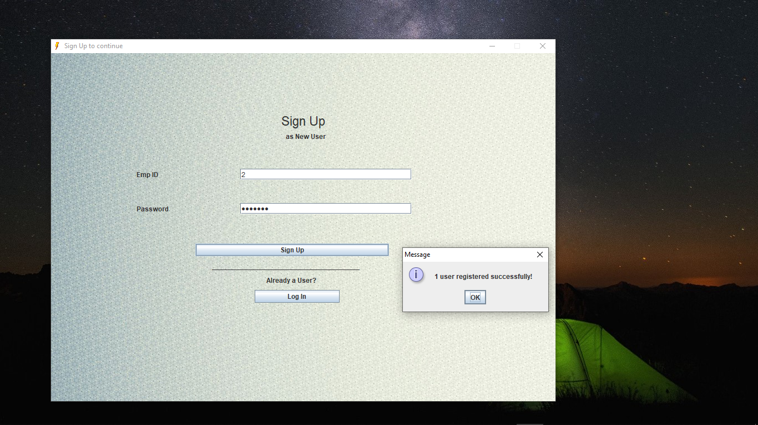

**Now that the new user(employee) has registered,the new user must now be able to login.Therefore we will create a login page**

**And named it as UserLogin.We must create a class UserLogin.java. Here’s the code below.**

**package** com.java.employeesystem;

**import** java.awt.EventQueue;

**import** javax.swing.JFrame;

**import** javax.swing.JLabel;

**import** java.awt.Font;

**import** javax.swing.JOptionPane;

**import** javax.swing.JTextField;

**import** javax.swing.JPasswordField;

**import** javax.swing.JButton;

**import** java.awt.event.ActionListener;

**import** java.awt.event.ActionEvent;

**import** java.sql.Connection;

**import** java.sql.DriverManager;

**import** java.sql.ResultSet;

**import** java.sql.SQLException;

**import** java.sql.Statement;

**import** javax.swing.SwingConstants;

**import** javax.swing.ImageIcon;

**import** java.awt.Color;

**import** java.awt.Toolkit;

**public** **class** UserLogin {

**static** **int** *uempidtopass*;

JFrame frameLoginPage;

**private** JPasswordField passwordField;

**private** JTextField textFieldEmpid;

/**

* Launch the application.

*/

**public** **static** **void** main(String[] args) {

EventQueue.*invokeLater*(**new** Runnable() {

**public** **void** run() {

**try** {

UserLogin window = **new** UserLogin();

window.frameLoginPage.setVisible(**true**);

} **catch** (Exception e) {

e.printStackTrace();

}

}

});

}

**public** UserLogin() {

initialize();

}

**private** **void** initialize() {

frameLoginPage = **new** JFrame();

frameLoginPage.setIconImage(Toolkit.*getDefaultToolkit*().getImage(UserLogin.**class**.getResource("/com/java/employeesystem/power_icon.png")));

frameLoginPage.setResizable(**false**);

frameLoginPage.getContentPane().setBackground(Color.***WHITE***);

frameLoginPage.setBackground(Color.***WHITE***);

frameLoginPage.setTitle("Log In to continue");

frameLoginPage.setBounds(100, 100, 924, 634);

frameLoginPage.setDefaultCloseOperation(JFrame.***EXIT_ON_CLOSE***);

frameLoginPage.getContentPane().setLayout(**null**);

JLabel lblLogInTo = **new** JLabel("Log In to continue");

lblLogInTo.setHorizontalAlignment(SwingConstants.***CENTER***);

lblLogInTo.setFont(**new** Font("Raleway", Font.***PLAIN***, 18));

lblLogInTo.setBounds(10, 69, 847, 67);

frameLoginPage.getContentPane().add(lblLogInTo);

JLabel lblUsername = **new** JLabel("EmpID");

lblUsername.setFont(**new** Font("Raleway", Font.***PLAIN***, 15));

lblUsername.setHorizontalAlignment(SwingConstants.***CENTER***);

lblUsername.setBounds(10, 184, 847, 23);

frameLoginPage.getContentPane().add(lblUsername);

JLabel lblPassword = **new** JLabel("Password");

lblPassword.setFont(**new** Font("Raleway", Font.***PLAIN***, 15));

lblPassword.setHorizontalAlignment(SwingConstants.***CENTER***);

lblPassword.setBounds(10, 252, 847, 39);

frameLoginPage.getContentPane().add(lblPassword);

passwordField = **new** JPasswordField();

passwordField.setToolTipText("Enter Password ");

passwordField.setHorizontalAlignment(SwingConstants.***CENTER***);

passwordField.setBounds(148, 302, 565, 23);

frameLoginPage.getContentPane().add(passwordField);

textFieldEmpid = **new** JTextField();

textFieldEmpid.setHorizontalAlignment(SwingConstants.***CENTER***);

textFieldEmpid.setToolTipText("Enter EmpID");

textFieldEmpid.setBounds(148, 218, 565, 23);

frameLoginPage.getContentPane().add(textFieldEmpid);

textFieldEmpid.setColumns(10);

JButton btnLogIn = **new** JButton("Log In");

btnLogIn.setForeground(**new** Color(255, 255, 255));

btnLogIn.setFont(**new** Font("Raleway", Font.***PLAIN***, 13));

btnLogIn.setBackground(**new** Color(100, 149, 237));

btnLogIn.addActionListener(**new** ActionListener() {

**public** **void** actionPerformed(ActionEvent e) {

String s_empid=textFieldEmpid.getText();

**int** emp_id=0;

**if**( ! s_empid.equals(""))

{

s_empid=textFieldEmpid.getText();

emp_id=Integer.*valueOf*(s_empid);

}

**else**

{

JOptionPane.*showMessageDialog*(**null**,"Please Enter EmpID");

}

*uempidtopass*=emp_id;

String password=**new** String(passwordField.getPassword());

**if** (password.equals("")) {

JOptionPane.*showMessageDialog*(frameLoginPage, "Password cannot be blank");

}

**else**{

**try**{

Class.*forName*("com.mysql.jdbc.Driver");

Connection connection;

connection=DriverManager.*getConnection*(

"jdbc:mysql://"+DBValues.*dbhost*+":"+DBValues.*dbport*+"/"+DBValues.*dbname*+"",""+DBValues.*dbuname*+"",""+DBValues.*dbpass*+"");

String qu2= "select * from login_master where empid='"+emp_id+"'&& password='"+password+"' ";

Statement statement= connection.createStatement();

ResultSet row= statement.executeQuery(qu2);

**if** (row.first()) {

JOptionPane.*showMessageDialog*(frameLoginPage, " Logged In successfully!");

EmployeeSection landingPage = **new** EmployeeSection();

landingPage.setVisible(**true**);

frameLoginPage.dispose();

}

**else**{

JOptionPane.*showMessageDialog*(frameLoginPage, " EmpID/Password is Wrong or User is not verified by Admin. Contact Admin");

}

} **catch** (ClassNotFoundException e1) {

// **TODO** Auto-generated catch block

e1.printStackTrace();

} **catch** (SQLException e2) {

// **TODO** Auto-generated catch block

e2.printStackTrace();

}

}

}});

btnLogIn.setBounds(225, 336, 401, 47);

frameLoginPage.getContentPane().add(btnLogIn);

JLabel lblOr = **new** JLabel("or");

lblOr.setHorizontalAlignment(SwingConstants.***CENTER***);

lblOr.setBounds(363, 425, 115, 14);

frameLoginPage.getContentPane().add(lblOr);

JButton btnSignup = **new** JButton("Signup");

btnSignup.setForeground(**new** Color(0, 0, 0));

btnSignup.setBackground(**new** Color(0, 250, 154));

btnSignup.setFont(**new** Font("Raleway", Font.***PLAIN***, 12));

btnSignup.addActionListener(**new** ActionListener() {

**public** **void** actionPerformed(ActionEvent e) {

SignUpPage page = **new** SignUpPage();

page.frameSignUp.setVisible(**true**);

frameLoginPage.dispose();

}

});

btnSignup.setBounds(290, 465, 271, 39);

frameLoginPage.getContentPane().add(btnSignup);

JLabel lblUserLogin = **new** JLabel("User Login");

lblUserLogin.setBackground(Color.***LIGHT_GRAY***);

lblUserLogin.setHorizontalAlignment(SwingConstants.***CENTER***);

lblUserLogin.setFont(**new** Font("Raleway", Font.***PLAIN***, 20));

lblUserLogin.setBounds(297, 27, 264, 47);

frameLoginPage.getContentPane().add(lblUserLogin);

JButton btnGoBack = **new** JButton("Go Back");

btnGoBack.addActionListener(**new** ActionListener() {

**public** **void** actionPerformed(ActionEvent e) {

StartPage page = **new** StartPage();

page.frmWelcome.setVisible(**true**);

frameLoginPage.dispose();

}

});

btnGoBack.setBounds(10, 10, 153, 23);

frameLoginPage.getContentPane().add(btnGoBack);

JLabel label = **new** JLabel("");

label.setIcon(**new** ImageIcon(UserLogin.**class**.getResource("/com/java/employeesystem/bg_gray.png")));

label.setBackground(Color.***LIGHT_GRAY***);

label.setBounds(0, 0, 918, 617);

frameLoginPage.getContentPane().add(label);

}

}

**But after the new user has logged in ,the new user must be able to be redirected somewhere.So we need to create an EmployeeSection page where a new user(employee)**

**will perform all the required functions. Therefore we must create a class called EmployeeSection.java.Here’s the code below.**

**package** com.java.employeesystem;

**import** java.awt.Color;

**import** java.awt.EventQueue;

**import** java.awt.Font;

**import** java.awt.event.ActionEvent;

**import** java.awt.event.ActionListener;

**import** javax.swing.GroupLayout;

**import** javax.swing.GroupLayout.Alignment;

**import** javax.swing.JButton;

**import** javax.swing.JFrame;

**import** javax.swing.JLabel;

**import** javax.swing.JPanel;

**import** javax.swing.JScrollPane;

**import** javax.swing.border.EmptyBorder;

**public** **class** EmployeeSection **extends** JFrame {

/**

*

*/

**private** **static** **final** **long** ***serialVersionUID*** = 1L;

**static** EmployeeSection *frame*;

**private** JPanel contentPane;

JScrollPane sp;

/**

* Launch the application.

*/

**public** **static** **void** main(String[] args) {

EventQueue.*invokeLater*(**new** Runnable() {

**public** **void** run() {

**try** {

*frame* = **new** EmployeeSection();

*frame*.setVisible(**true**);

} **catch** (Exception e) {

e.printStackTrace();

}

}

});

}

/**

* Create the frame.

*/

**public** EmployeeSection() {

setDefaultCloseOperation(JFrame.***EXIT_ON_CLOSE***);

setBounds(100, 100, 450, 300);

contentPane = **new** JPanel();

contentPane.setBorder(**new** EmptyBorder(5, 5, 5, 5));

setContentPane(contentPane);

JLabel lblEmployeeSection = **new** JLabel("Employee Section");

lblEmployeeSection.setForeground(Color.***DARK_GRAY***);

lblEmployeeSection.setFont(**new** Font("Tahoma", Font.***PLAIN***, 20));

JButton btnViewRegulation = **new** JButton("View Regulations");

btnViewRegulation.addActionListener(**new** ActionListener() {

**public** **void** actionPerformed(ActionEvent e) {

ViewRegulations.*main*(**new** String[]{});

}

});

JButton btnSendFeedback = **new** JButton("Send Your Comments");

btnSendFeedback.addActionListener(**new** ActionListener() {

**public** **void** actionPerformed(ActionEvent e) {

SendComments.*main*(**new** String[]{});

}

});

JButton btnViewComment = **new** JButton("View your Comments sent");

btnViewComment.addActionListener(**new** ActionListener() {

**public** **void** actionPerformed(ActionEvent e) {

ViewComments.*main*(**new** String[]{});

}

});

JButton btnEditComment = **new** JButton("Edit Your Comments");

btnEditEditComment.addActionListener(**new** ActionListener() {

**public** **void** actionPerformed(ActionEvent e) {

EditComments.*main*(**new** String[]{});

}

});

JButton btnLogout = **new** JButton("Logout");

btnLogout.addActionListener(**new** ActionListener() {

**public** **void** actionPerformed(ActionEvent e) {

UserLogin.*main*(**new** String[]{});

*frame*.dispose();

}

});

GroupLayout gl_contentPane = **new** GroupLayout(contentPane);

gl_contentPane.setHorizontalGroup(

gl_contentPane.createParallelGroup(Alignment.***LEADING***)

.addGroup(gl_contentPane.createSequentialGroup()

.addGroup(gl_contentPane.createParallelGroup(Alignment.***LEADING***)

.addGroup(gl_contentPane.createSequentialGroup()

.addGap(161)

.addComponent(lblEmployeeSection))

.addGroup(gl_contentPane.createSequentialGroup()

.addGap(149)

.addGroup(gl_contentPane.createParallelGroup(Alignment.***LEADING***)

.addComponent(btnViewRegulation, GroupLayout.***PREFERRED_SIZE***, 195, GroupLayout.***PREFERRED_SIZE***)

.addComponent(btnSendFeedback, GroupLayout.***PREFERRED_SIZE***, 195, GroupLayout.***PREFERRED_SIZE***)

.addComponent(btnViewComment, GroupLayout.***PREFERRED_SIZE***, 195, GroupLayout.***PREFERRED_SIZE***)

.addComponent(btnEditComment, GroupLayout.***PREFERRED_SIZE***, 195, GroupLayout.***PREFERRED_SIZE***)

.addComponent(btnLogout, GroupLayout.***PREFERRED_SIZE***, 195, GroupLayout.***PREFERRED_SIZE***))))

.addContainerGap(144, Short.***MAX_VALUE***))

);

gl_contentPane.setVerticalGroup(

gl_contentPane.createParallelGroup(Alignment.***LEADING***)

.addGroup(gl_contentPane.createSequentialGroup()

.addComponent(lblEmployeeSection)

.addGap(29)

.addComponent(btnViewRegulation, GroupLayout.***PREFERRED_SIZE***, 34, GroupLayout.***PREFERRED_SIZE***)

.addGap(18)

.addComponent(btnSendFeedback, GroupLayout.***PREFERRED_SIZE***, 34, GroupLayout.***PREFERRED_SIZE***)

.addGap(18)

.addComponent(btnViewComment, GroupLayout.***PREFERRED_SIZE***, 34, GroupLayout.***PREFERRED_SIZE***)

.addGap(18)

.addComponent(btnEditFeedback, GroupLayout.***PREFERRED_SIZE***, 34, GroupLayout.***PREFERRED_SIZE***)

.addGap(18)

.addComponent(btnLogout, GroupLayout.***PREFERRED_SIZE***, 34, GroupLayout.***PREFERRED_SIZE***)

.addContainerGap(59, Short.***MAX_VALUE***))

);

contentPane.setLayout(gl_contentPane);

}

}

**Below is the user-interface of the UserLogin page.Now that the new user(employee) is registered he/she can be able to login.After the**

**New user has entered the login credentials,the new user will be redirected to an EmployeeSection page.**

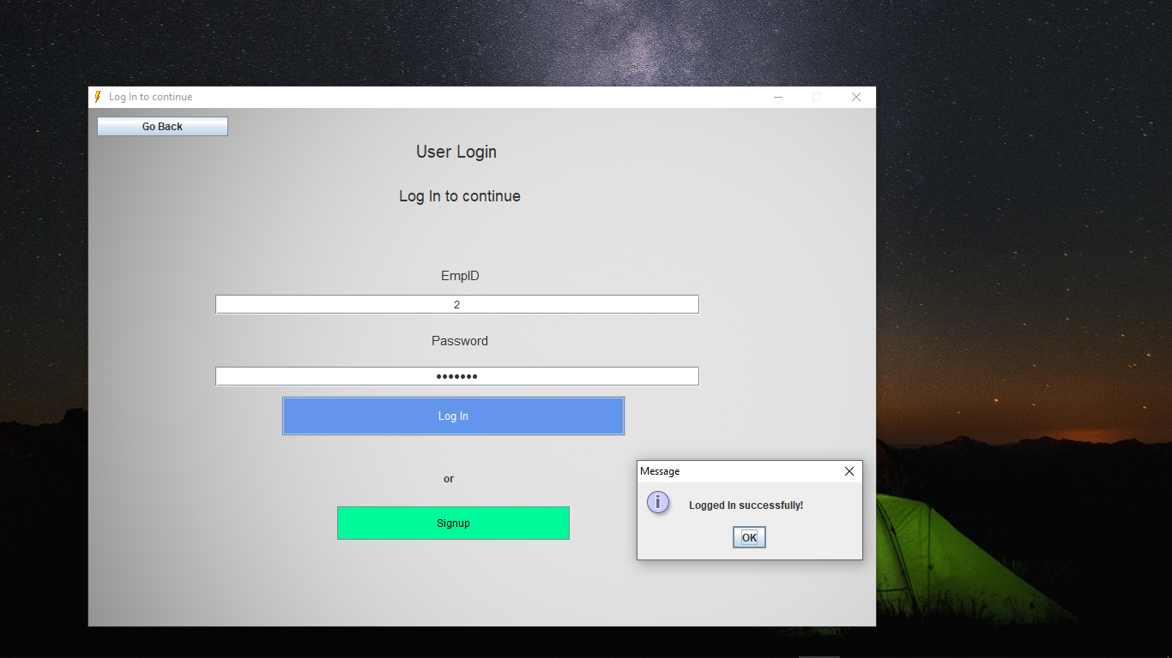

**This is the EmployeeSection where the Employee as a new user will perform the required functions.The Employee**

**will View Regulations,Send Comments on the Regulations,View Comments sent and Edit Comments**.

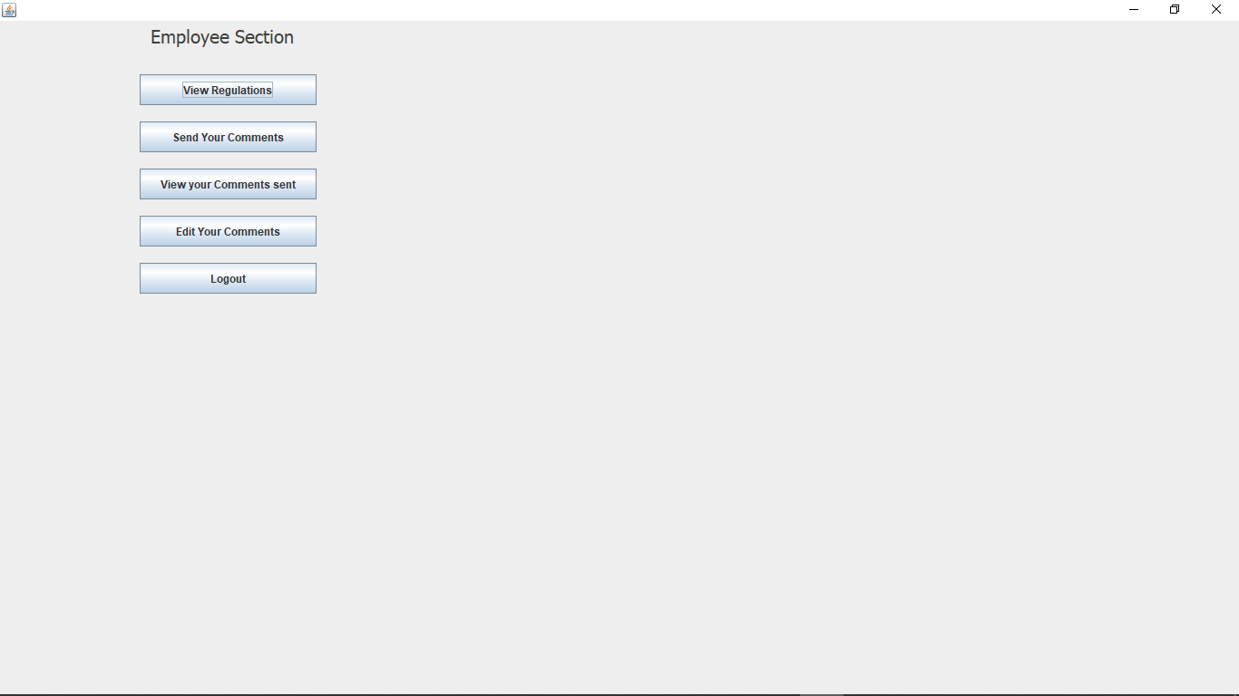

We can create a startpage.Here’s the code.

**package** com.java.employeesystem;

**import** java.awt.EventQueue;

**import** javax.swing.JFrame;

**import** javax.swing.JLabel;

**import** javax.swing.JOptionPane;

**import** java.awt.Font;

**import** javax.swing.JButton;

**import** java.awt.event.ActionListener;

**import** java.awt.event.ActionEvent;

**import** java.awt.Color;

//import java.awt.SystemColor;

**import** javax.swing.SwingConstants;

**import** java.awt.Toolkit;

**import** javax.swing.ImageIcon;

**import** javax.swing.UIManager;

**public** **class** StartPage {

JFrame frmWelcome;

**public** **static** **void** main(String[] args) {

EventQueue.*invokeLater*(**new** Runnable() {

**public** **void** run() {

**try** {

StartPage window = **new** StartPage();

window.frmWelcome.setVisible(**true**);

} **catch** (Exception e) {

e.printStackTrace();

}

}

});

}

**public** StartPage() {

initialize();

}

**private** **void** initialize() {

frmWelcome = **new** JFrame();

frmWelcome.setResizable(**false**);

frmWelcome.setIconImage(Toolkit.*getDefaultToolkit*().getImage(StartPage.**class**.getResource("/com/java/employeesystem/power_icon.png")));

frmWelcome.setTitle("Welcome !");

frmWelcome.getContentPane().setBackground(**new** Color(255, 255, 255));

frmWelcome.getContentPane().setForeground(Color.***WHITE***);

frmWelcome.setBounds(100, 100, 1026, 750);

frmWelcome.setDefaultCloseOperation(JFrame.***EXIT_ON_CLOSE***);

frmWelcome.getContentPane().setLayout(**null**);

JLabel lblEmployeeManagementSystem = **new** JLabel("Employee Management System");

lblEmployeeManagementSystem.setHorizontalAlignment(SwingConstants.***CENTER***);

lblEmployeeManagementSystem.setFont(**new** Font("Cookie", Font.***PLAIN***, 36));

lblEmployeeManagementSystem.setBounds(10, 48, 1000, 55);

frmWelcome.getContentPane().add(lblEmployeeManagementSystem);

JLabel lblAJdbcswingApplication = **new** JLabel("A JDBC-Swing Application");

lblAJdbcswingApplication.setHorizontalAlignment(SwingConstants.***CENTER***);

lblAJdbcswingApplication.setFont(**new** Font("Segoe UI", Font.***PLAIN***, 15));

lblAJdbcswingApplication.setBounds(10, 102, 990, 24);

frmWelcome.getContentPane().add(lblAJdbcswingApplication);

JLabel label = **new** JLabel("________________________________________________");

label.setHorizontalAlignment(SwingConstants.***CENTER***);

label.setBounds(20, 89, 1000, 14);

frmWelcome.getContentPane().add(label);

JLabel lblMadeBy = **new** JLabel("Made by");

lblMadeBy.setHorizontalAlignment(SwingConstants.***CENTER***);

lblMadeBy.setBounds(10, 515, 1000, 14);

frmWelcome.getContentPane().add(lblMadeBy);

JLabel lblGauravSachdeva = **new** JLabel("Nkululeko Freedom Mqadi");

lblGauravSachdeva.setHorizontalAlignment(SwingConstants.***CENTER***);

lblGauravSachdeva.setFont(**new** Font("Baskerville Old Face", Font.***PLAIN***, 18));

lblGauravSachdeva.setBounds(10, 543, 1000, 32);

frmWelcome.getContentPane().add(lblGauravSachdeva);

JButton btnLogIn = **new** JButton("Log In");

btnLogIn.setFont(**new** Font("Raleway", Font.***PLAIN***, 13));

btnLogIn.addActionListener(**new** ActionListener() {

**public** **void** actionPerformed(ActionEvent e) {

UserLogin page = **new** UserLogin();

//page.frame

page.frameLoginPage.setVisible(**true**);

frmWelcome.dispose();

}

});

btnLogIn.setBackground(UIManager.*getColor*("Button.background"));

btnLogIn.setBounds(45, 208, 296, 48);

frmWelcome.getContentPane().add(btnLogIn);

JLabel lblOr = **new** JLabel("or");

lblOr.setHorizontalAlignment(SwingConstants.***CENTER***);

lblOr.setBounds(45, 267, 296, 14);

frmWelcome.getContentPane().add(lblOr);

JButton btnSignUp = **new** JButton("Sign Up");

btnSignUp.setFont(**new** Font("Raleway", Font.***PLAIN***, 12));

btnSignUp.setForeground(Color.***BLACK***);

btnSignUp.setBackground(UIManager.*getColor*("Button.background"));

btnSignUp.addActionListener(**new** ActionListener() {

**public** **void** actionPerformed(ActionEvent e) {

SignUpPage page = **new** SignUpPage();

//page.frame

page.frameSignUp.setVisible(**true**);

frmWelcome.dispose();

}

});

btnSignUp.setBounds(45, 292, 296, 38);

frmWelcome.getContentPane().add(btnSignUp);

JLabel lblUserLogin = **new** JLabel("User Login");

lblUserLogin.setFont(**new** Font("Raleway", Font.***PLAIN***, 15));

lblUserLogin.setHorizontalAlignment(SwingConstants.***CENTER***);

lblUserLogin.setBounds(45, 165, 296, 32);

frmWelcome.getContentPane().add(lblUserLogin);

JLabel lblAdminLogin = **new** JLabel("Admin Login");

lblAdminLogin.setFont(**new** Font("Raleway", Font.***PLAIN***, 15));

lblAdminLogin.setHorizontalAlignment(SwingConstants.***CENTER***);

lblAdminLogin.setBounds(692, 171, 268, 21);

frmWelcome.getContentPane().add(lblAdminLogin);

JButton btnLogin = **new** JButton("Login");

btnLogin.addActionListener(**new** ActionListener() {

**public** **void** actionPerformed(ActionEvent e) {

AdminLogin adminLogin = **new** AdminLogin();

adminLogin.setVisible(**true**);

frmWelcome.dispose();

}

});

btnLogin.setFont(**new** Font("Raleway", Font.***PLAIN***, 13));

btnLogin.setBounds(692, 208, 268, 48);

frmWelcome.getContentPane().add(btnLogin);

JLabel label_1 = **new** JLabel("");

label_1.setIcon(**new** ImageIcon(StartPage.**class**.getResource("/com/java/employeesystem/back_3.jpg")));

label_1.setBounds(0, 0, 1044, 743);

frmWelcome.getContentPane().add(label_1);

}

}

A startpage of an Employee Management System

